**Azure Infrastructure Deployment with ARM/Bicep + Automation**

**Objective**

The main objectives of this project are:

1. **Automate Infrastructure Deployment**: Deploy Azure resources programmatically using Bicep templates.
2. **Secure Resource Provisioning**: Use Azure Key Vault and NSGs to protect resources.
3. **Create Scalable Architecture**: Deploy resources that can be scaled for future applications.
4. **Enable Repeatable Deployments**: Support multiple deployments with minimal configuration changes.
5. **Include Storage and Backup**: Ensure persistent data storage and reliable backup mechanisms.

## Project Background

Modern cloud environments require **efficient, repeatable, and secure deployment of resources**. Manually creating Azure resources is prone to errors, time-consuming, and difficult to maintain. This project addresses these challenges by using **Infrastructure as Code (IaC)** with **Bicep**, a domain-specific language for Azure resource deployment.

**Key Goals:**

* Automate provisioning of core Azure infrastructure.
* Ensure security best practices are followed (NSGs, Key Vault, secure credentials).
* Make deployments consistent and repeatable.
* Minimize manual configuration and reduce human error.

## Project Scope

The project deploys the following **core infrastructure components**:

* **Virtual Network (VNet)**: The primary network backbone.
* **Subnets**: Logical segmentation of the VNet (Frontend, Backend, Management).
* **Network Security Groups (NSGs)**: Control inbound and outbound traffic at the subnet level.
* **Virtual Machines (Windows and Linux)**: Compute resources for applications and services.
* **Azure Key Vault**: Secure storage of sensitive data like admin passwords and secrets.
* **Storage Accounts**: Blob and file storage for applications and data.
* **Backup Vaults**: Recovery Services vaults to enable VM and data backup.

**Scenario**

**CloudKhan Solutions** is a growing IT services company migrating its on-premises infrastructure to Azure.  
As a **Cloud Administrator**, you are responsible for designing and deploying a **production-ready Azure environment** using ARM/Bicep templates to ensure **consistency, automation, security, and recoverability**.

The environment must support:

* Secure networking
* Windows & Linux workloads
* Centralized secrets management
* Backup and recovery
* Automation-friendly deployment

**High-Level Architecture Overview**

* Resource Group (logical container)
* Virtual Network with multiple subnets
* Network Security Groups (NSGs)
* Windows Virtual Machine
* Linux Virtual Machine
* Storage Account
* Azure Key Vault
* Recovery Services Vault (Azure Backup)
* ARM/Bicep templates for repeatable deployment

**Project Tasks & Detailed Steps**

**Task 1: Azure Environment Preparation**

**1. Create Resource Group**

* Create a dedicated Resource Group for the project
* Use a standardized naming convention
* Select a single Azure region for all resources

**Task 2: Network Infrastructure Deployment**

**1. Deploy Virtual Network (VNet)**

* Create a VNet with a private IP address space (CIDR)
* Plan address ranges to support future scaling

**2. Create Subnets**

* **Frontend Subnet** (for application/public-facing VM)
* **Backend Subnet** (for internal services)
* **Management Subnet** (optional – for admin access)

**Task 3: Network Security Implementation**

**1. Create Network Security Groups (NSGs)**

* Create separate NSGs for each subnet
* Define inbound and outbound security rules

**2. Configure NSG Rules**

* Allow RDP (3389) to Windows VM (restricted source)
* Allow SSH (22) to Linux VM (restricted source)
* Deny unnecessary inbound traffic
* Allow required outbound traffic

**3. Associate NSGs**

* Attach NSGs to subnets or NICs

**Task 4: Compute Resource Deployment**

**1. Deploy Windows Virtual Machine**

* Use Windows Server 2019 or 2022
* Assign VM to Backend or Management subnet
* Configure:
  + VM size
  + OS disk
  + Admin credentials
  + Network interface

**2. Deploy Linux Virtual Machine**

* Use Ubuntu LTS
* Assign VM to Frontend or Backend subnet
* Configure:
  + SSH authentication
  + OS disk
  + Network interface

**Task 5: Storage Services Deployment**

**1. Create Storage Account**

* Use **Standard / LRS**
* Enable secure transfer (HTTPS only)
* Disable public access where possible

**2. Configure Storage Features**

* Blob containers
* Access tiers (Hot / Cool)
* RBAC-based access

**Task 6: Secrets & Key Management**

**1. Deploy Azure Key Vault**

* Create Key Vault in same region
* Enable:
  + Soft delete
  + Purge protection

**2. Store Secrets**

* VM admin passwords
* Storage account keys
* SSH private keys (optional)

**3. Configure Access Policies / RBAC**

* Allow VM or admin access to secrets
* Follow least-privilege principle

**Task 7: Backup & Recovery Implementation**

**1. Create Recovery Services Vault**

* Deploy Recovery Services Vault
* Configure storage redundancy

**2. Enable Azure Backup for VMs**

* Register both Windows & Linux VMs
* Apply backup policy:
  + Daily backup
  + Retention (30 days or more)

**Task 8: Infrastructure as Code (ARM/Bicep)**

**1. Create Bicep Templates**

* Main Bicep file (orchestrates deployment)
* Modular templates:
  + Network
  + Compute
  + Storage
  + Security
  + Backup

**2. Use Parameters**

* VM size
* Admin username
* Location
* Address spaces

**3. Deploy Using Automation**

* Azure CLI
* PowerShell
* Repeatable, version-controlled deployments

Paste your screenshots here….

**Task 1: Azure Environment Preparation**

1. Create Resource Group

* Create a dedicated Resource Group for the project
* Use a standardized naming convention
* Select a single Azure region for all resources

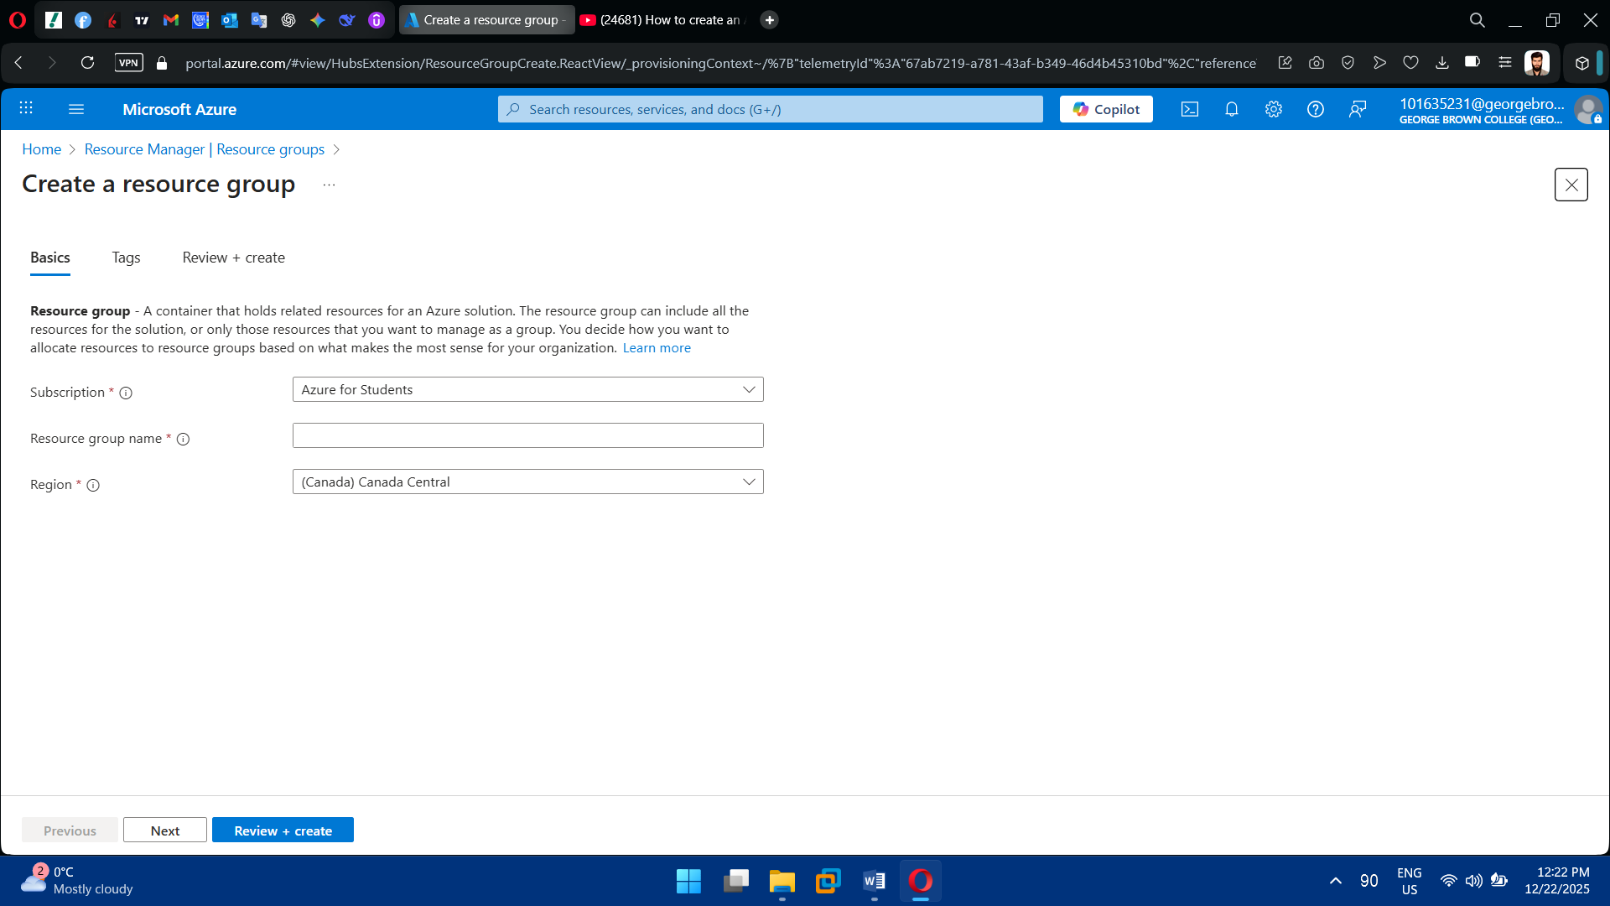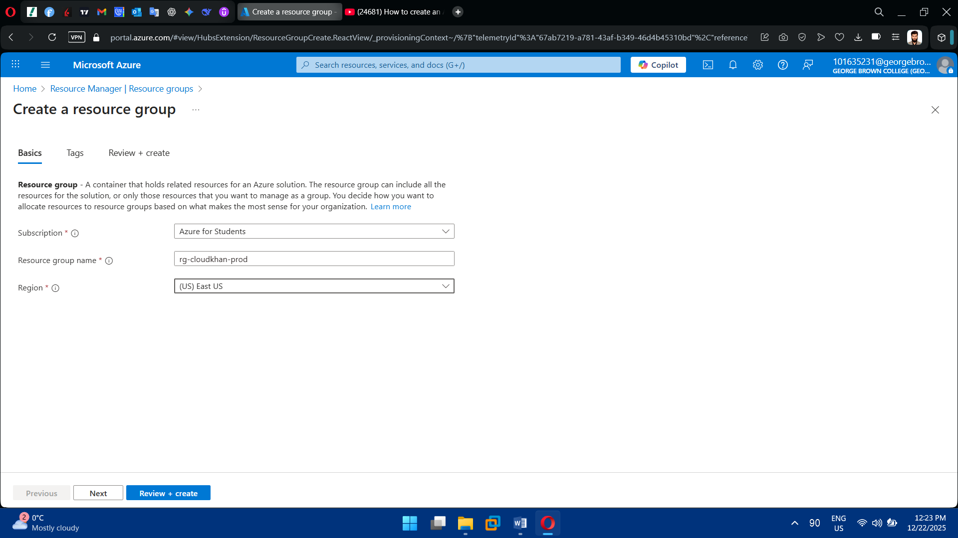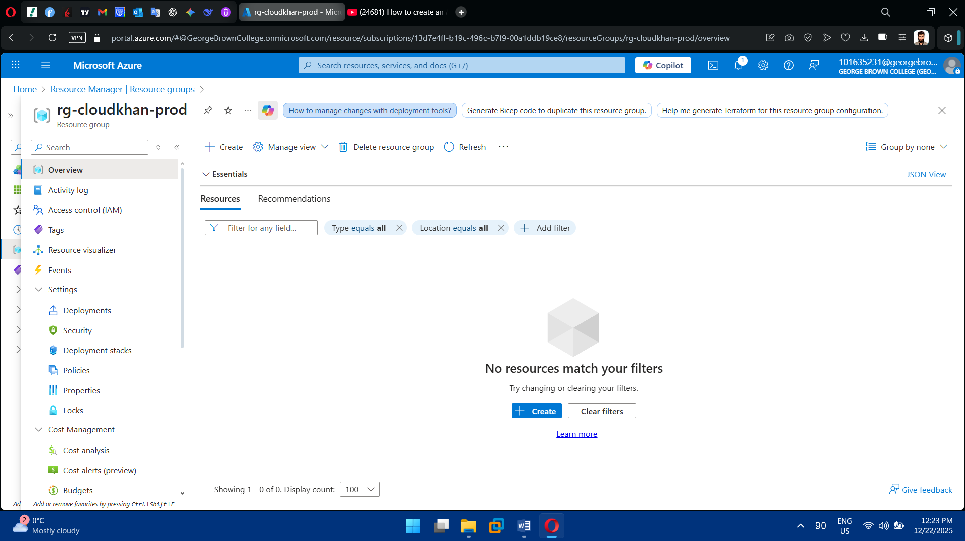

**Task 2: Network Infrastructure Deployment**

1. Deploy Virtual Network (VNet)

* Create a VNet with a private IP address space (CIDR)
* Plan address ranges to support future scaling

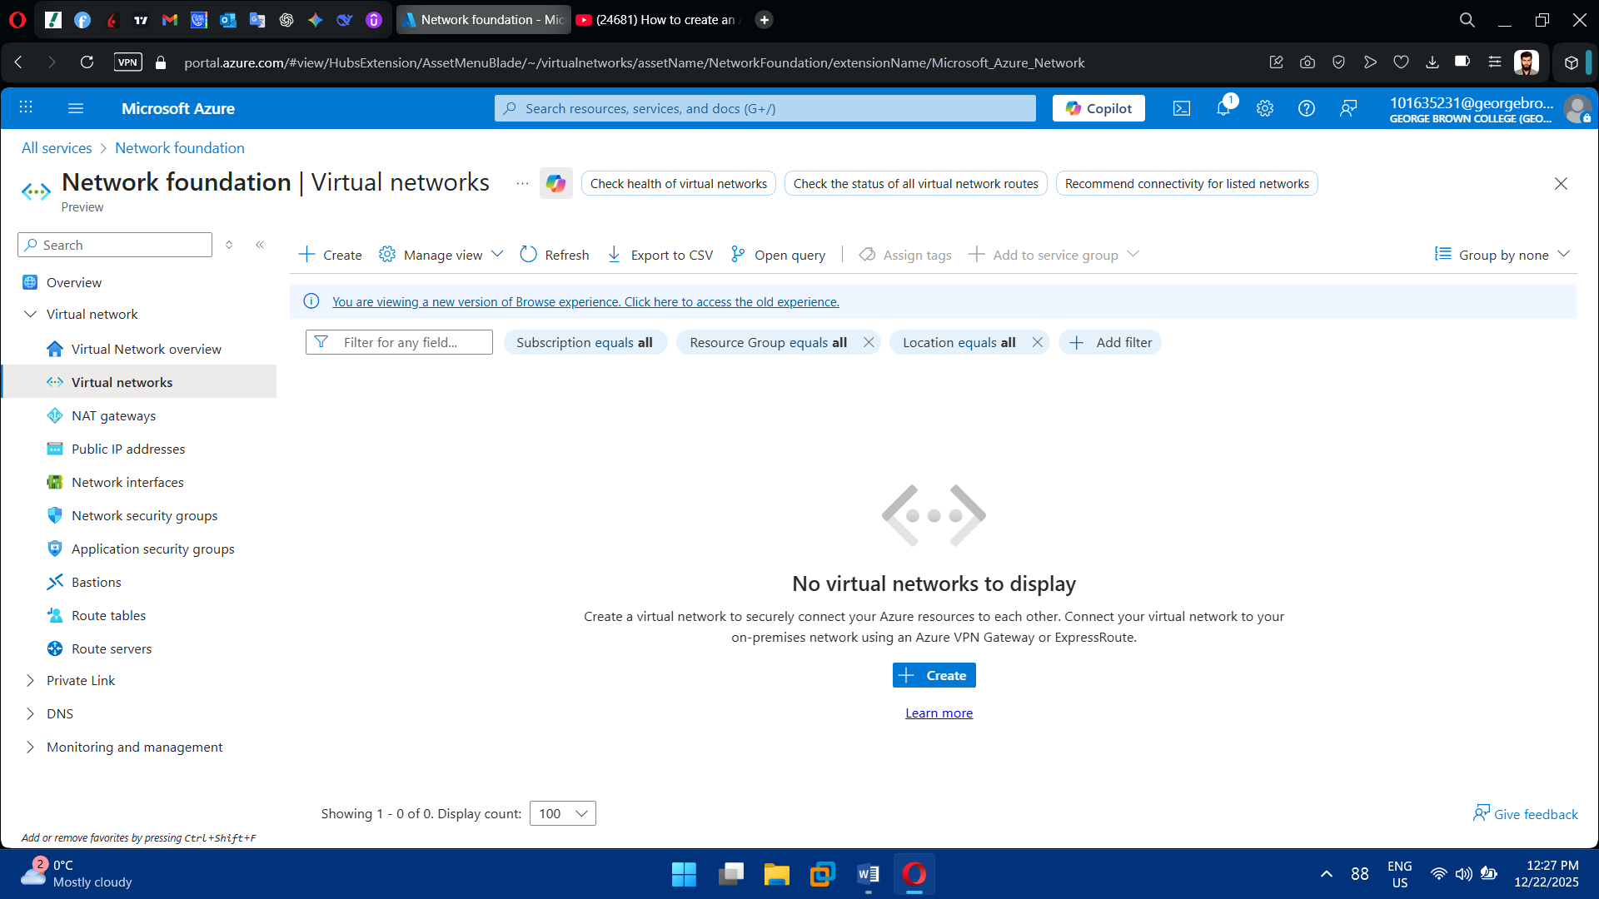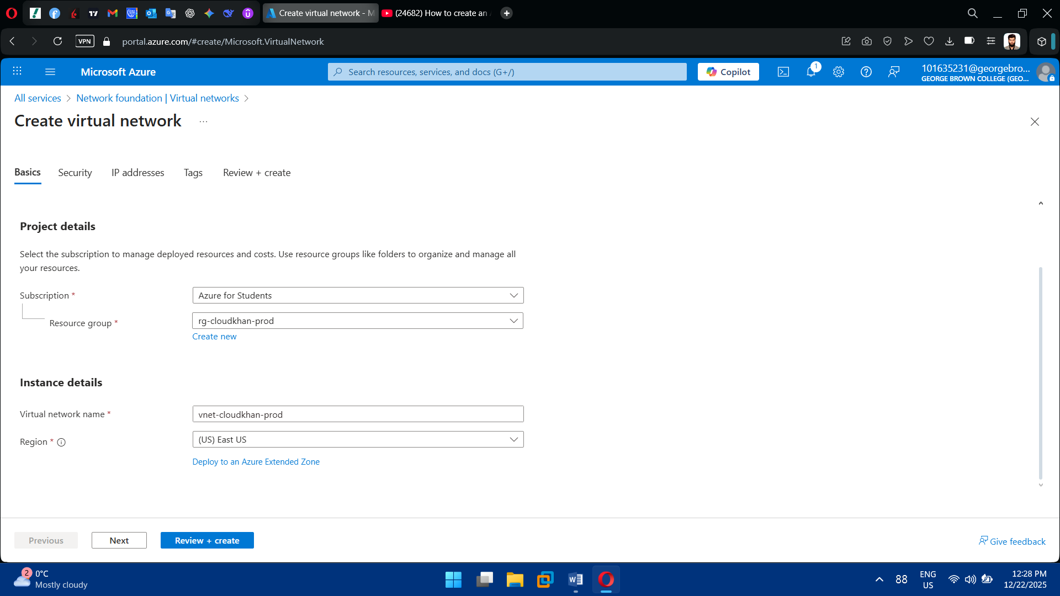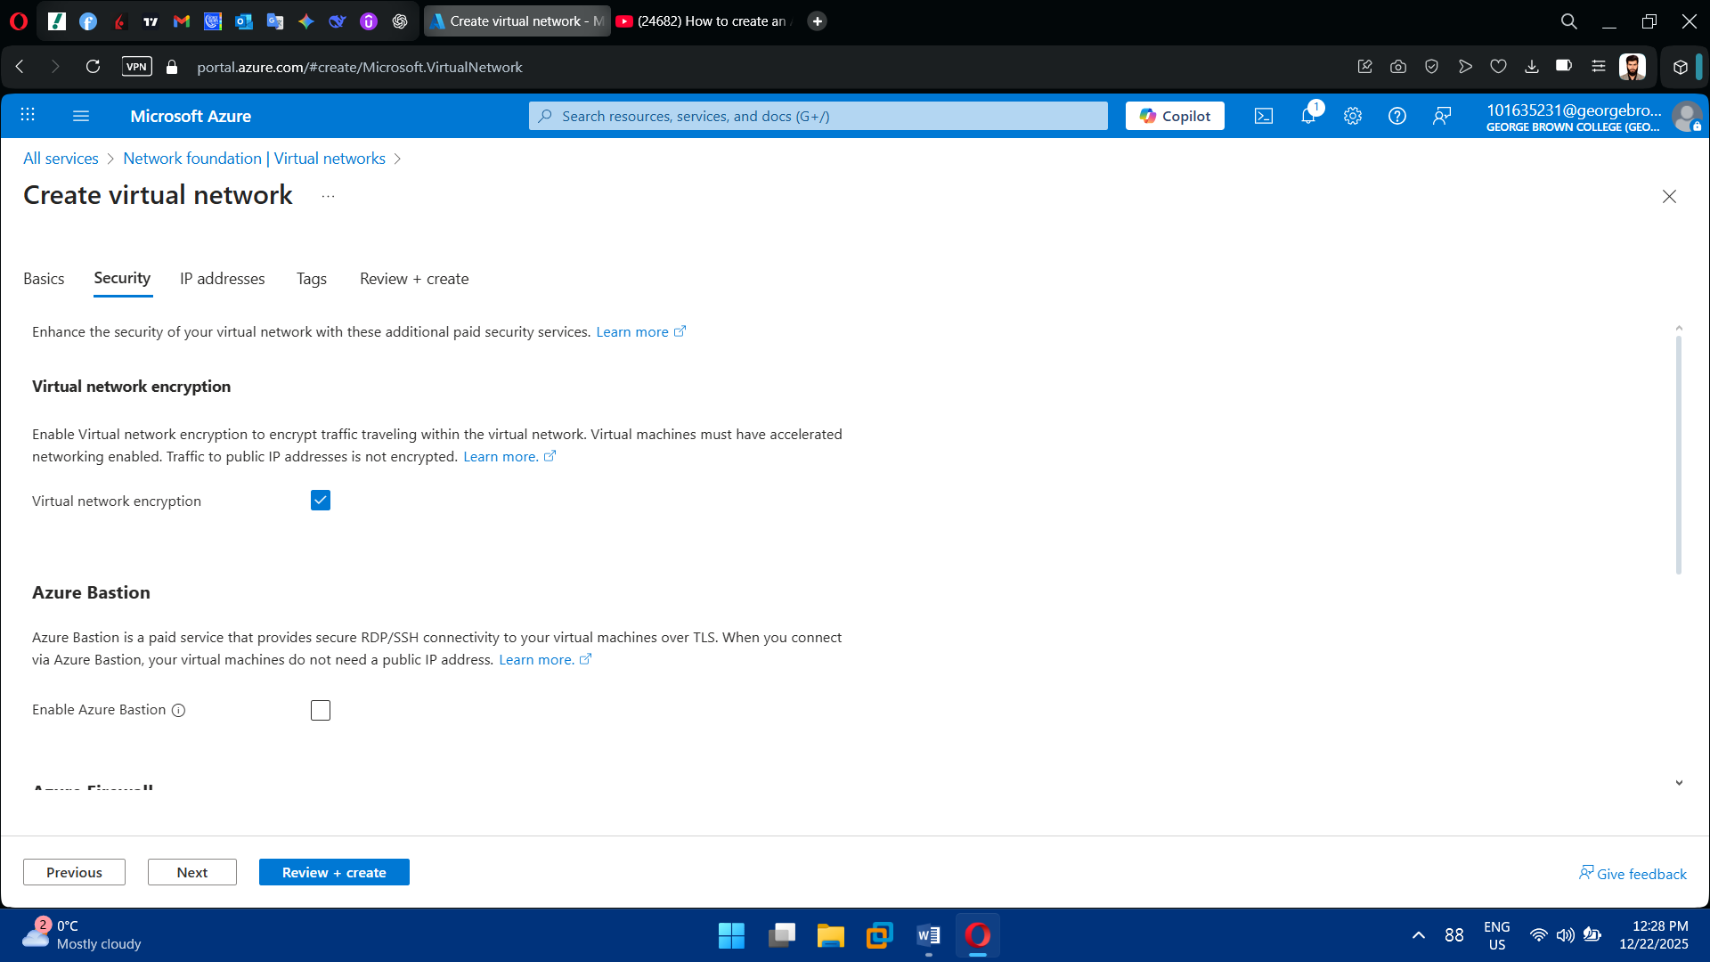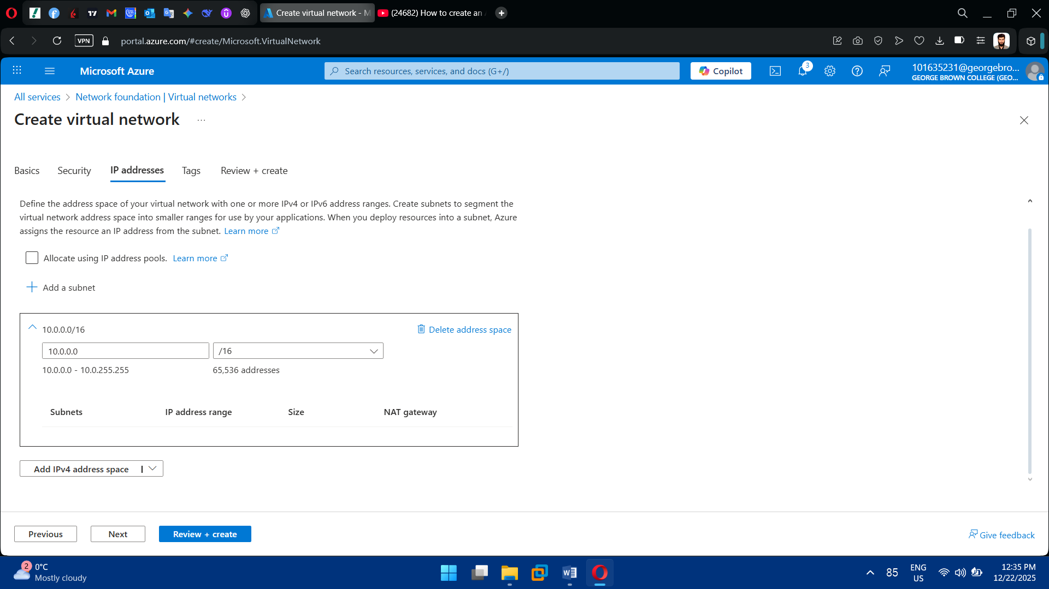

2. Create Subnets

* **Frontend Subnet** (for application/public-facing VM)
* **Backend Subnet** (for internal services)
* **Management Subnet** (optional – for admin access)

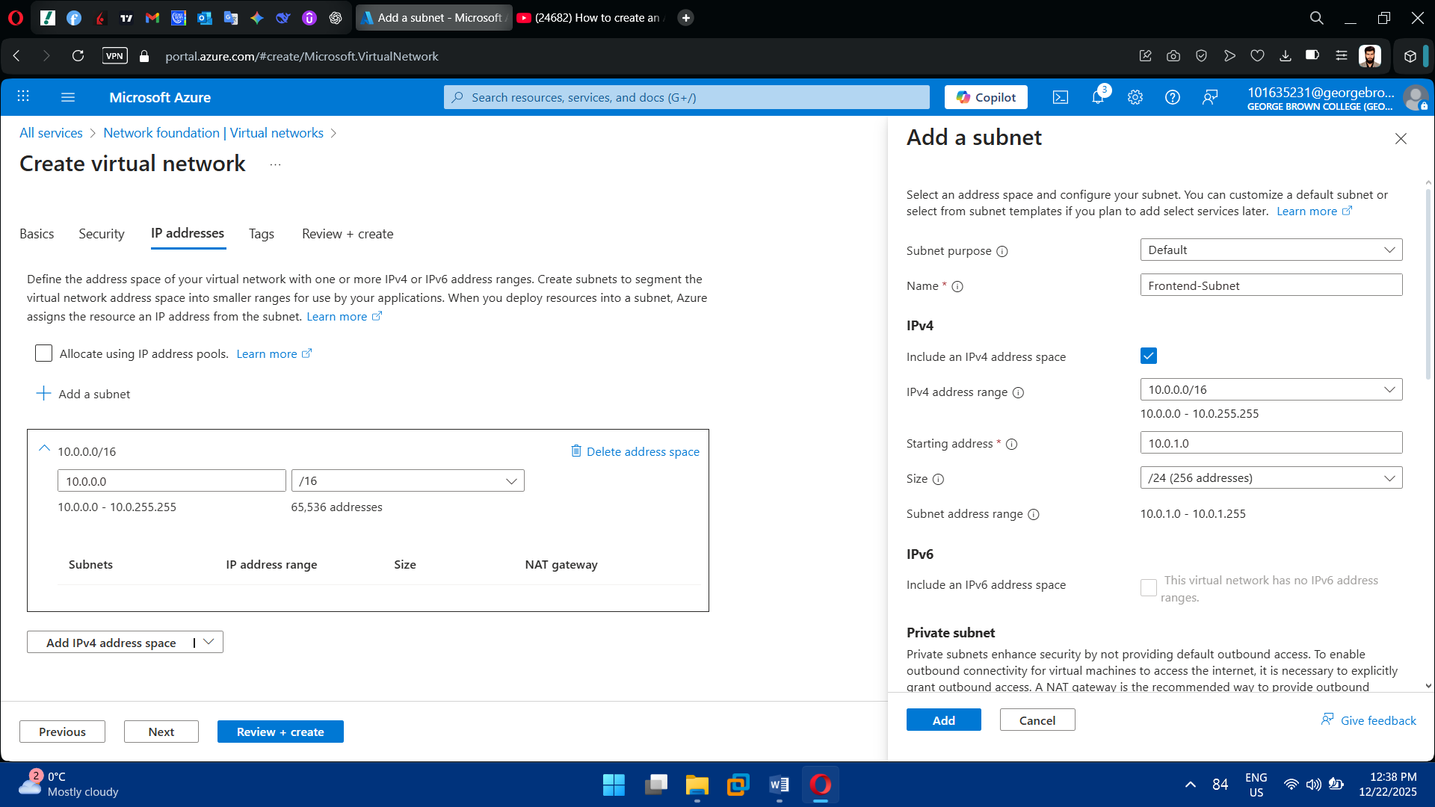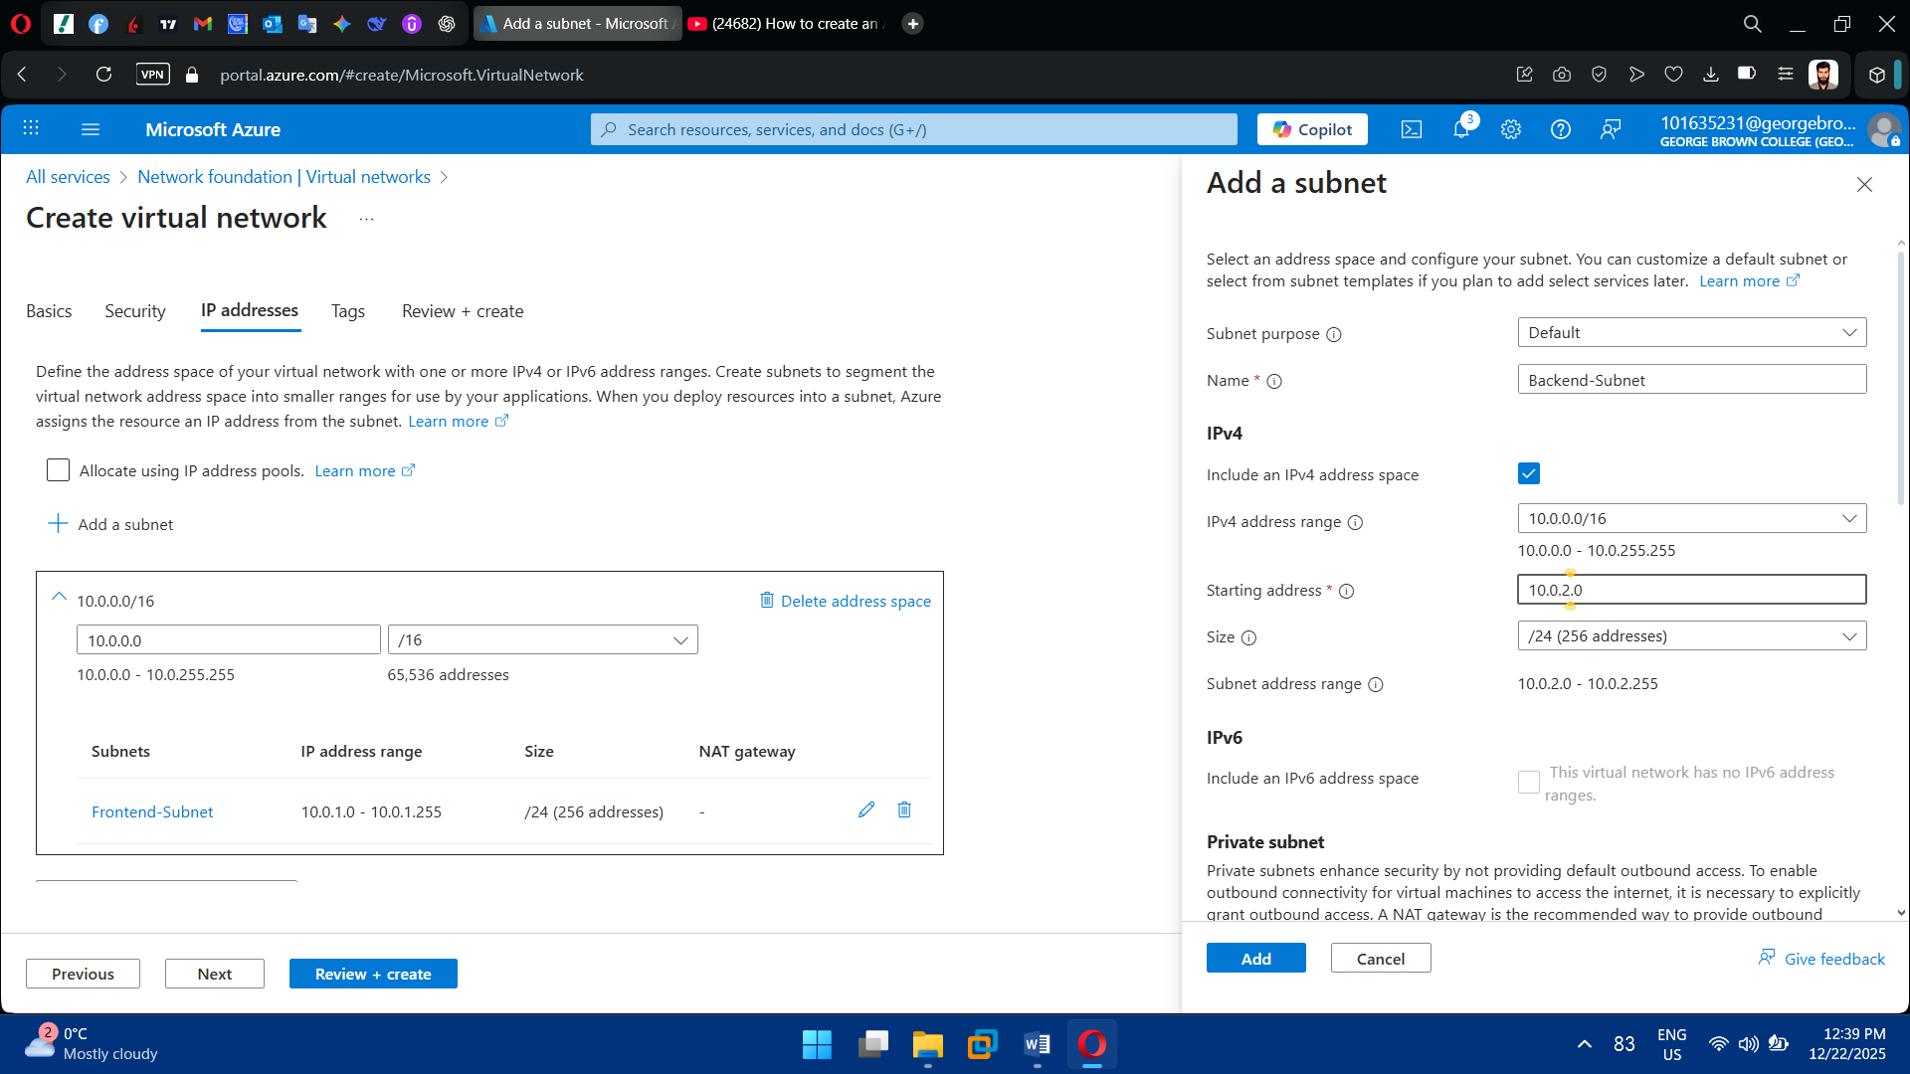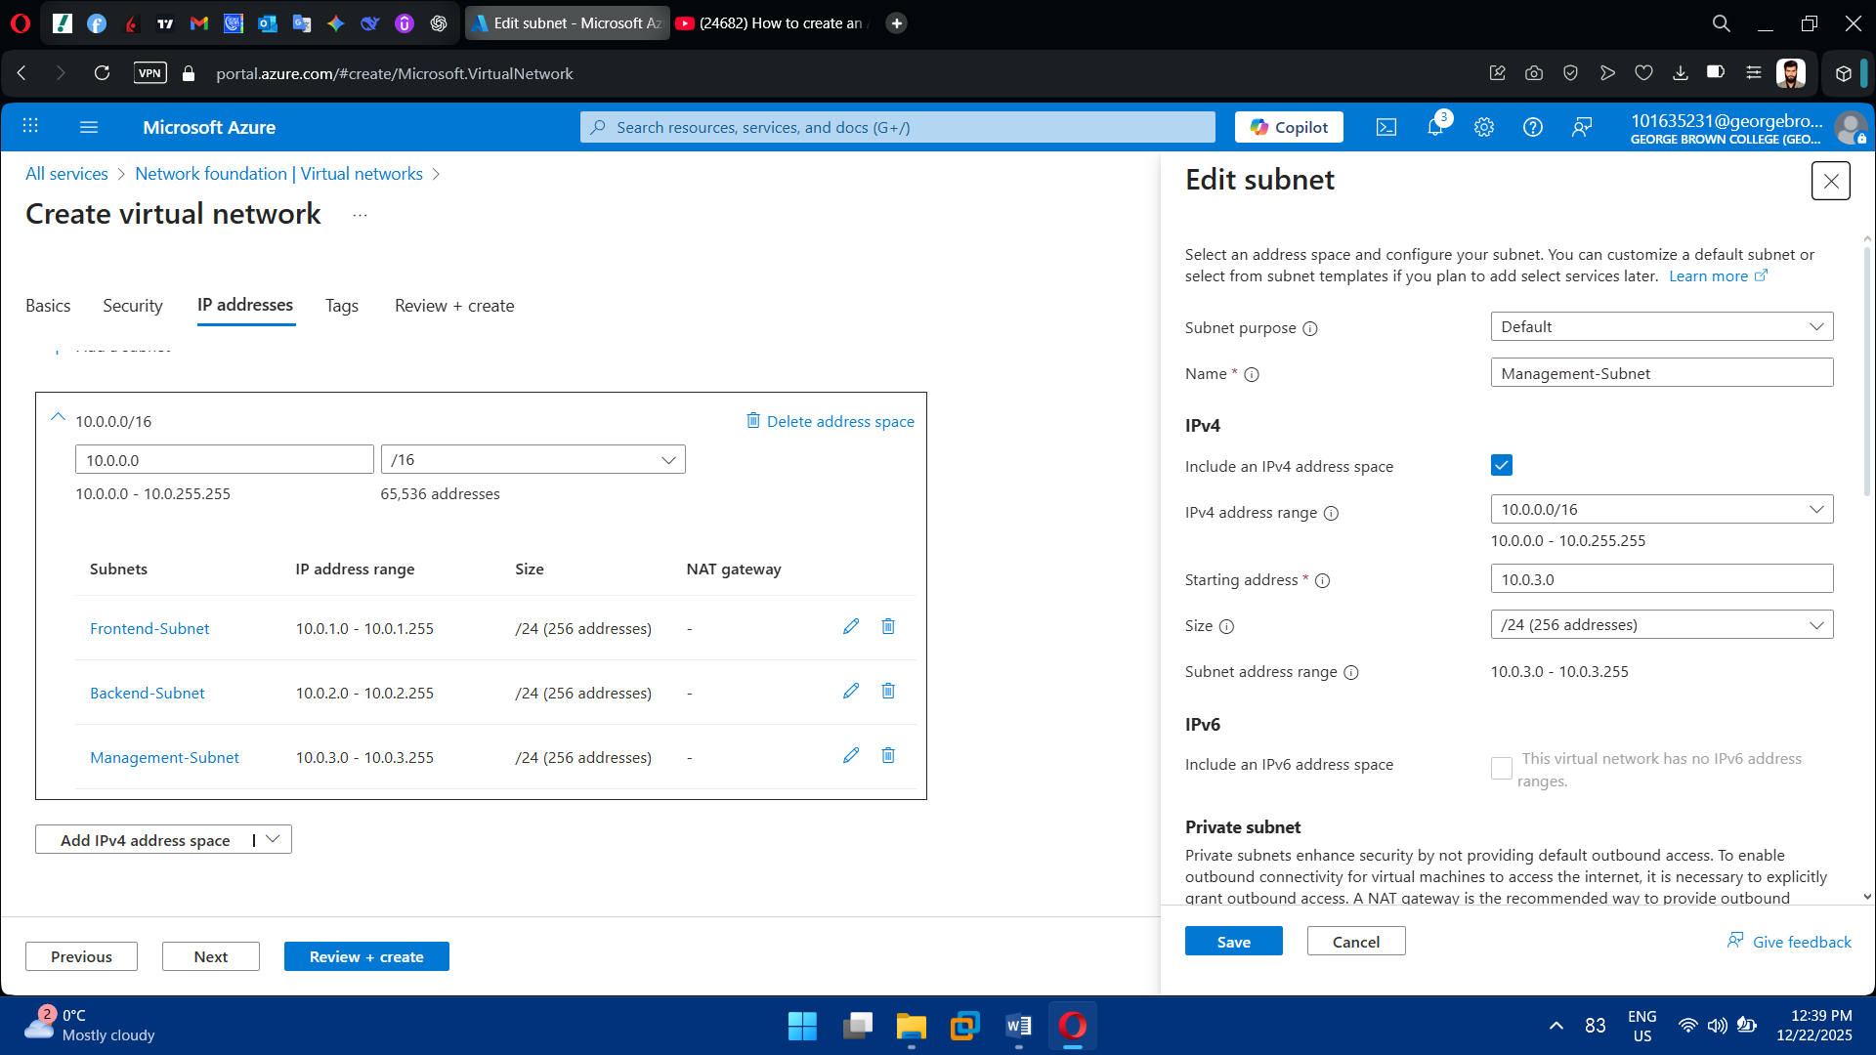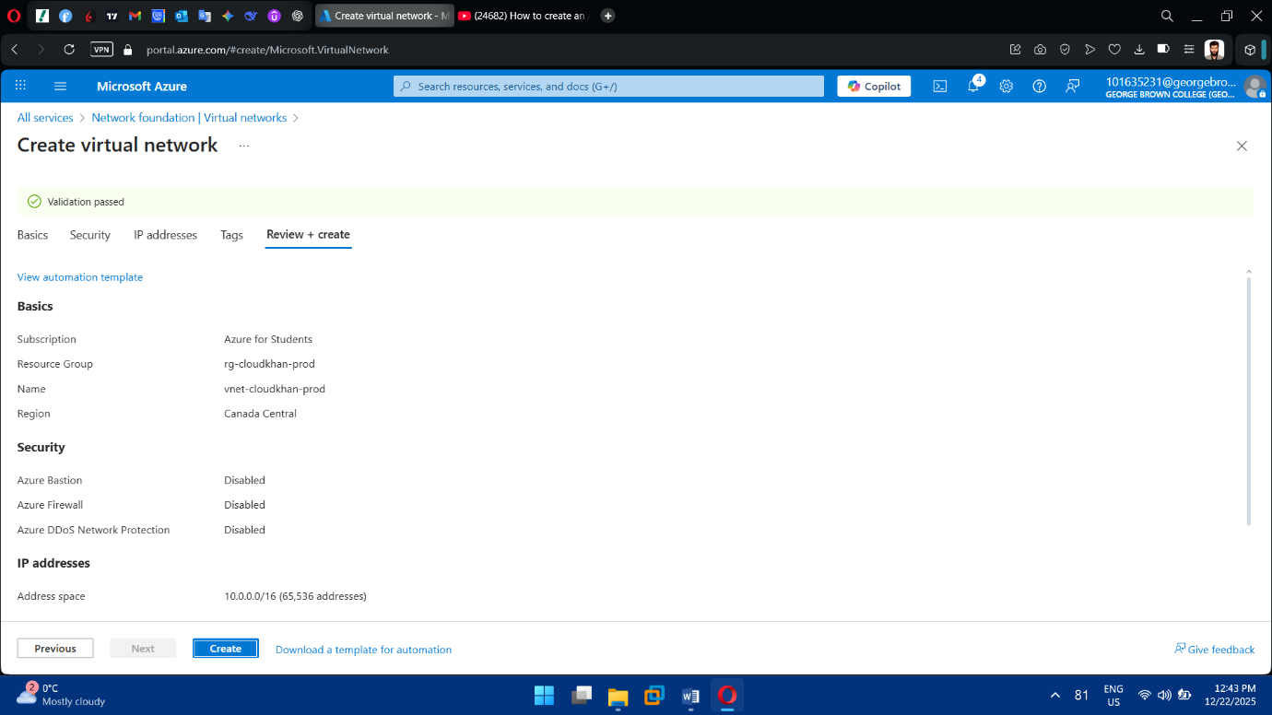

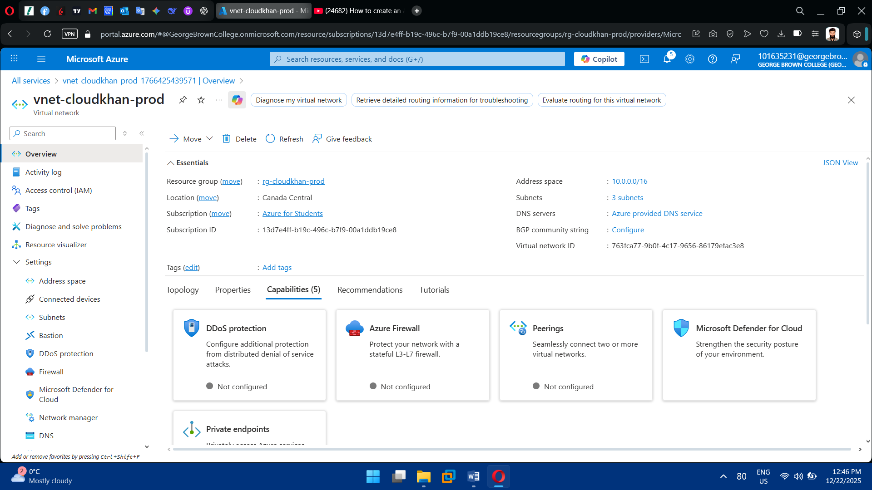

**Task 3: Network Security Implementation**

1. Create Network Security Groups (NSGs)

* Create separate NSGs for each subnet
* Define inbound and outbound security rules

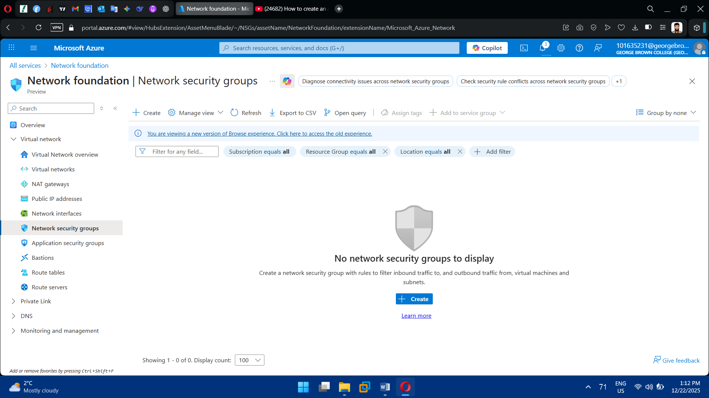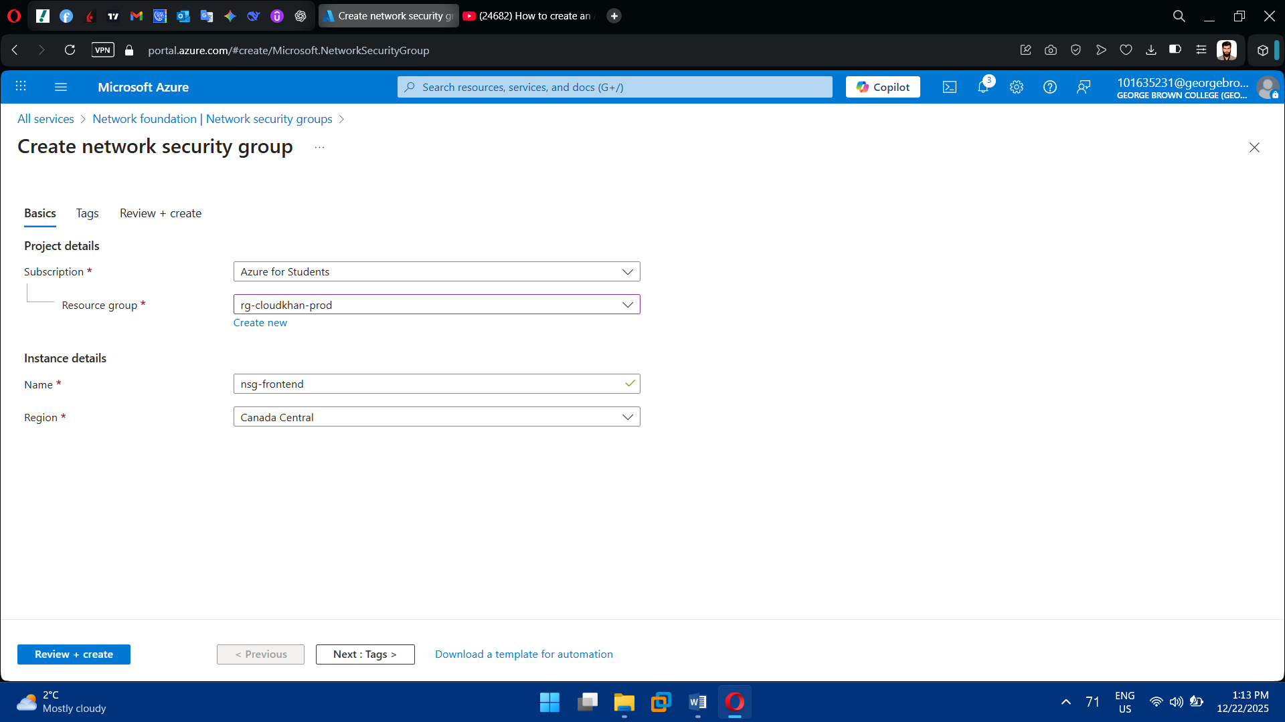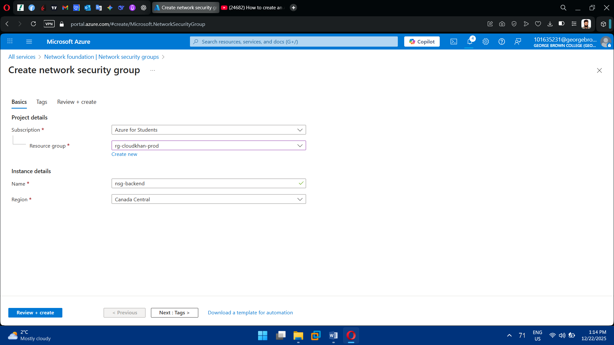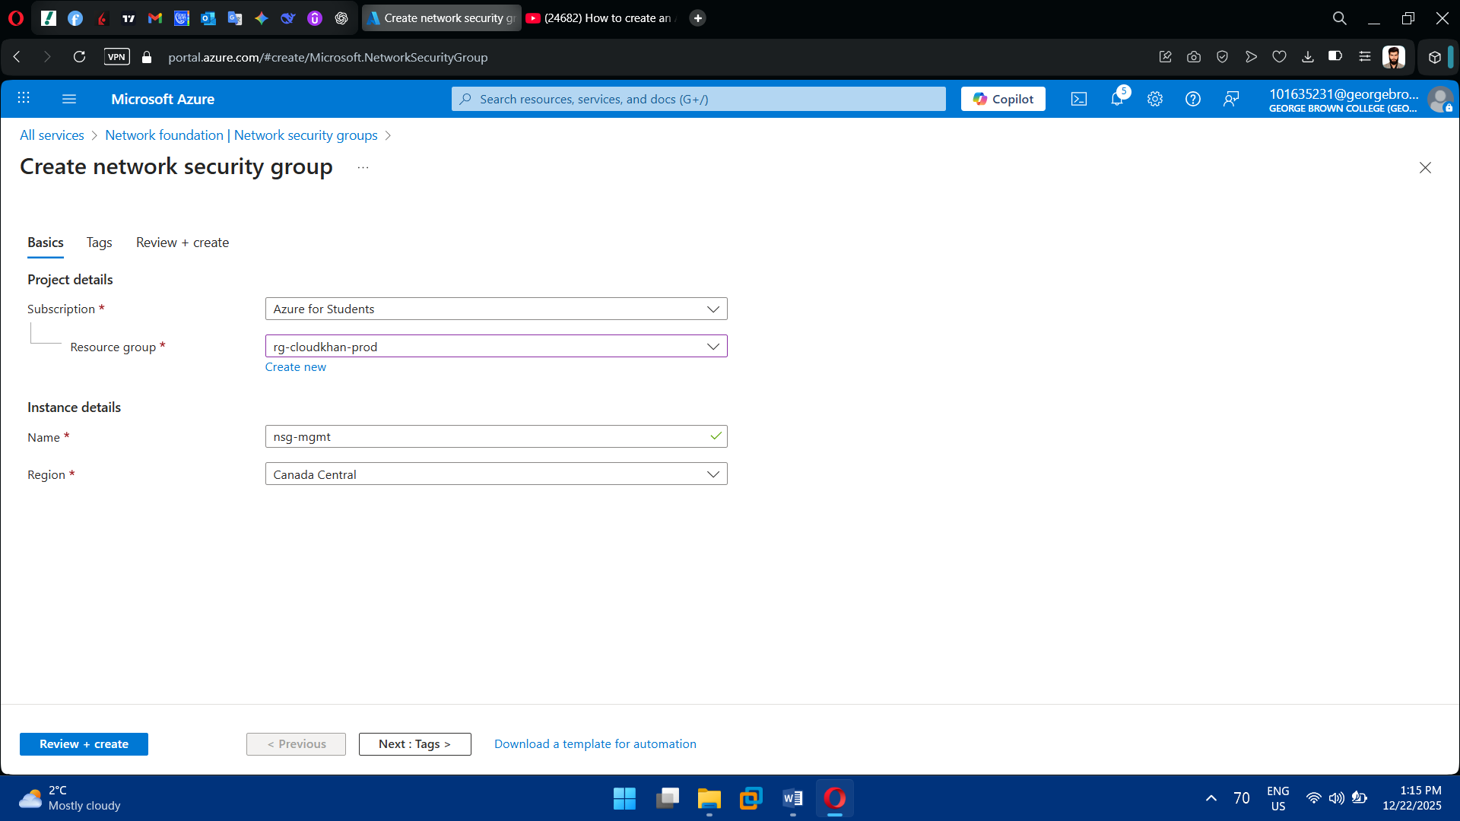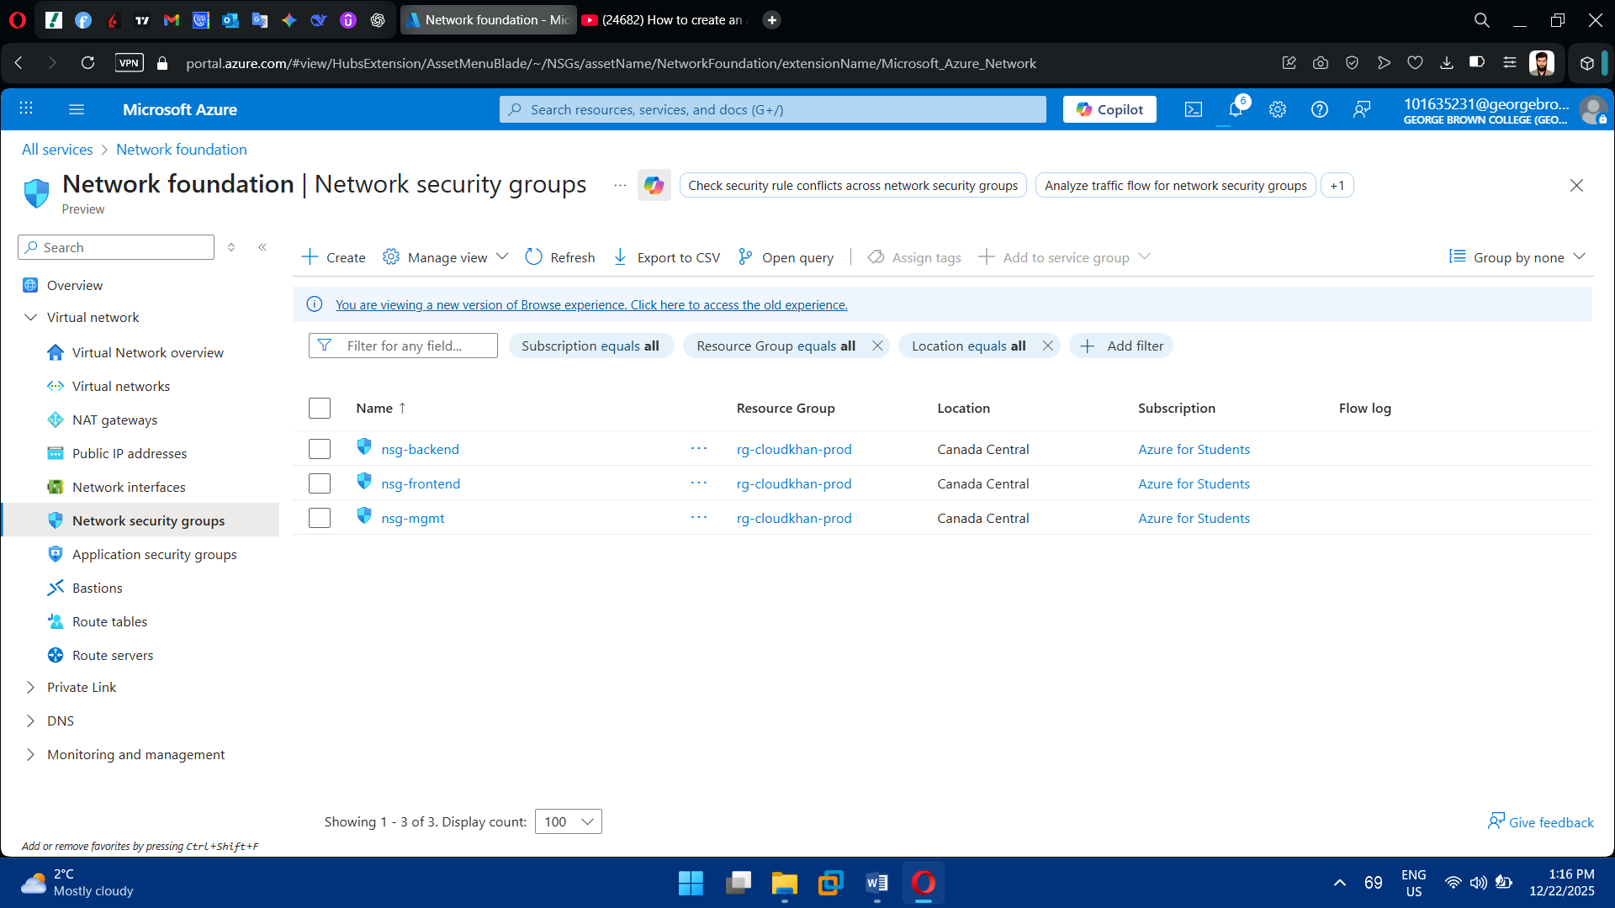

2. Configure NSG Rules

* Allow RDP (3389) to Windows VM (restricted source)
* Allow SSH (22) to Linux VM (restricted source)
* Deny unnecessary inbound traffic
* Allow required outbound traffic

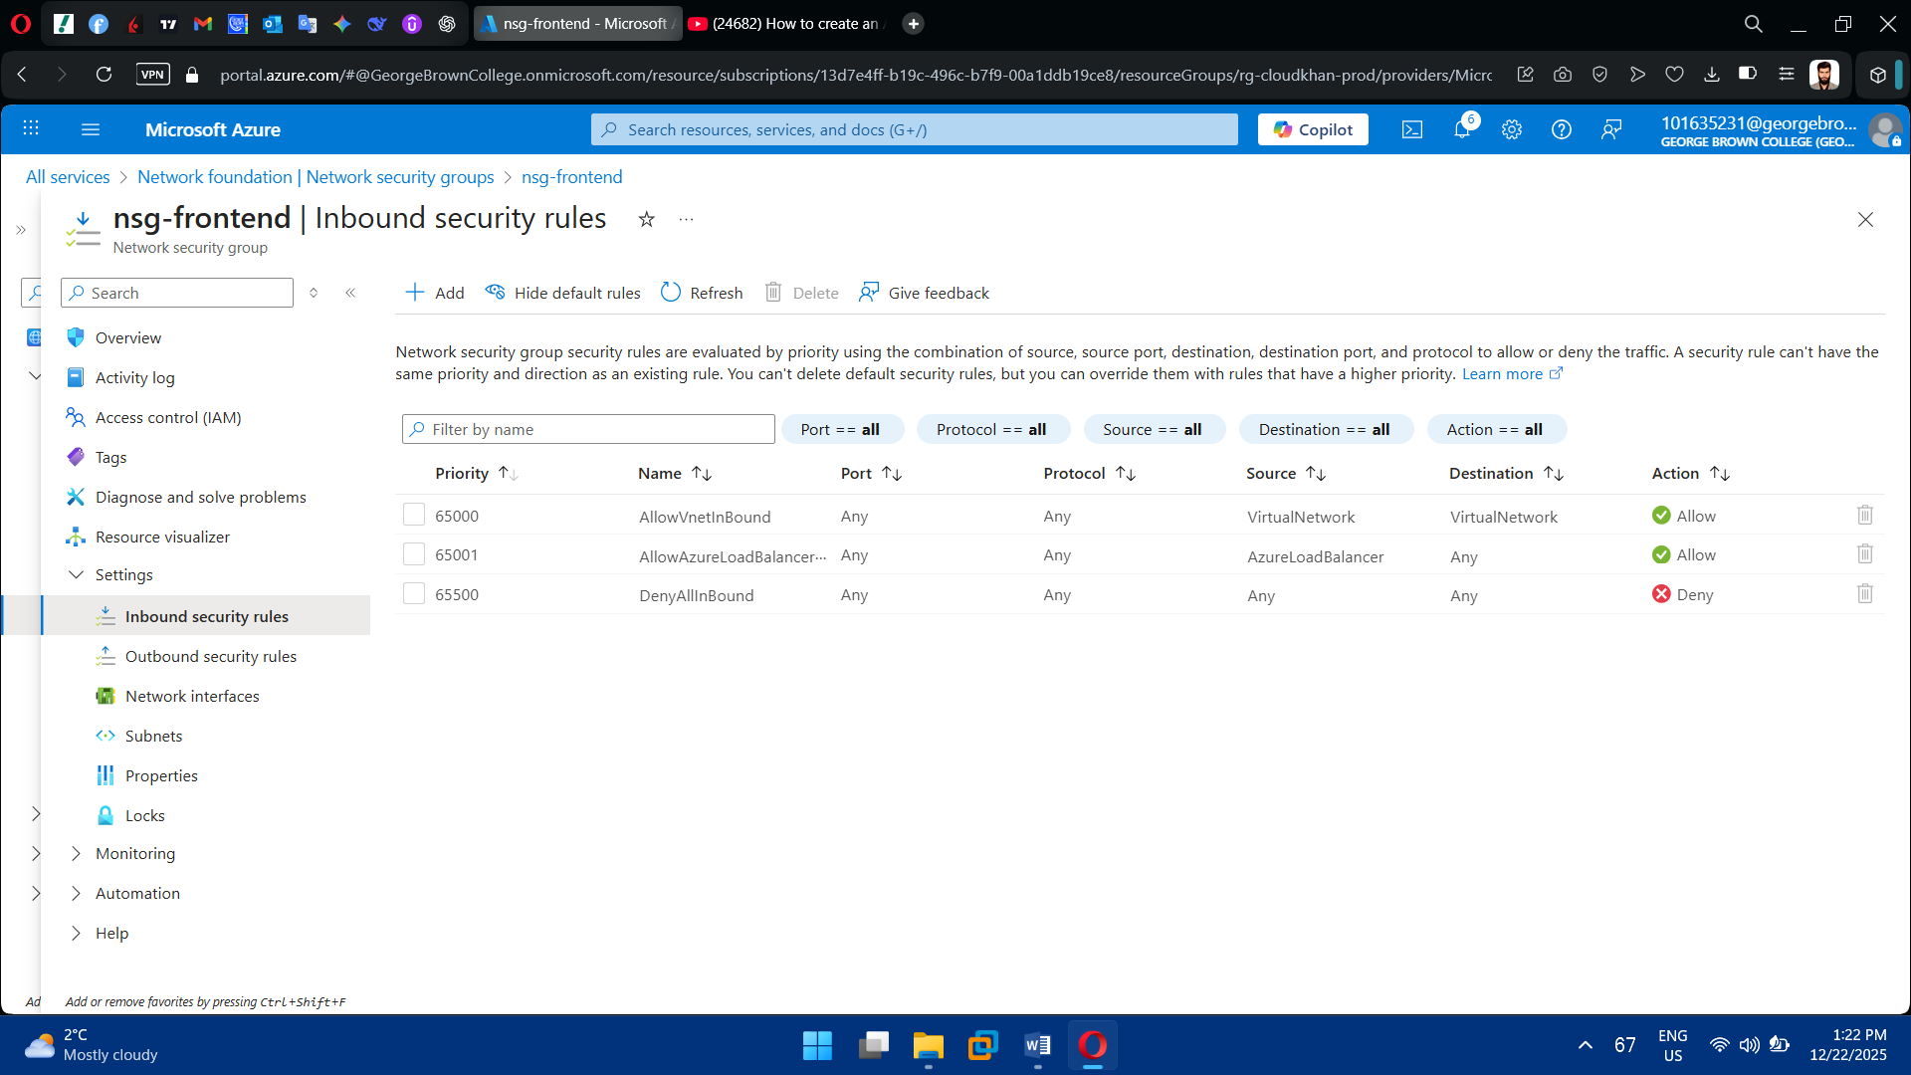

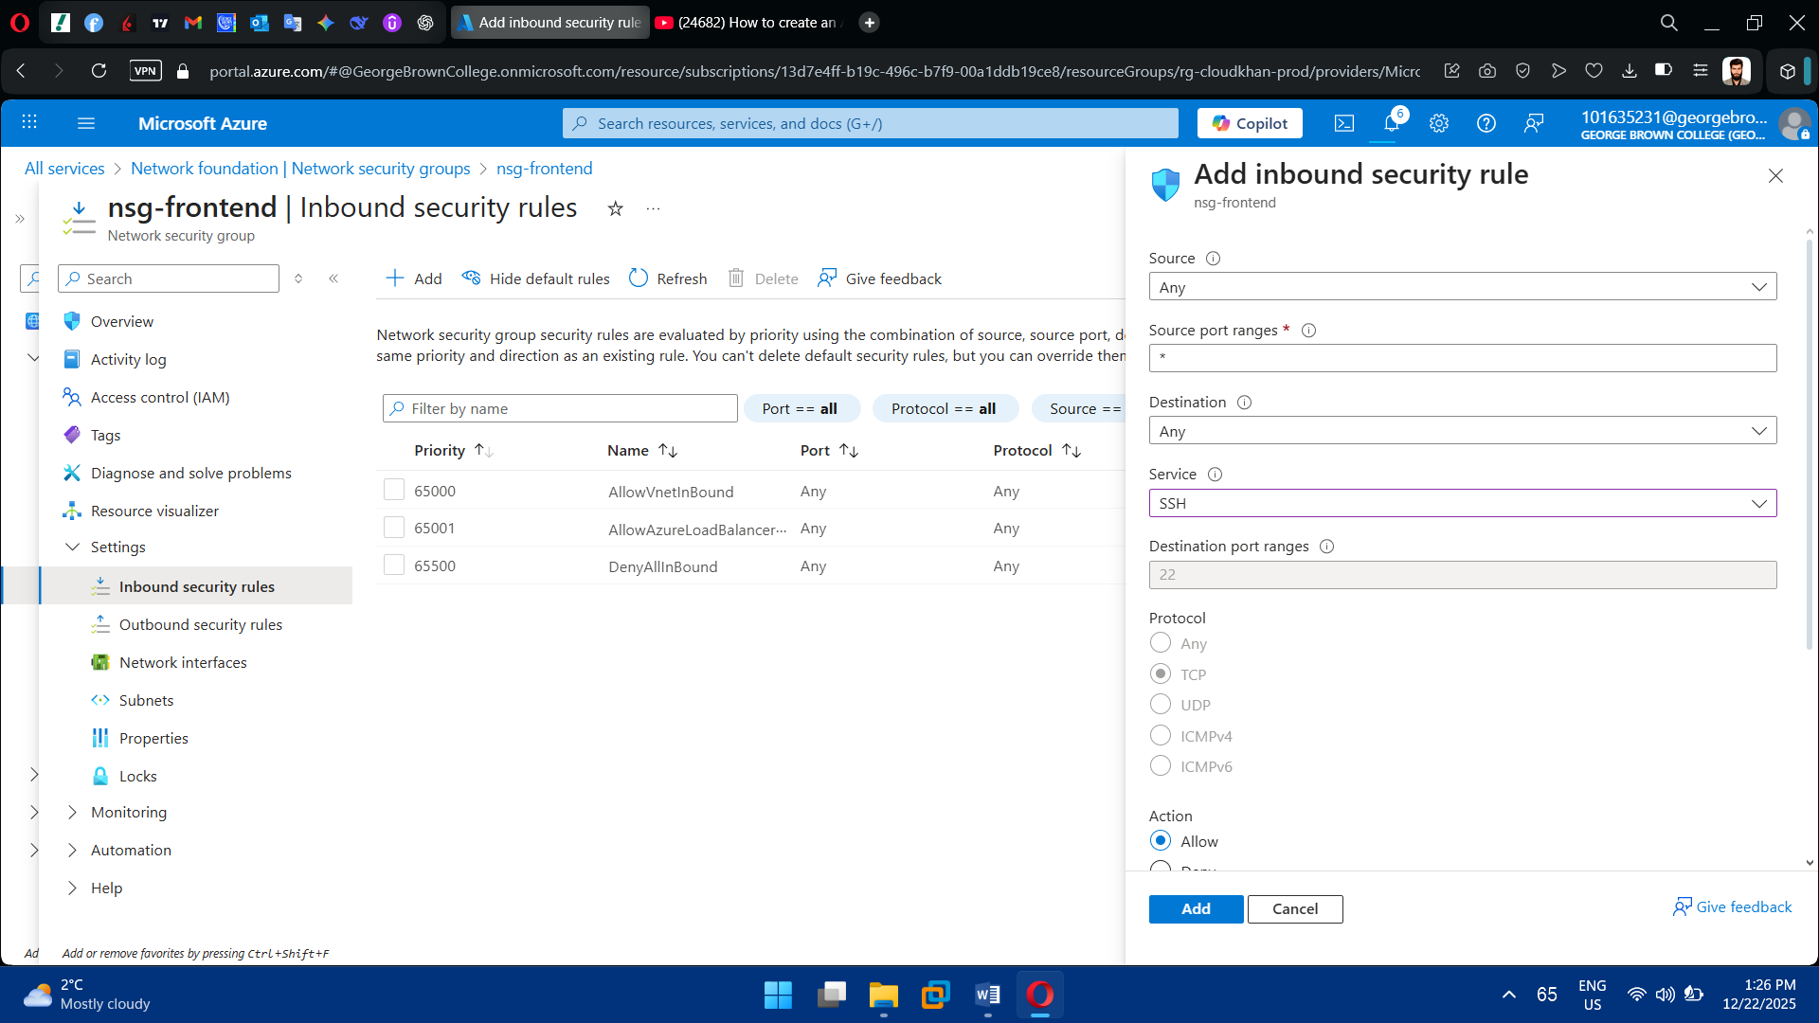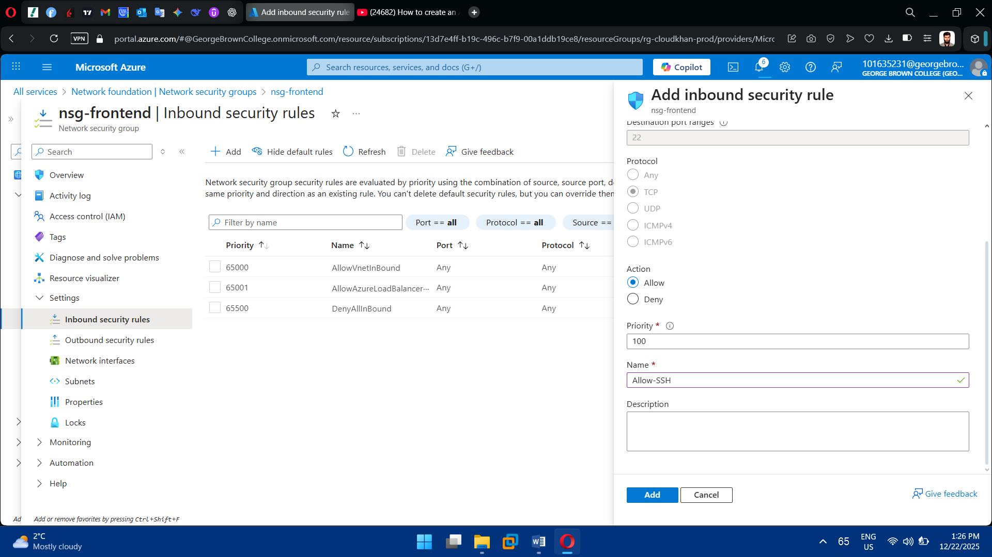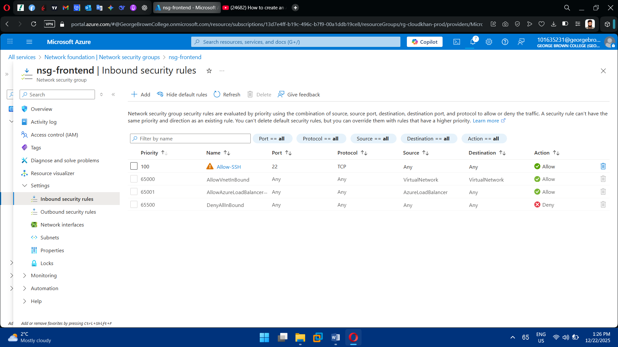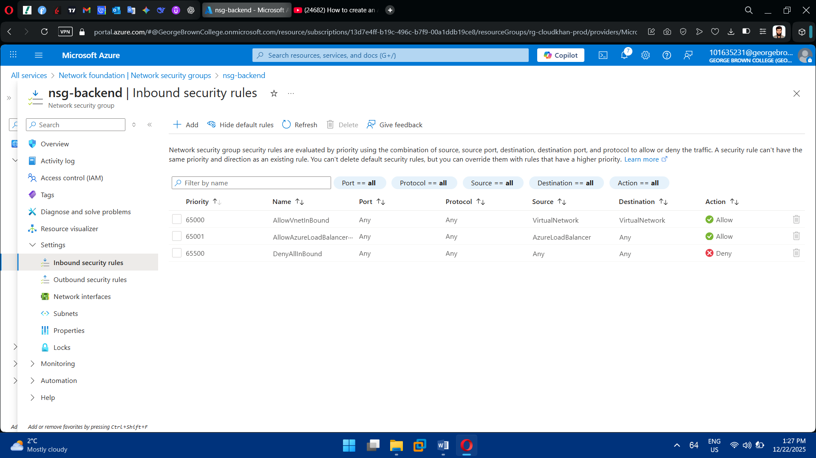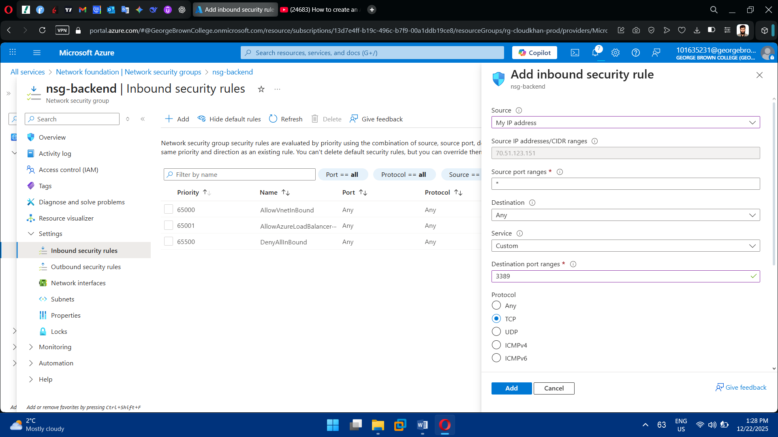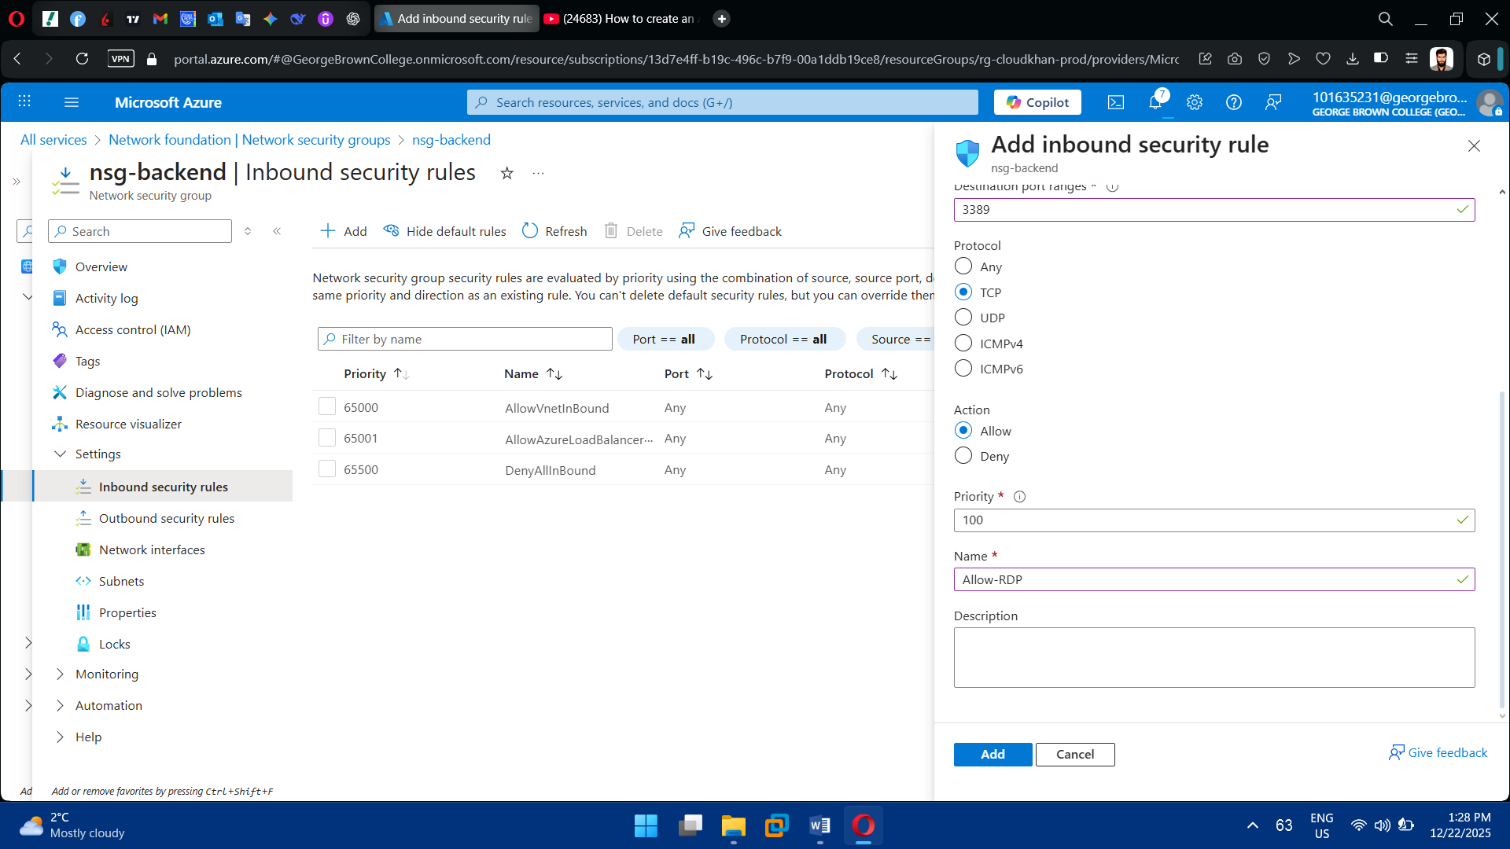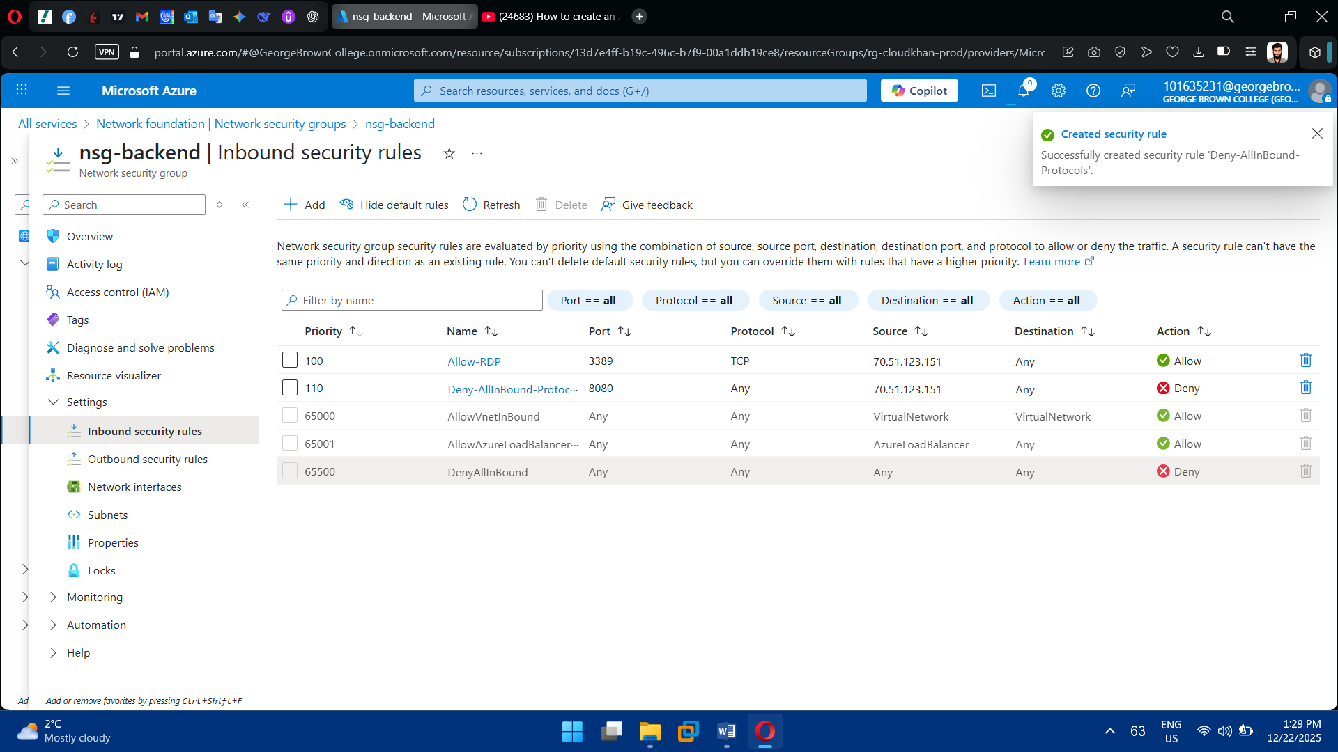

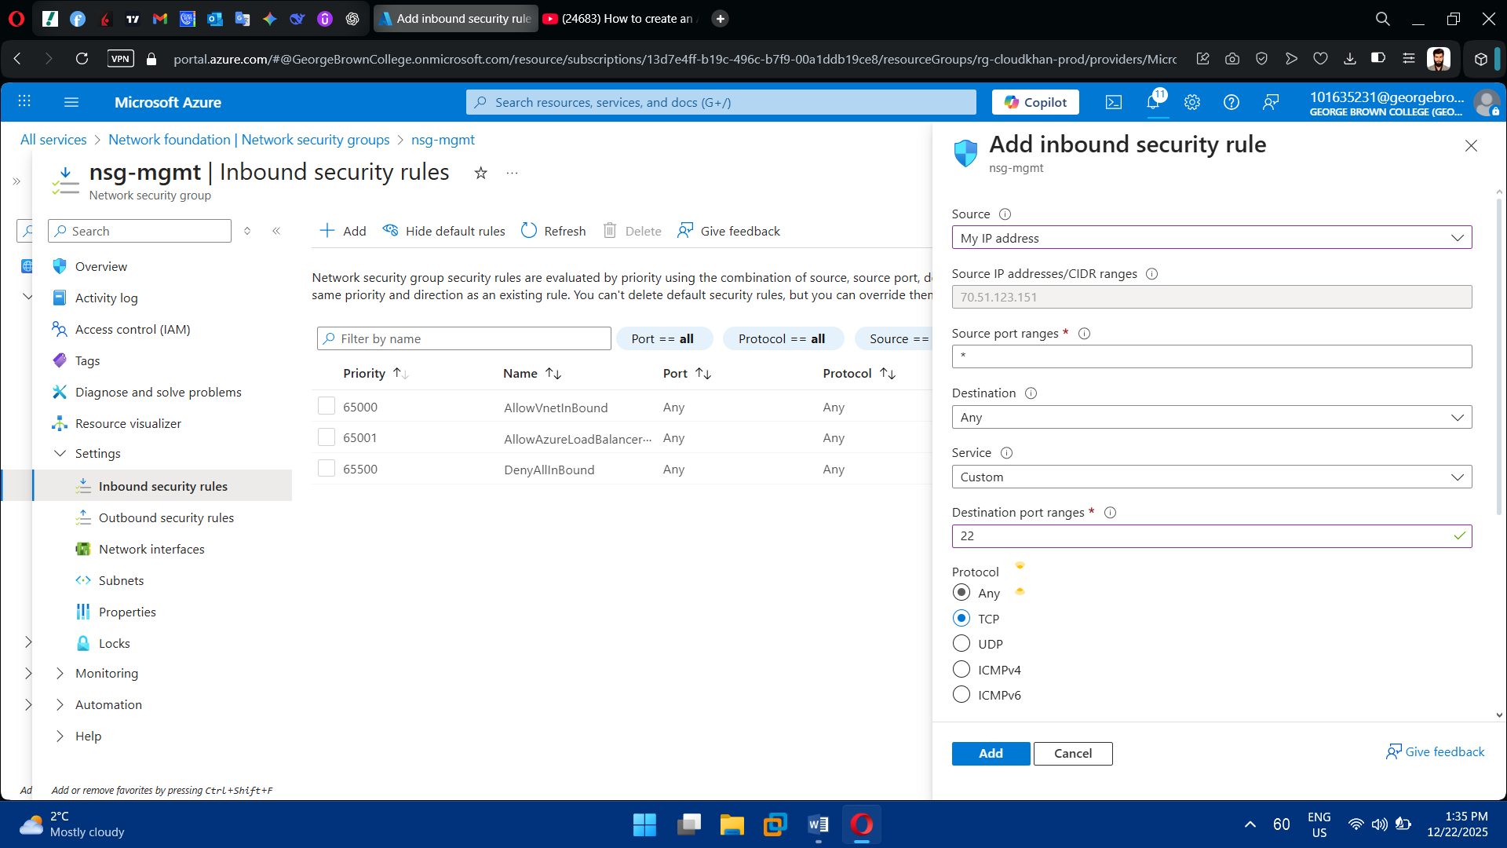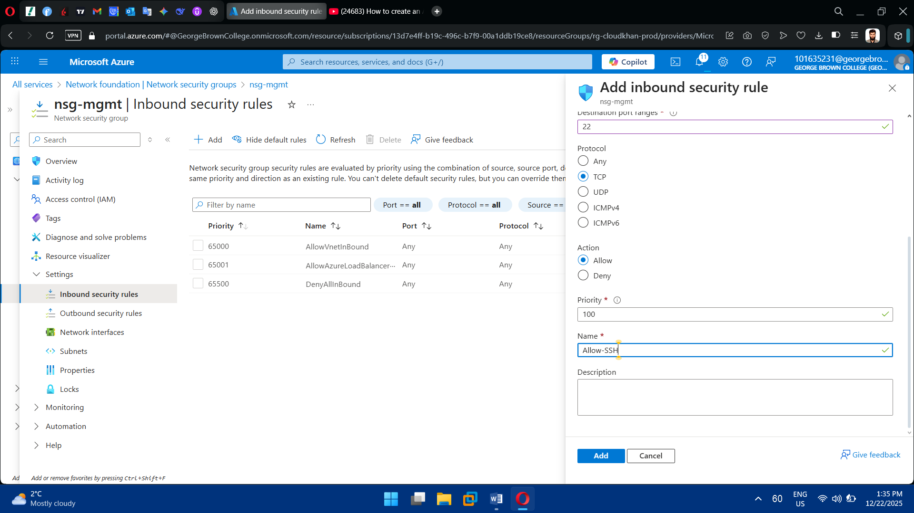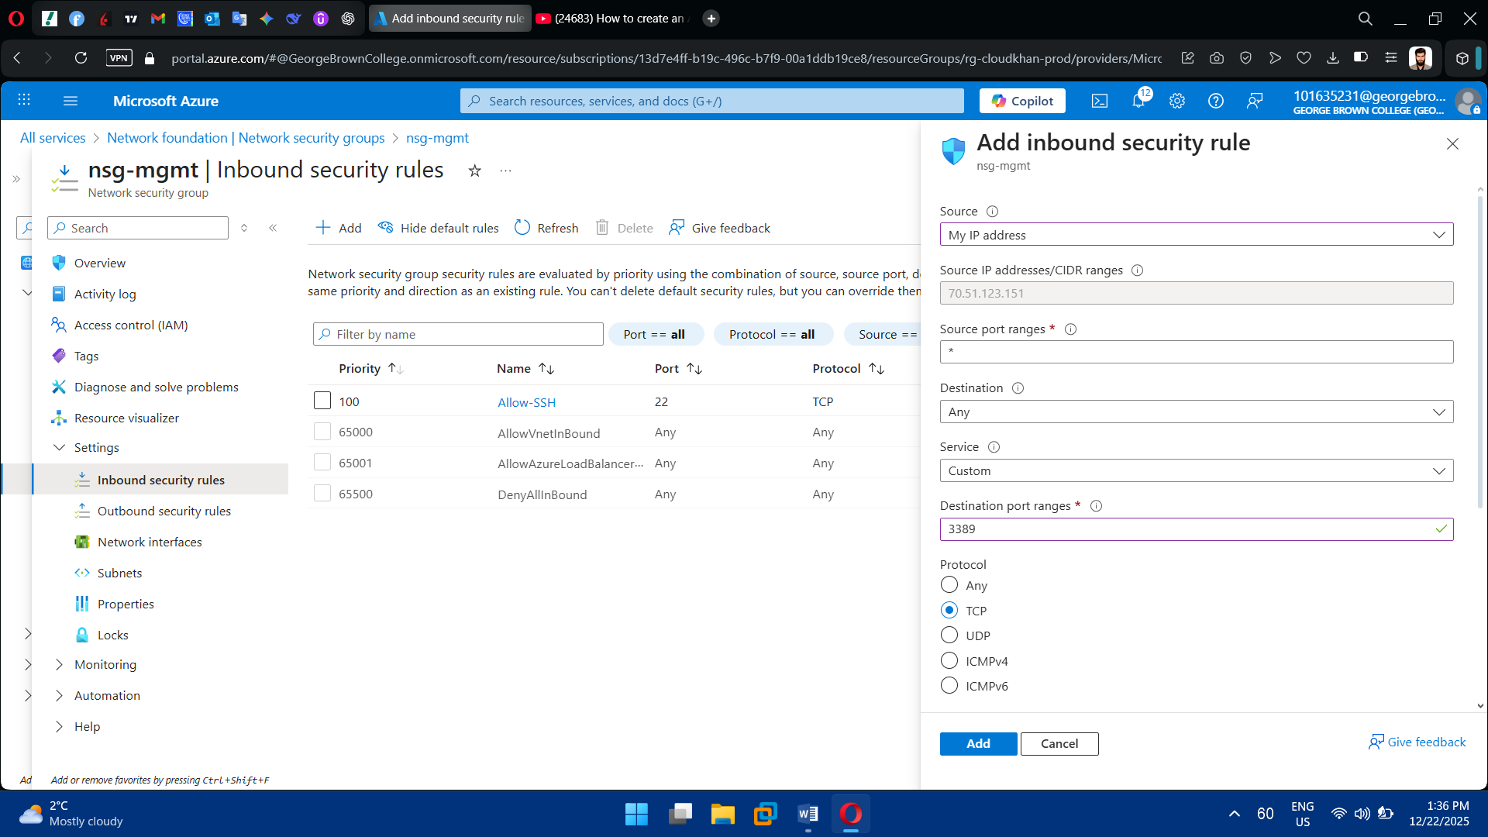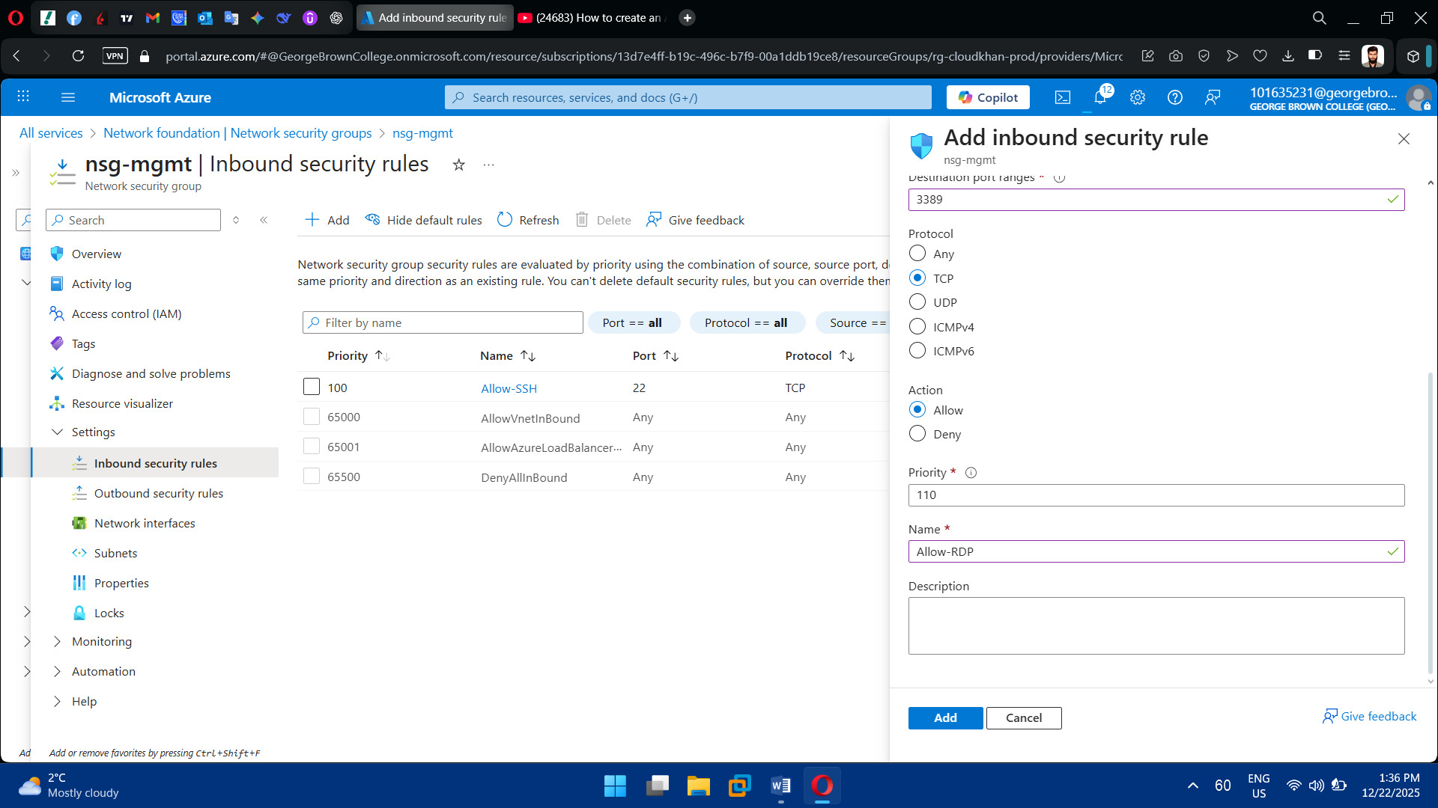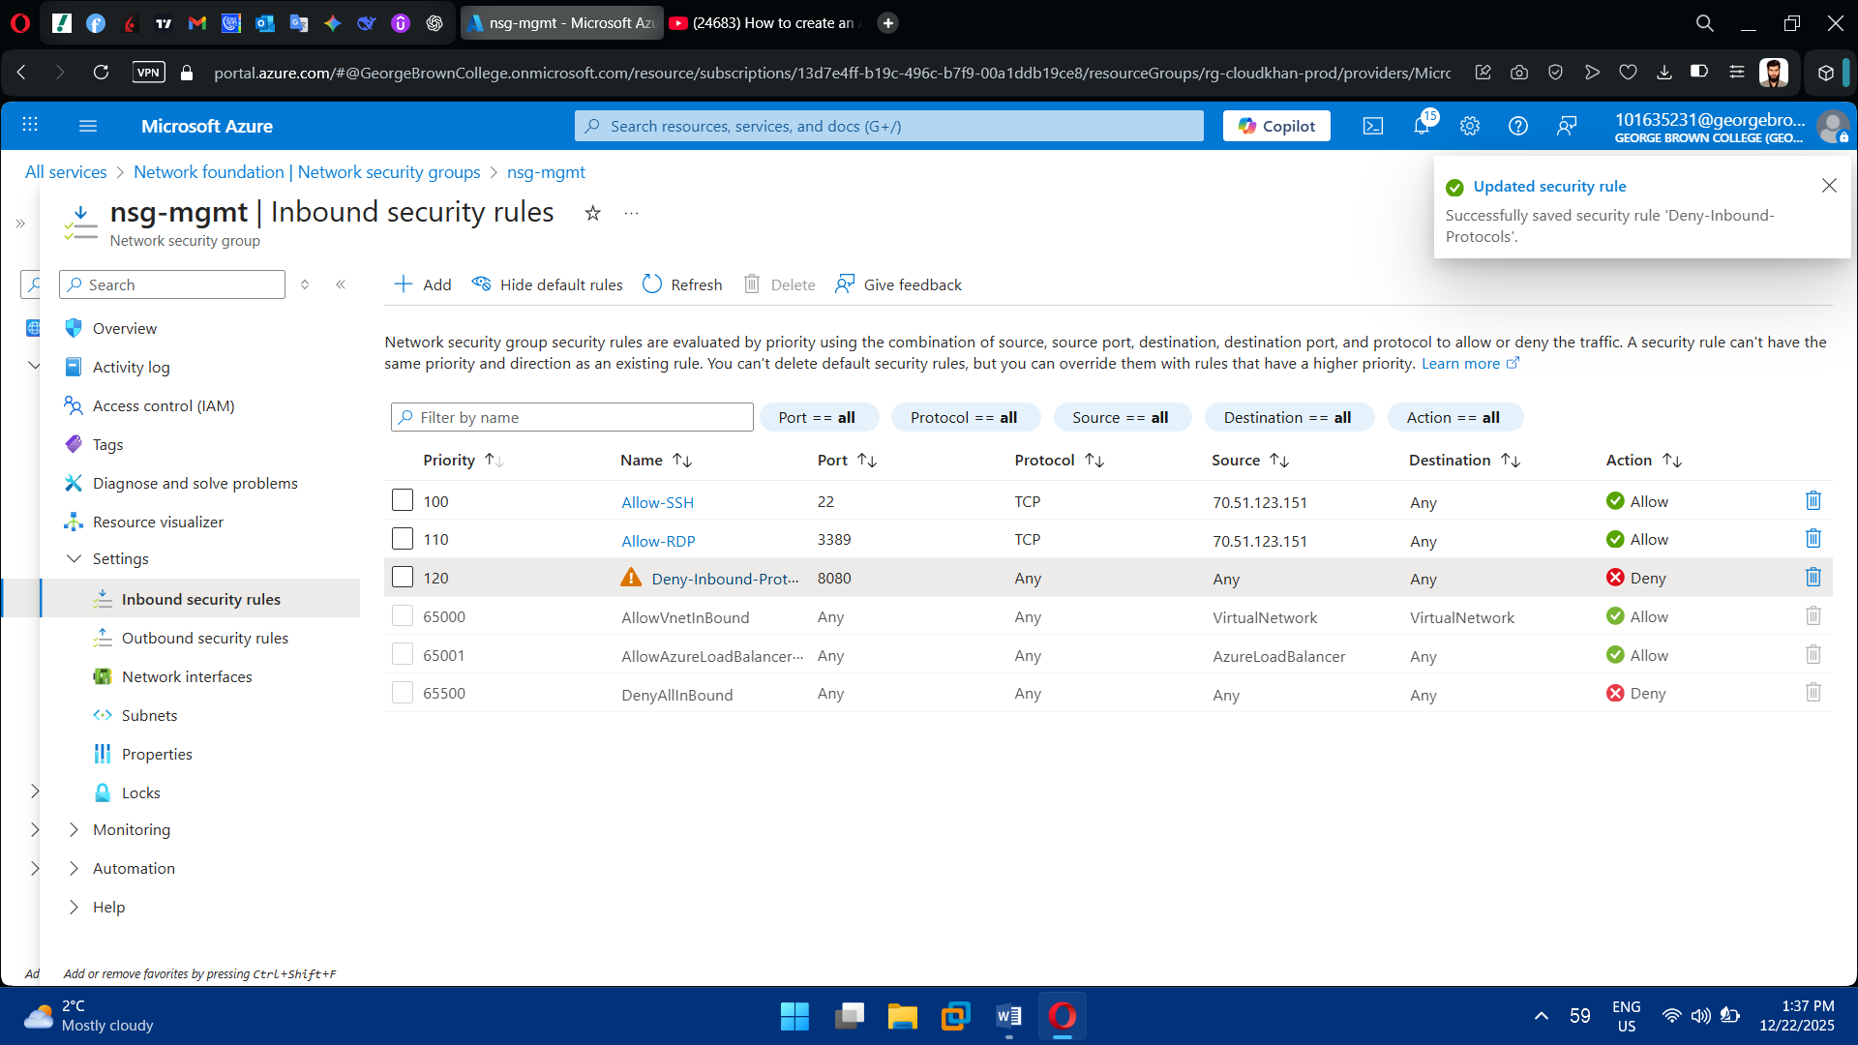

3. Associate NSGs

* Attach NSGs to subnets or NICs

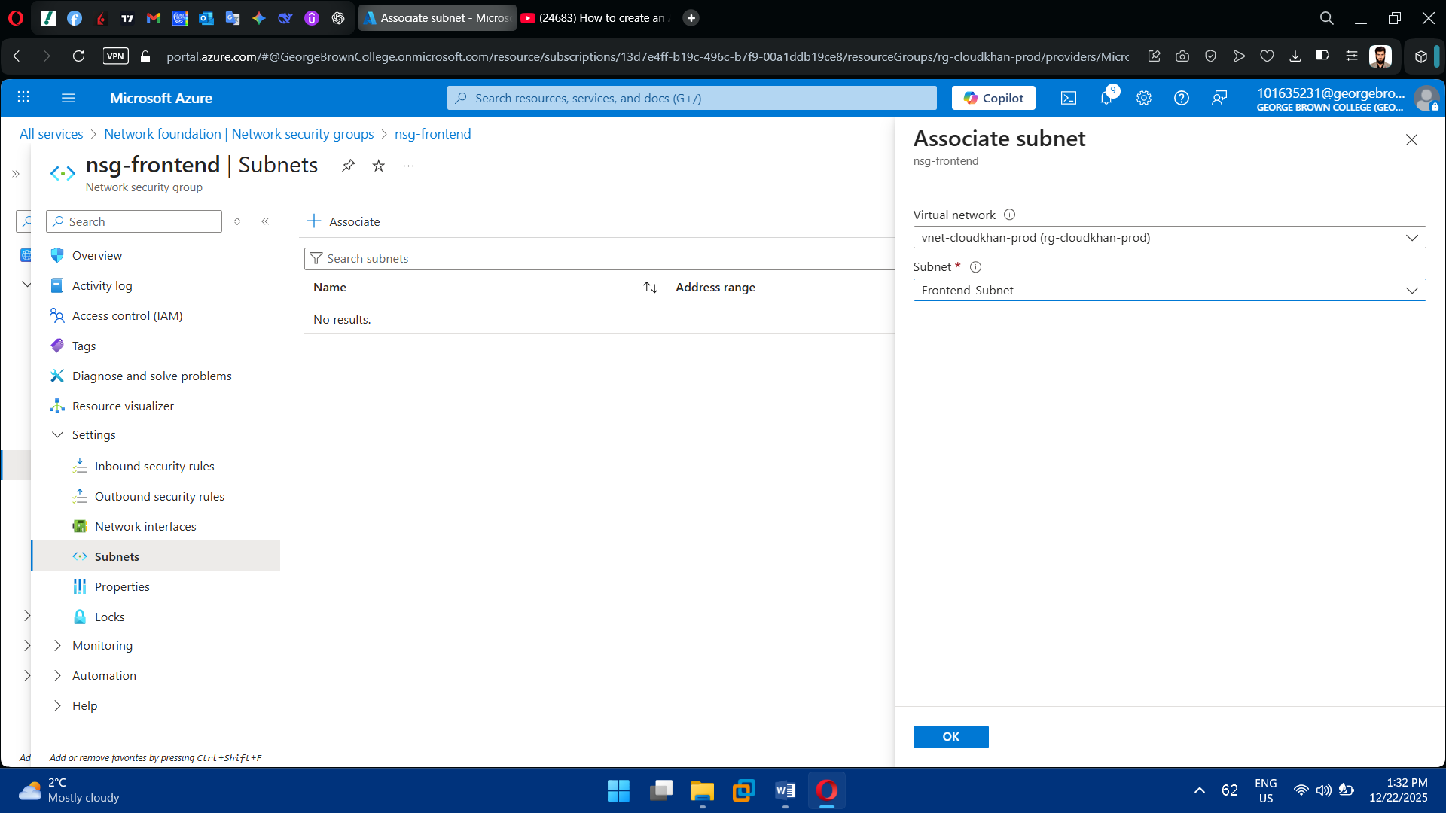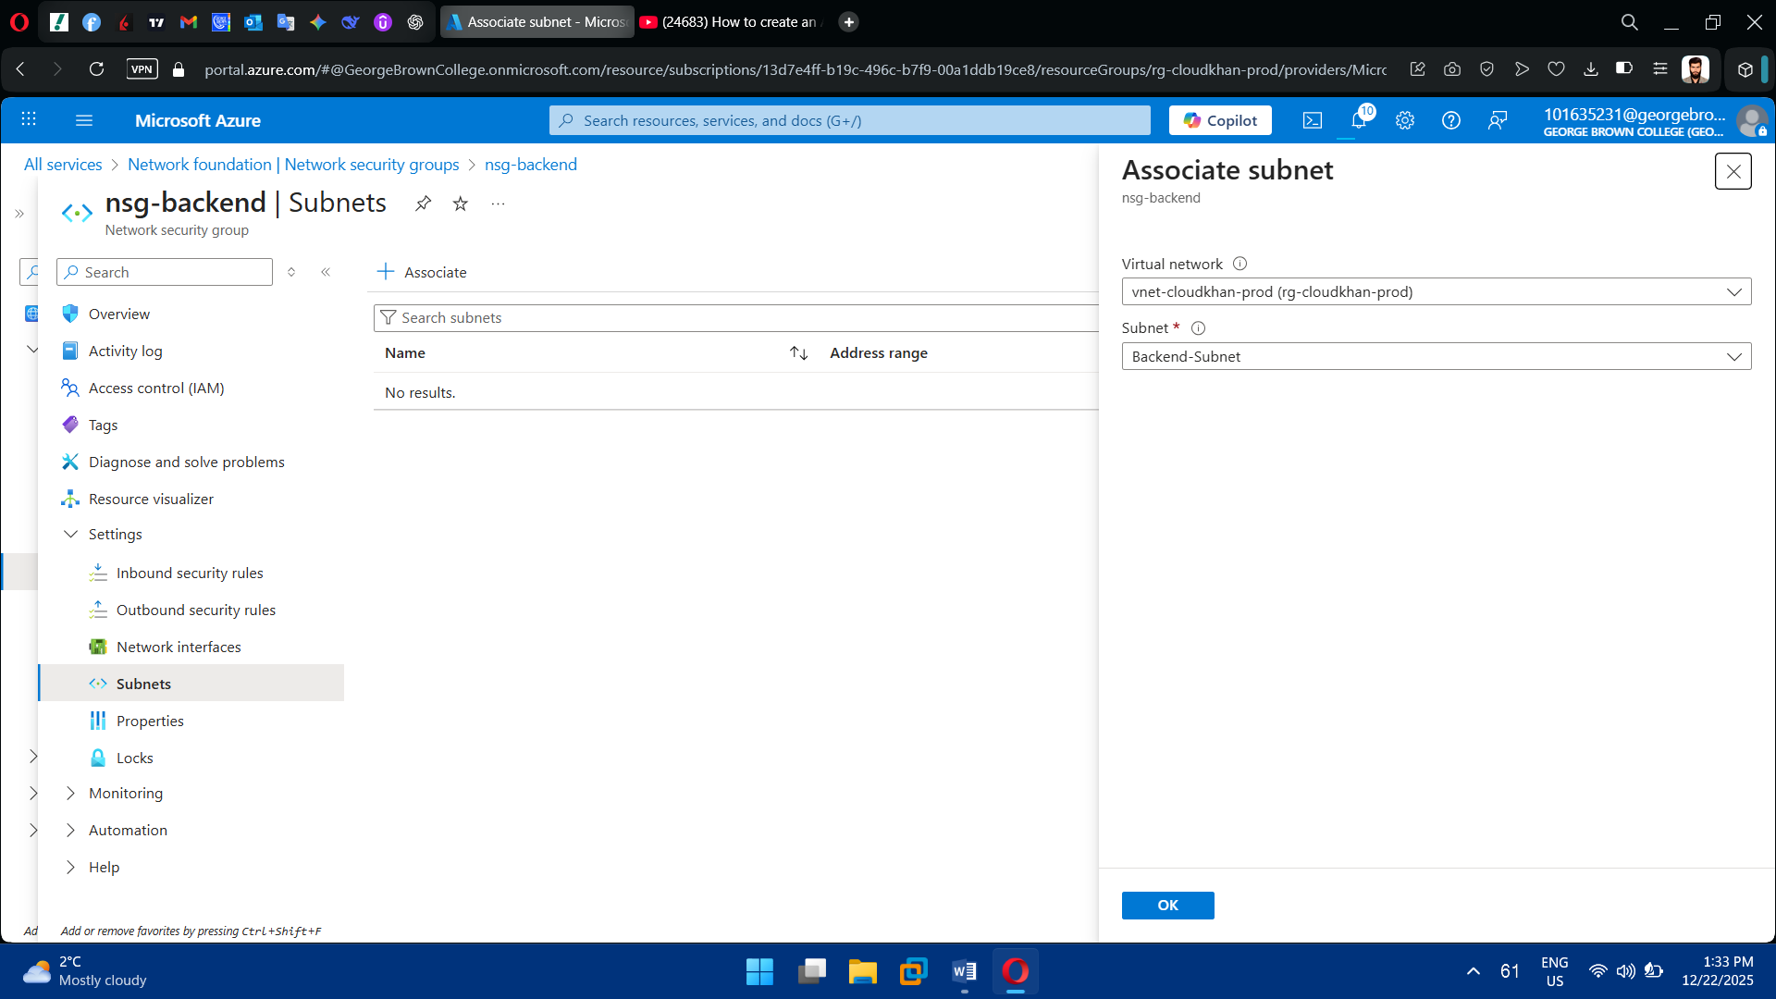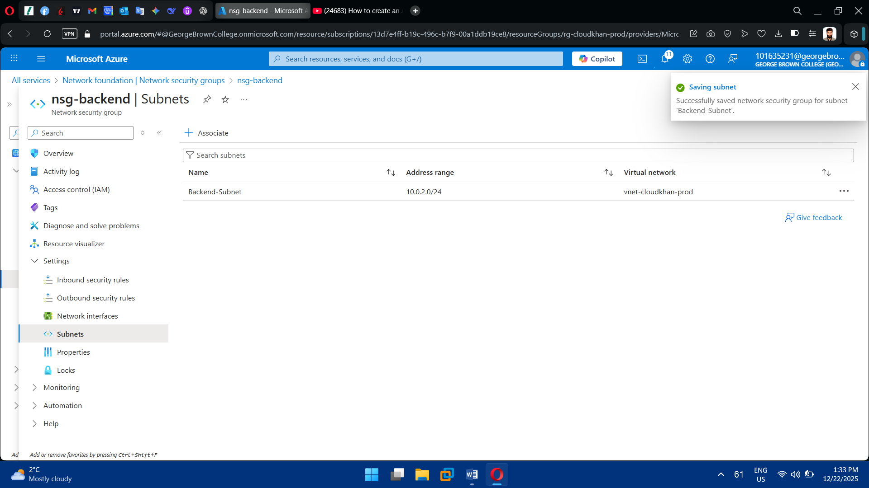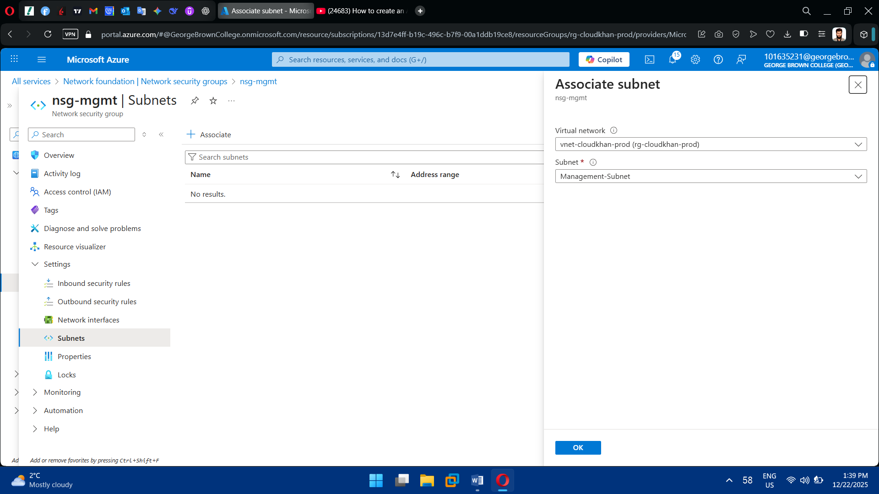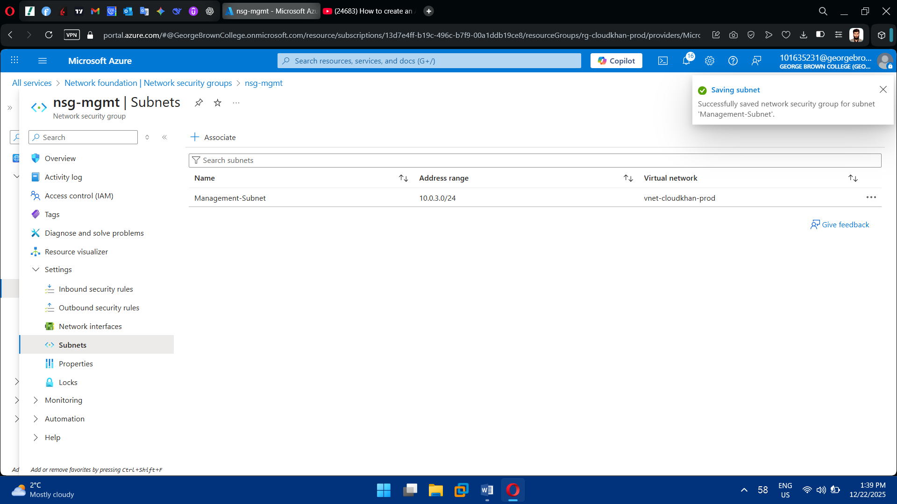

**Task 4: Compute Resource Deployment**

1. Deploy Windows Virtual Machine

* Use Windows Server 2019 or 2022
* Assign VM to Backend or Management subnet
* Configure:
  + VM size
  + OS disk
  + Admin credentials
  + Network interface

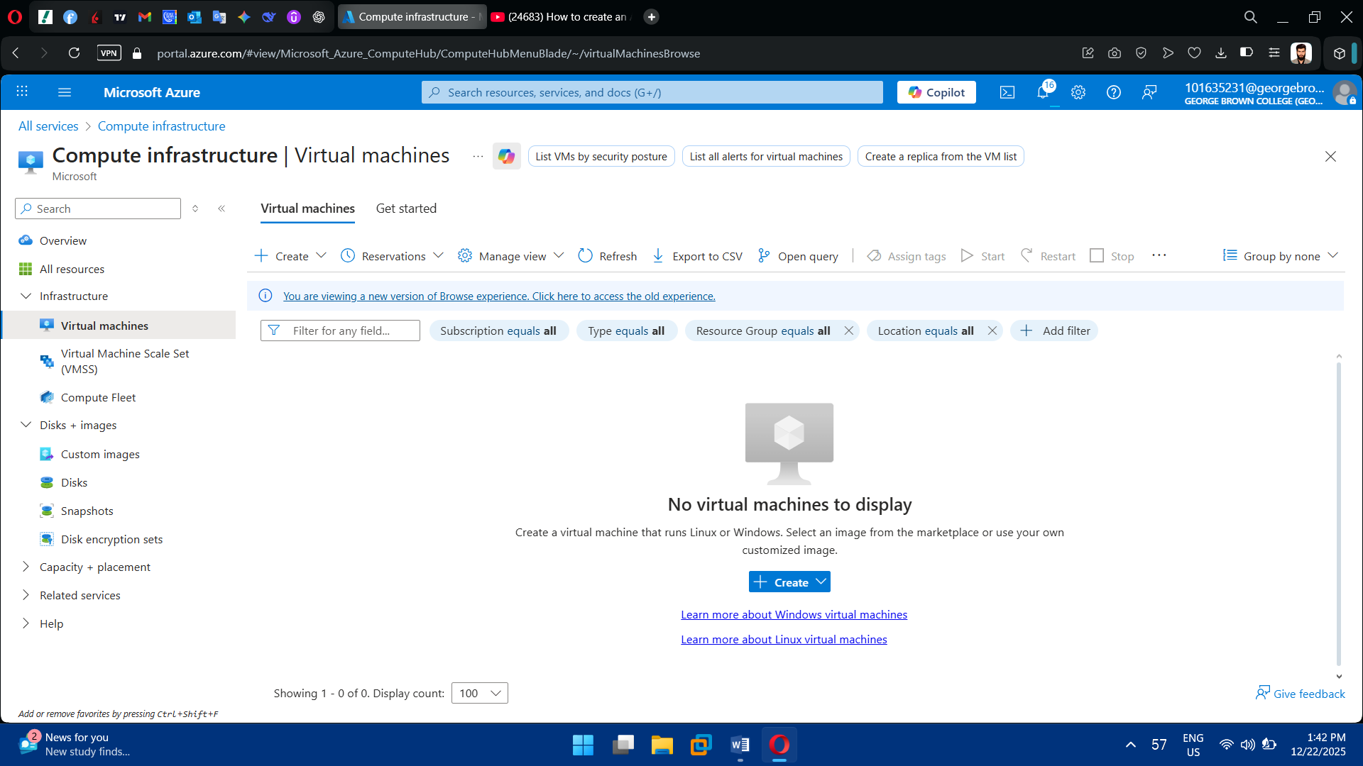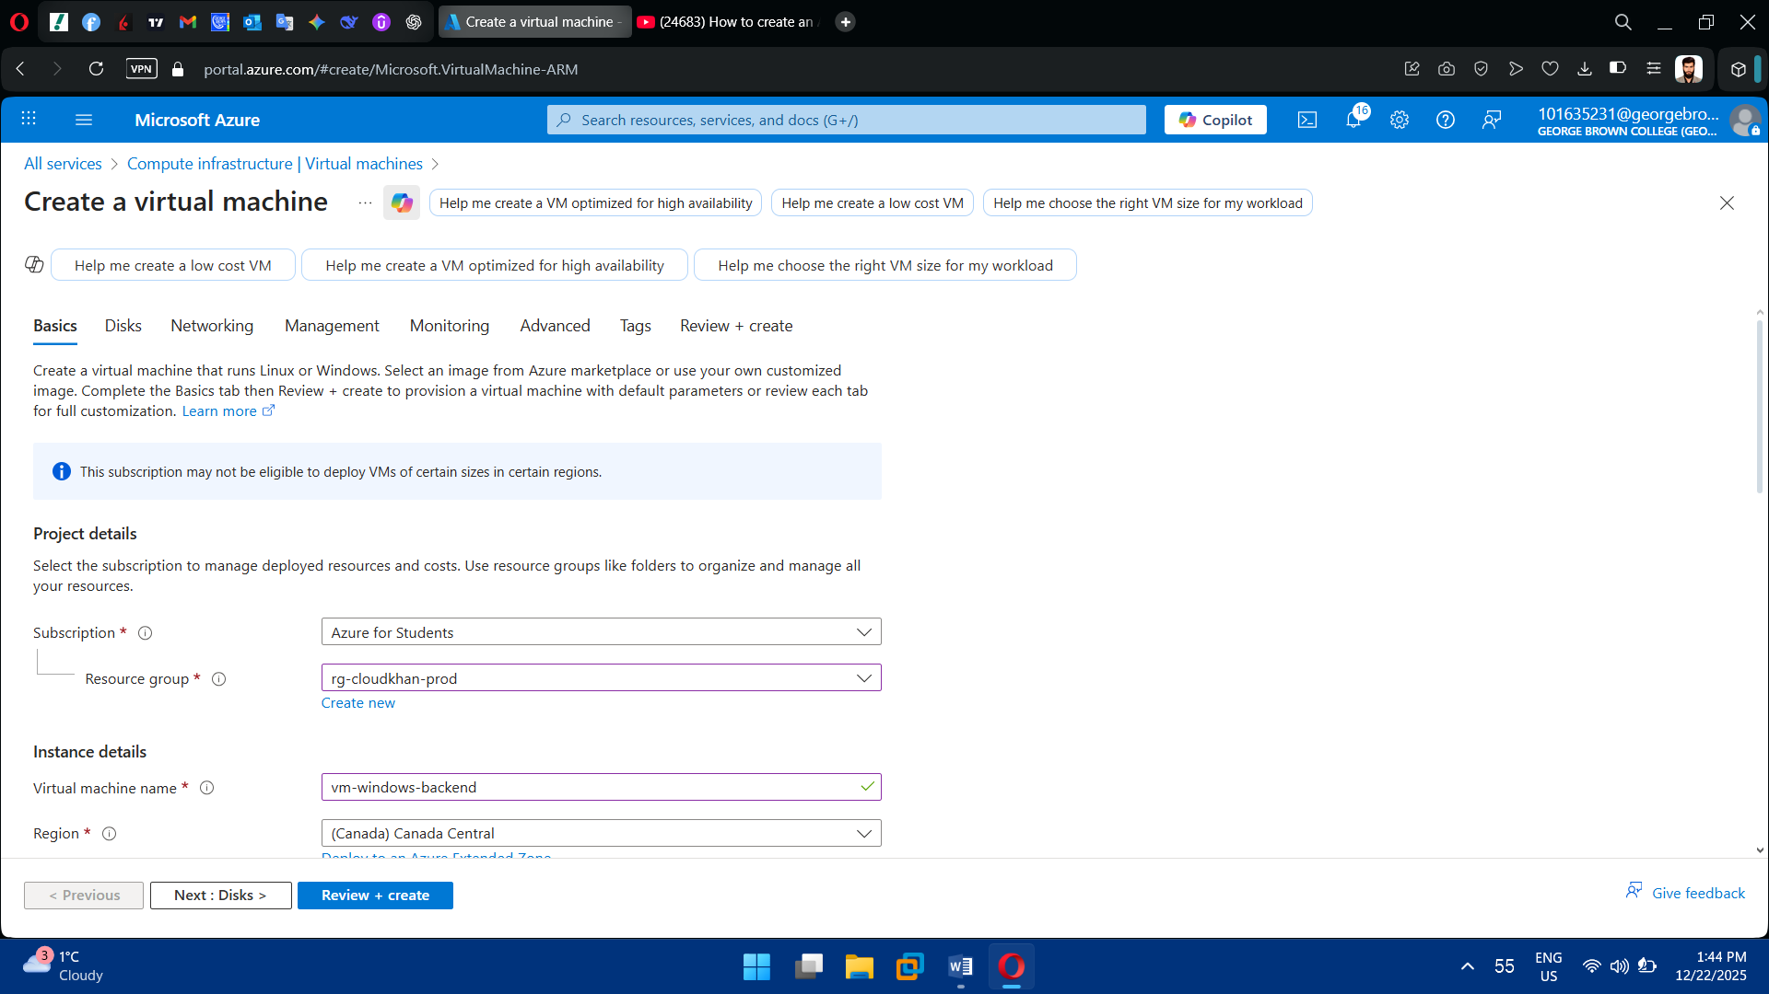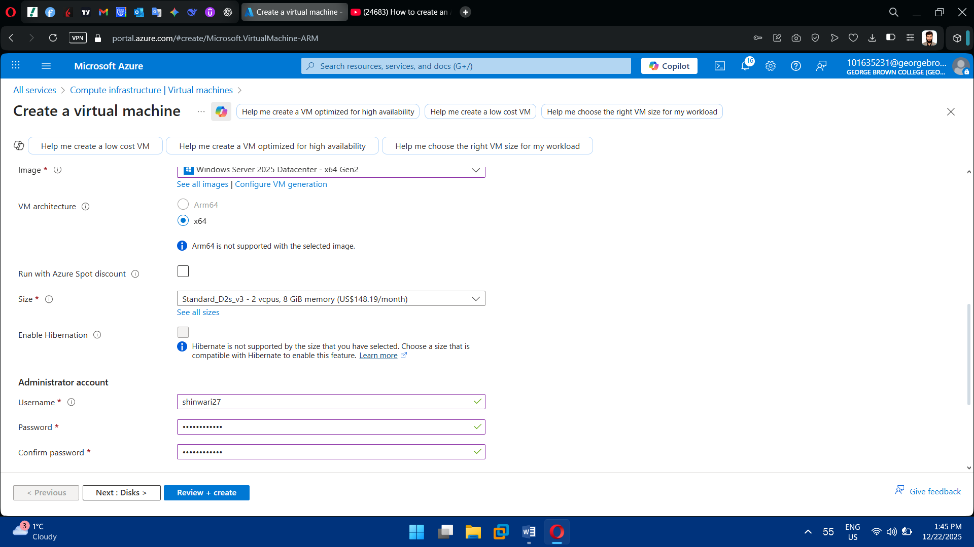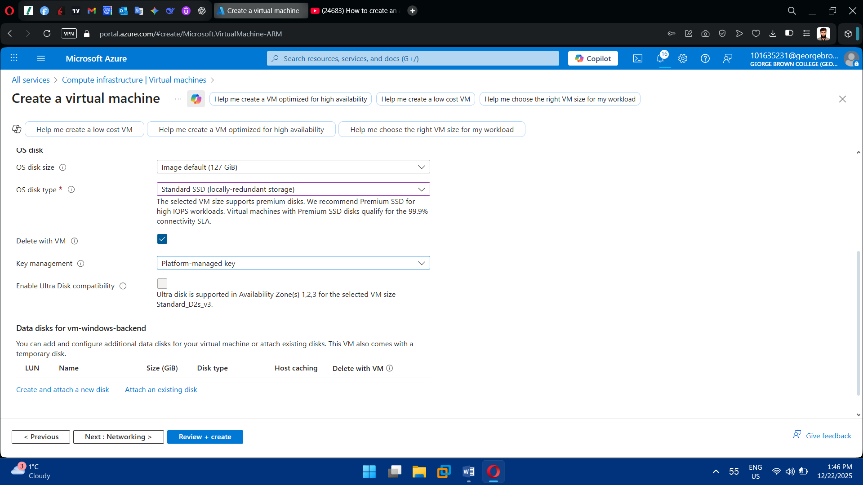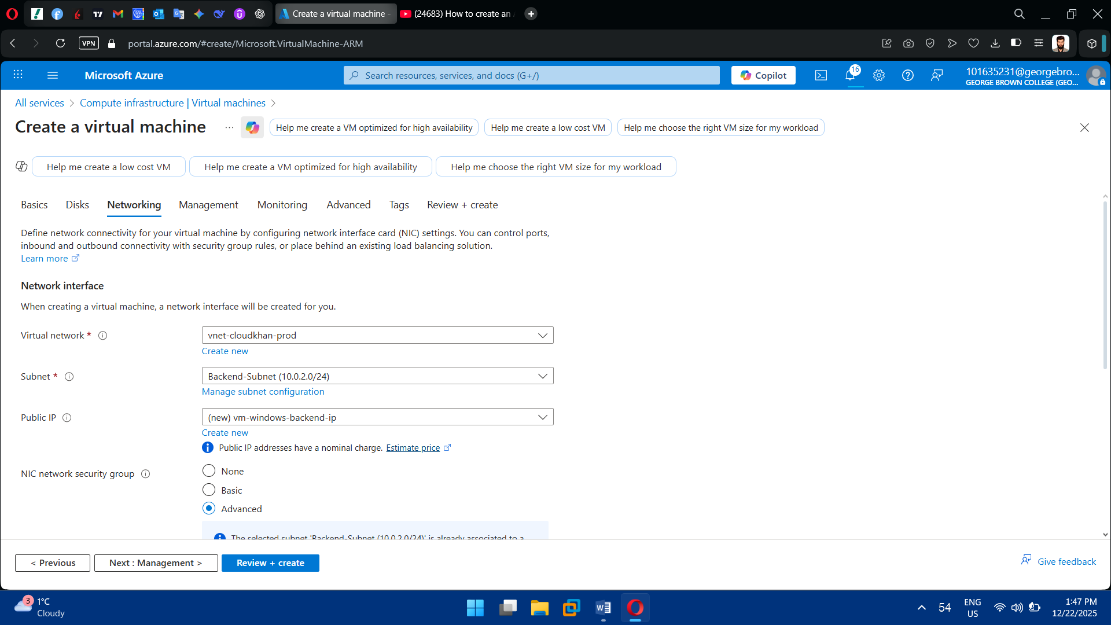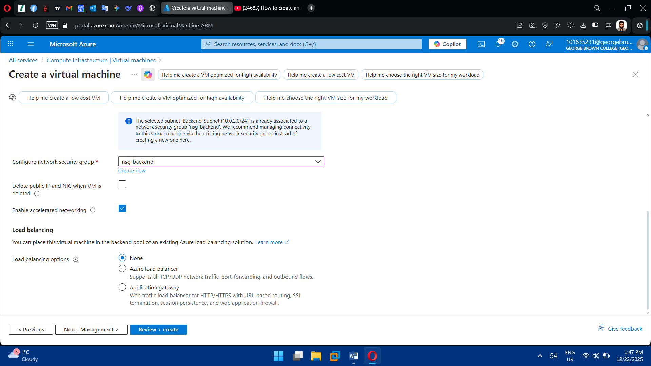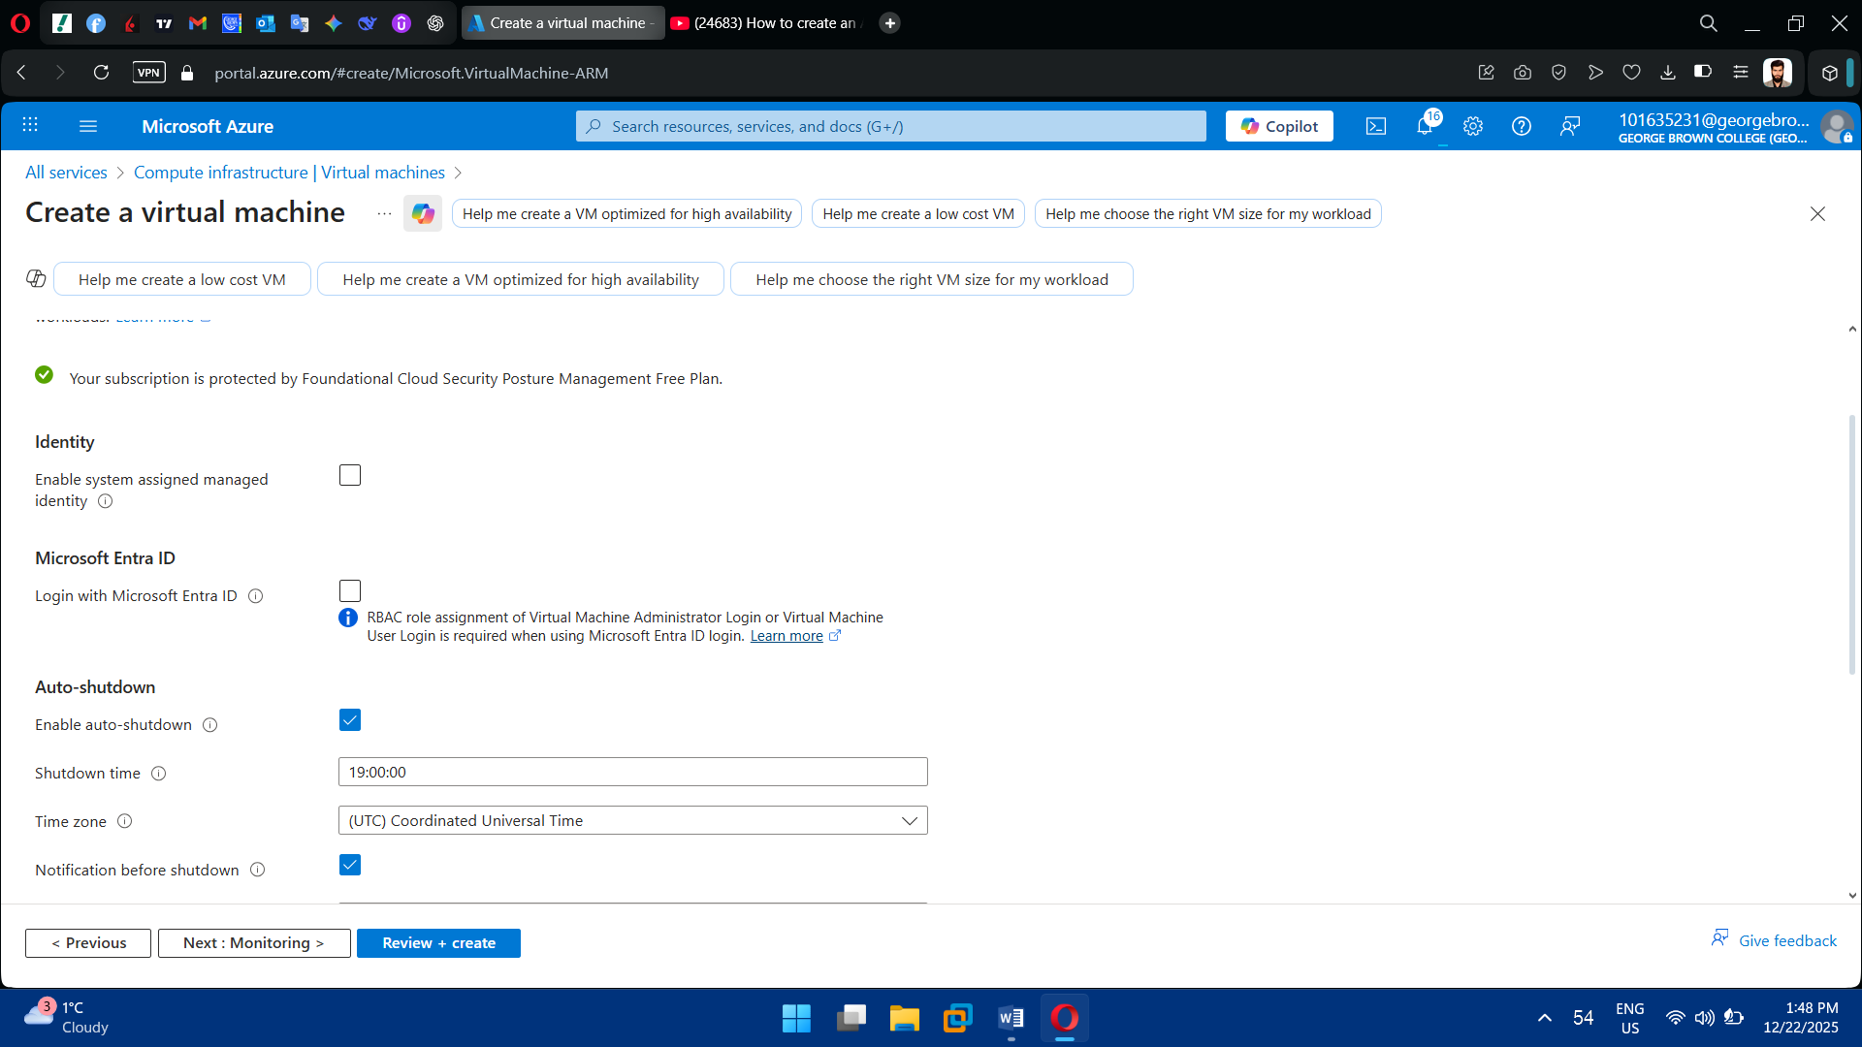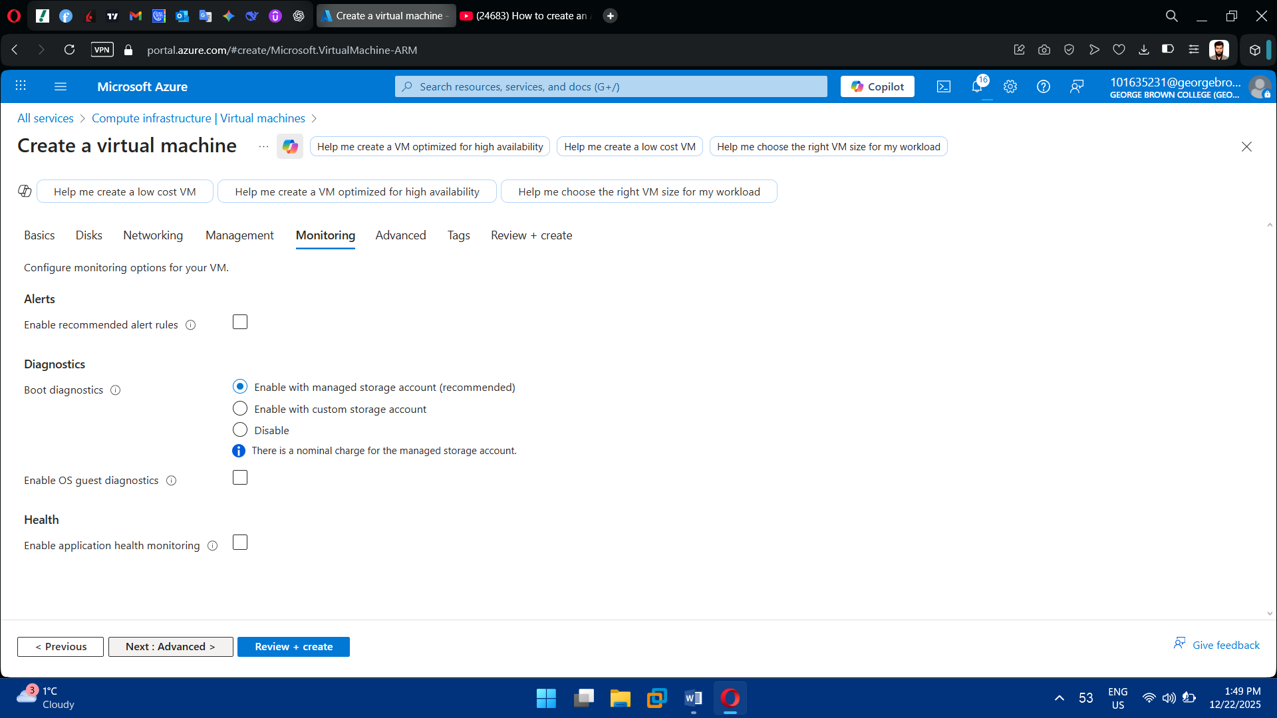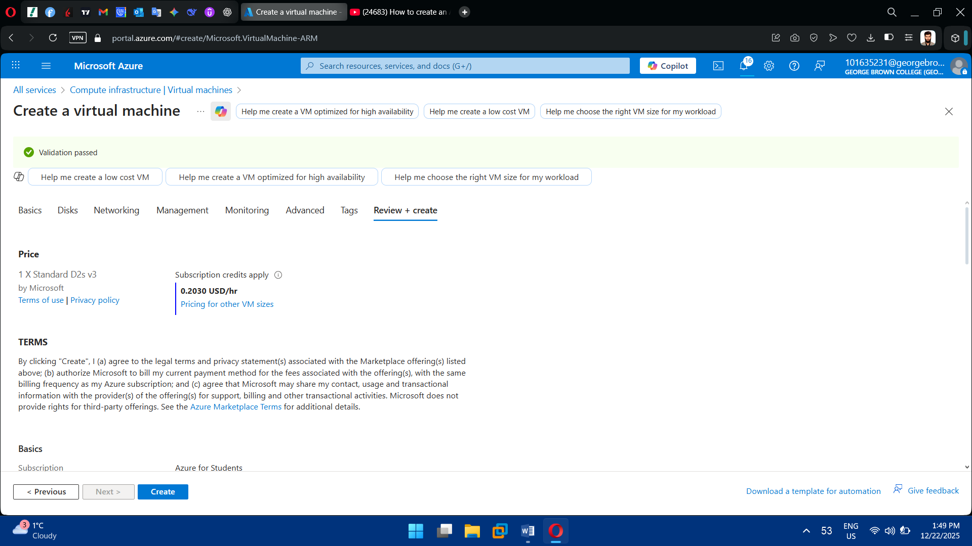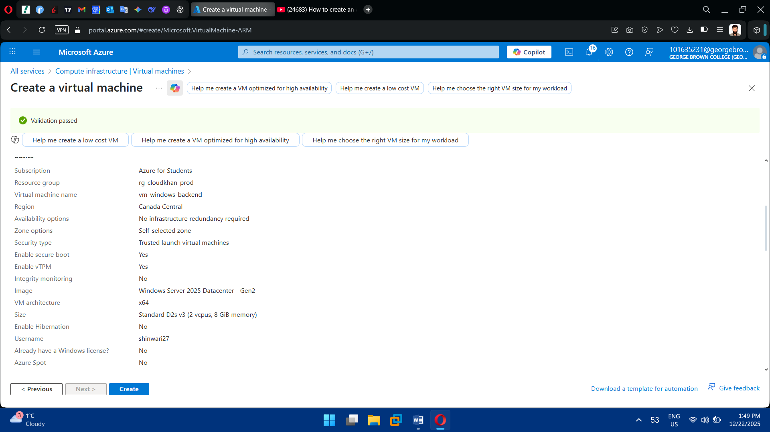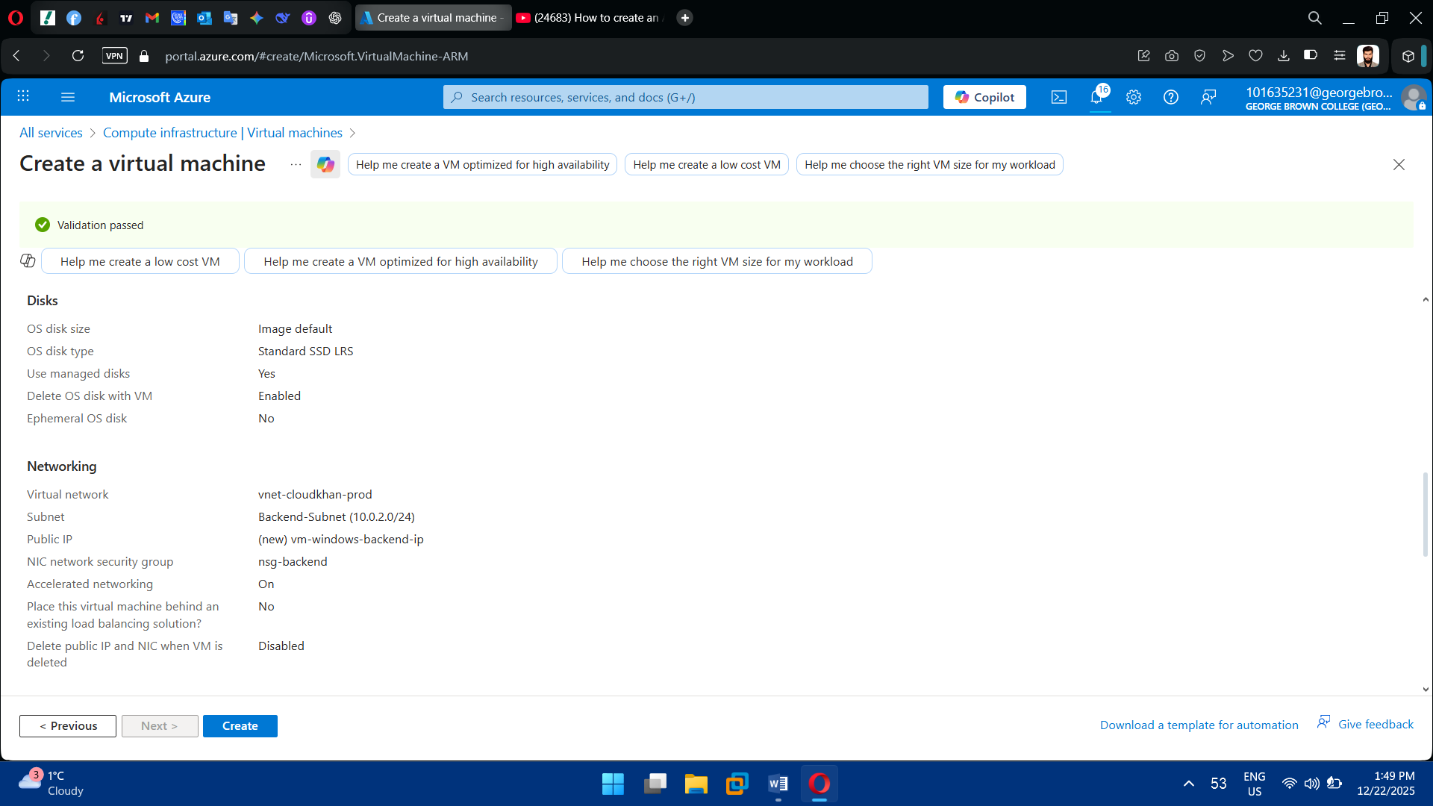

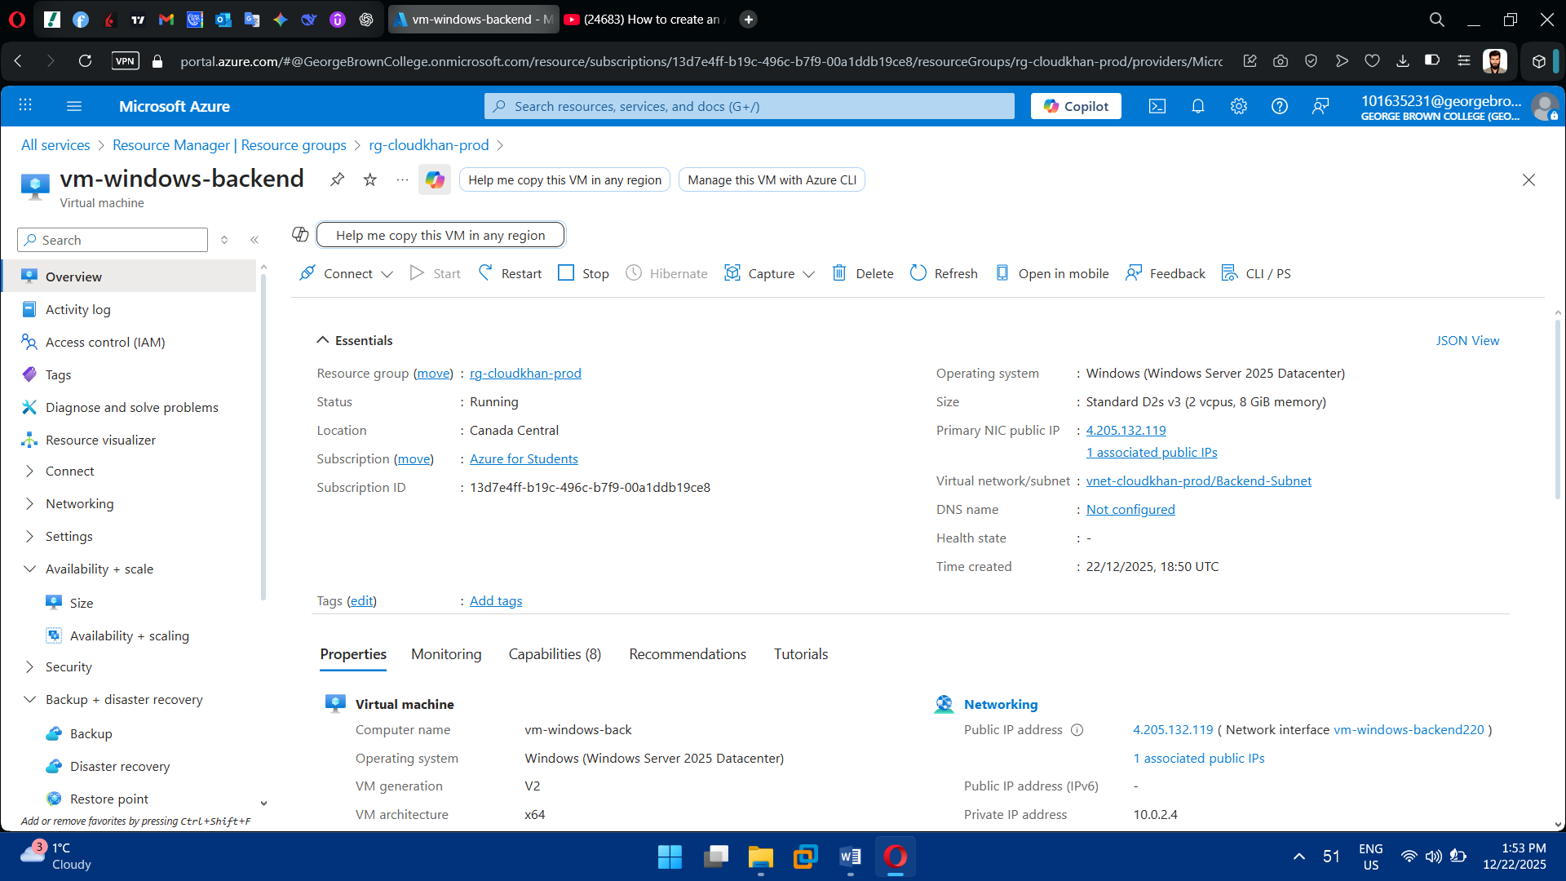

2. Deploy Linux Virtual Machine

* Use Ubuntu LTS
* Assign VM to Frontend or Backend subnet
* Configure:
  + SSH authentication
  + OS disk
  + Network interface

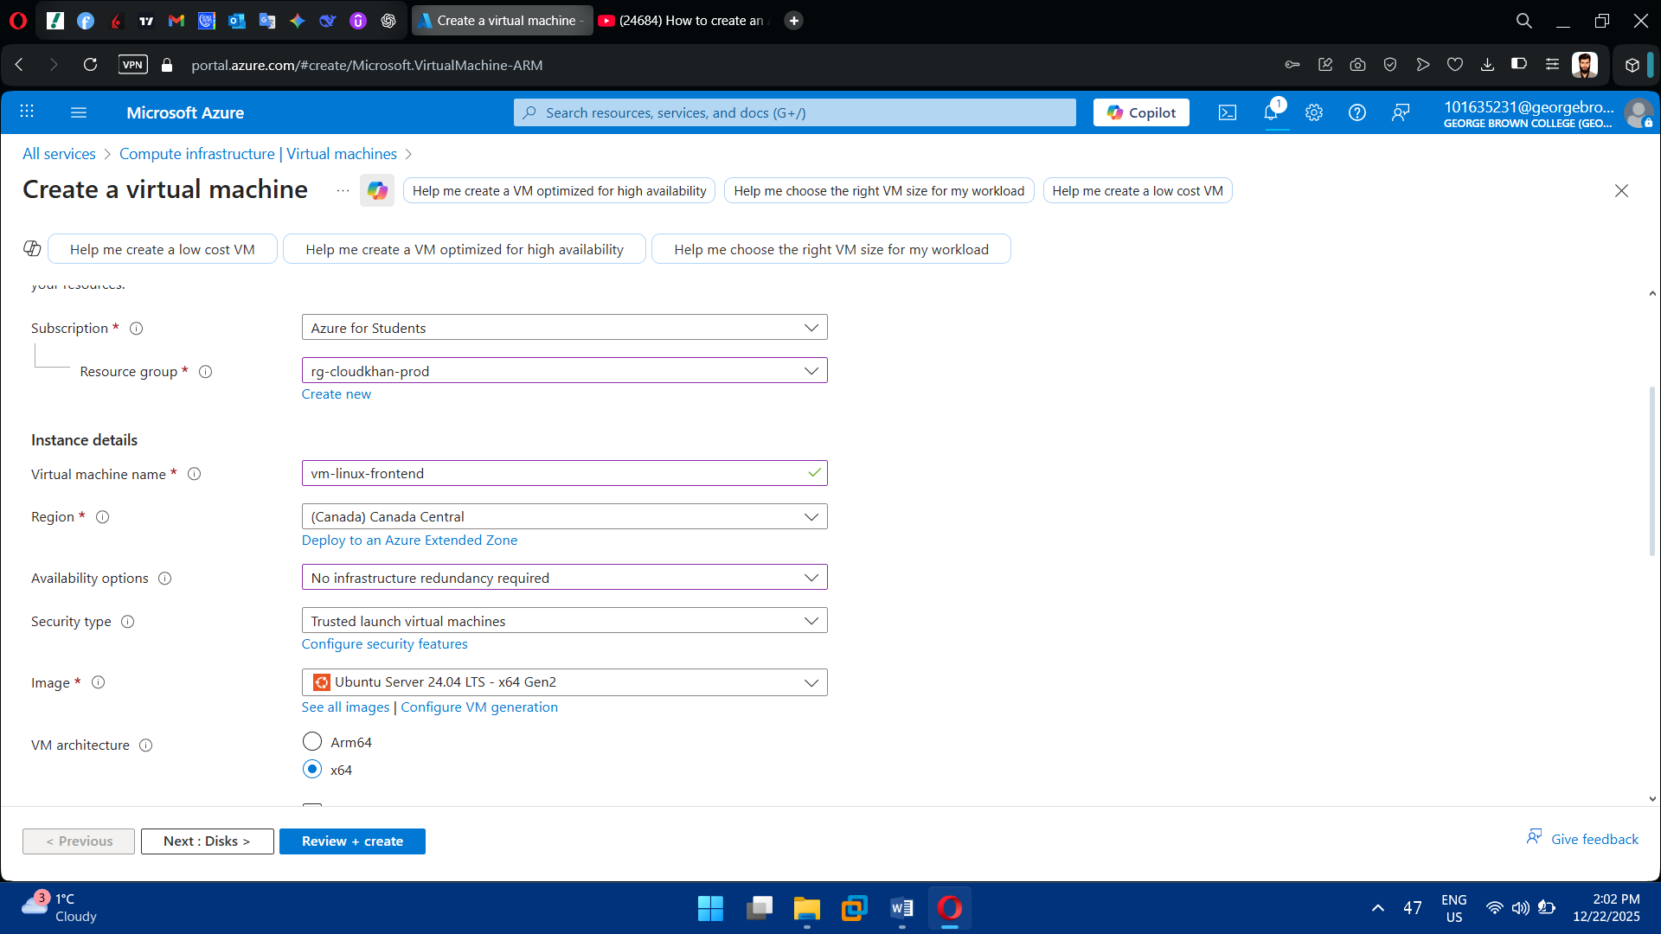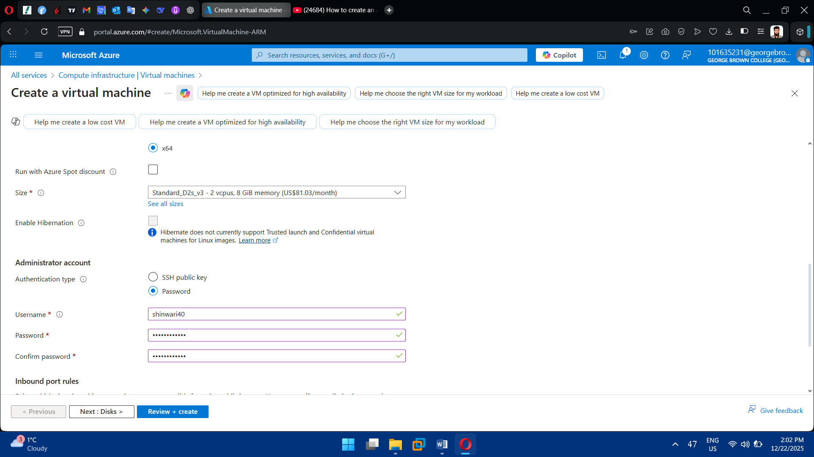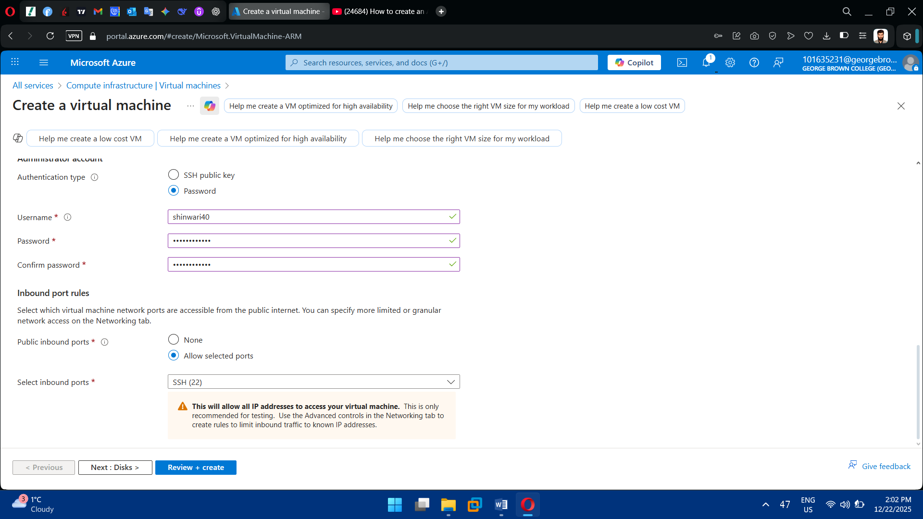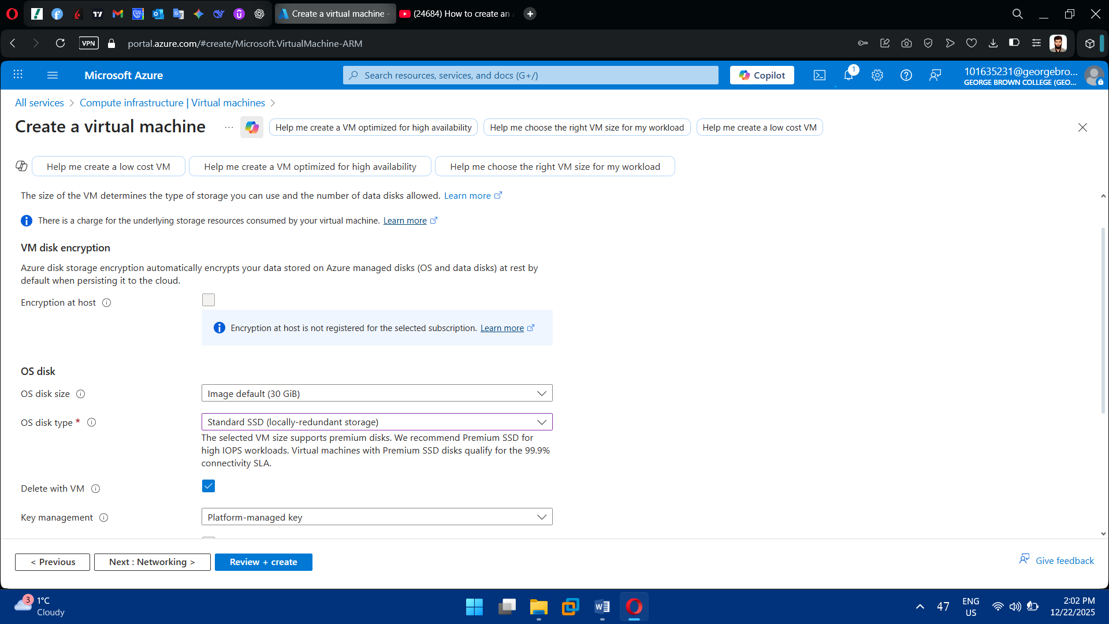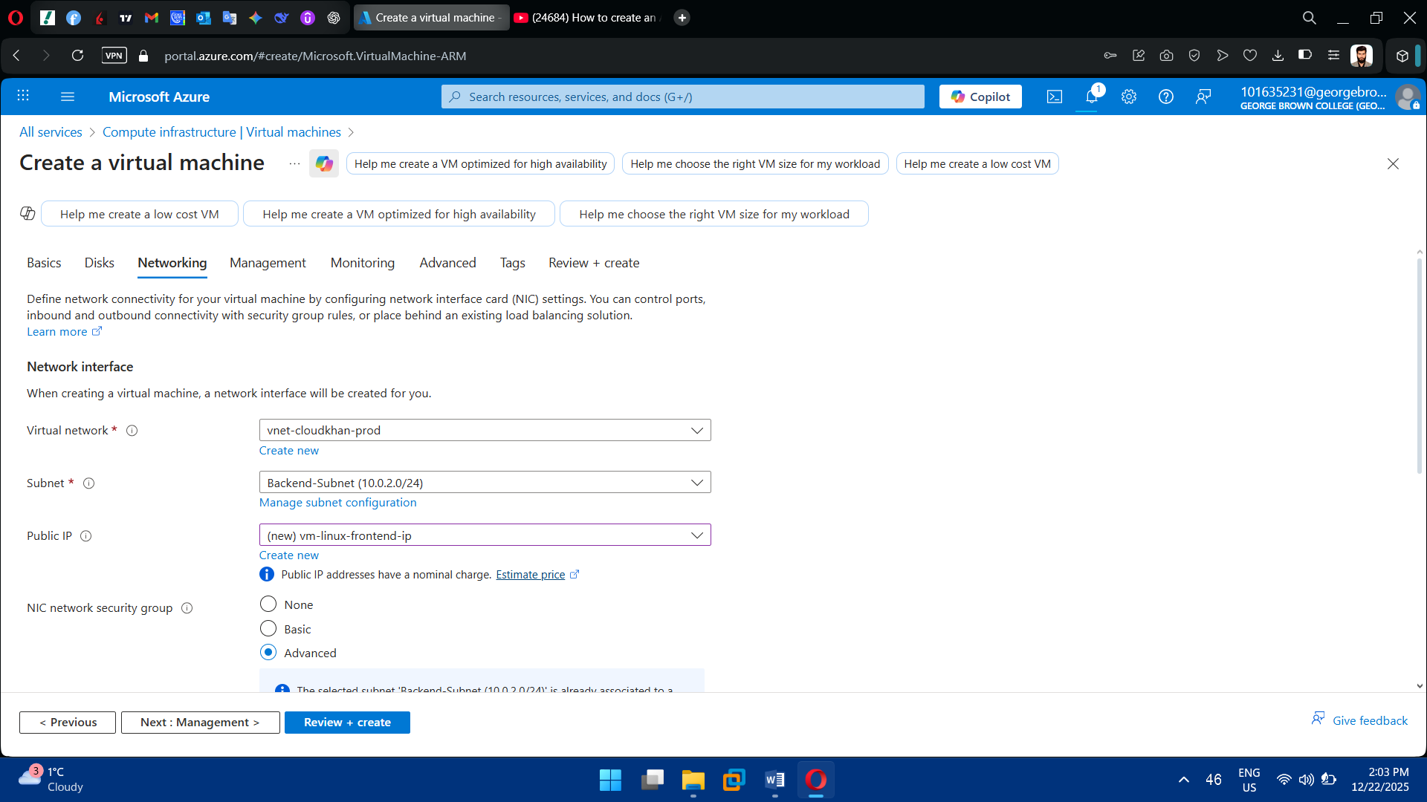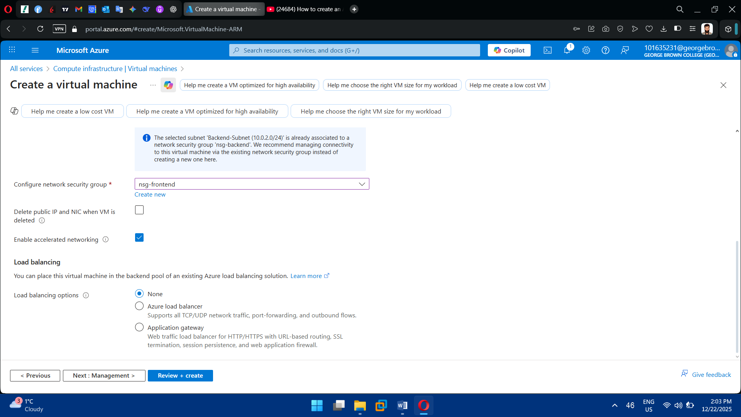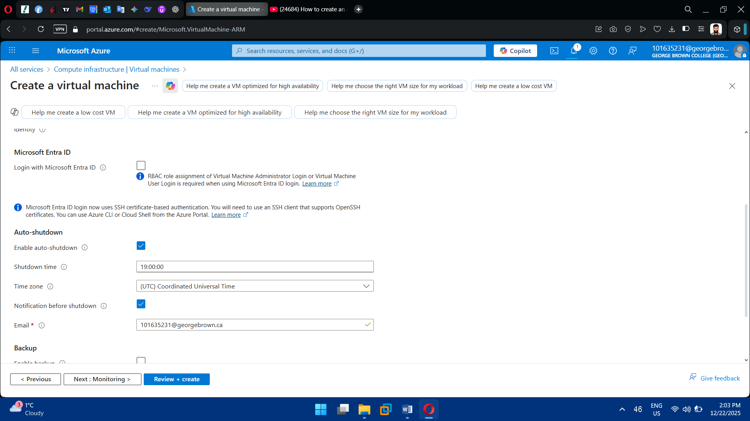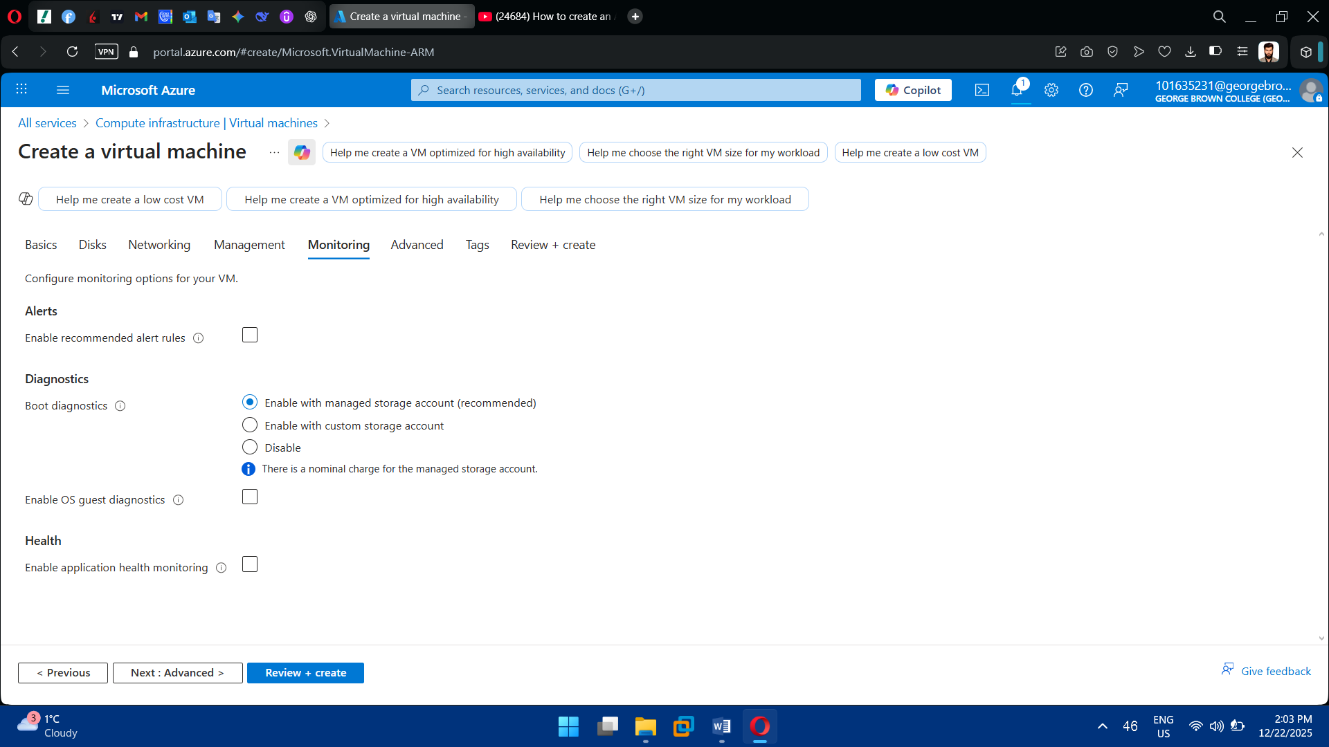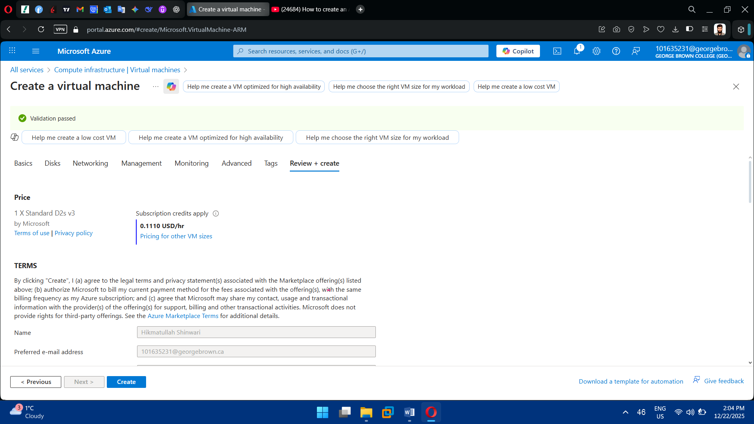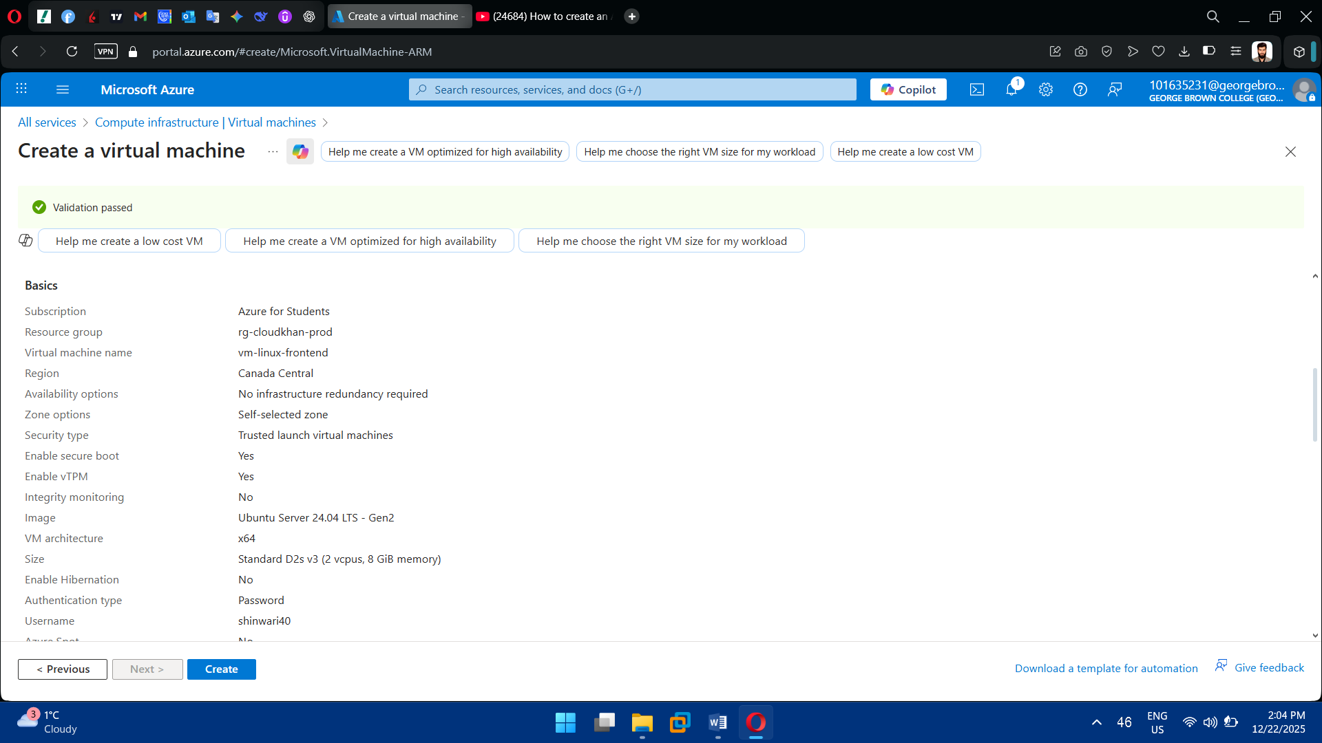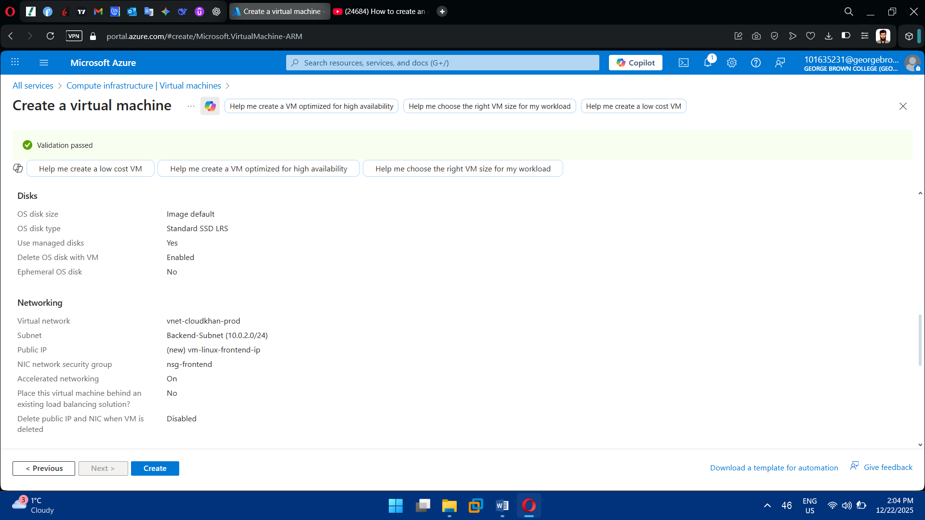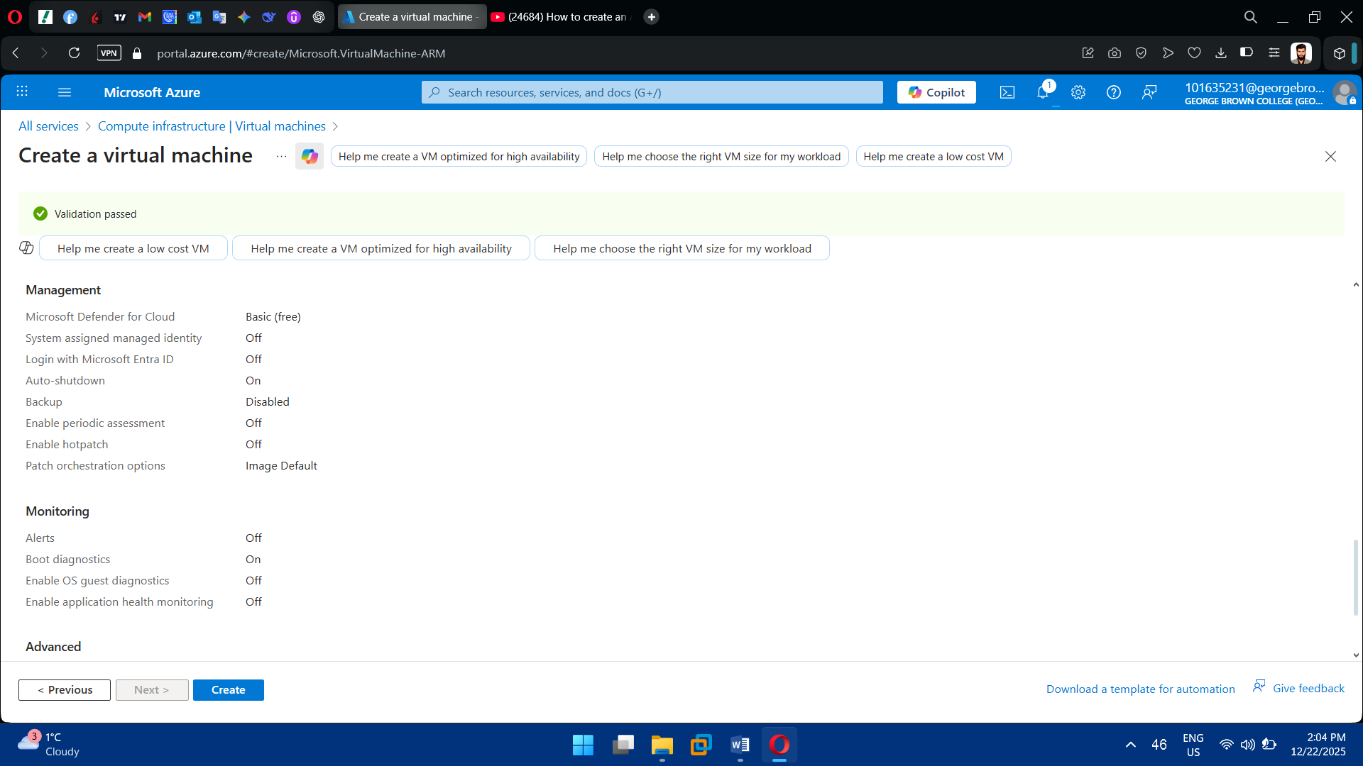

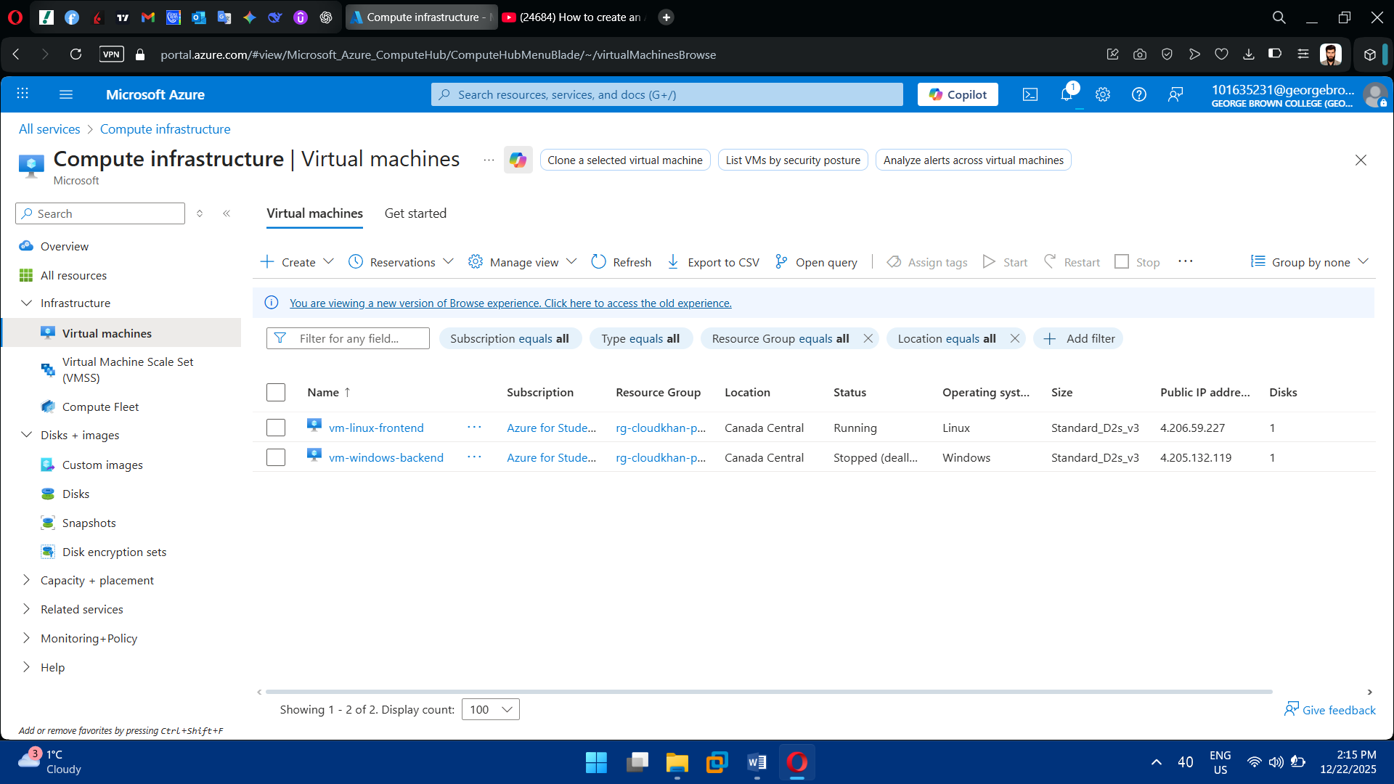

**Task 5: Storage Services Deployment**

1. Create Storage Account

* Use Standard / LRS
* Enable secure transfer (HTTPS only)
* Disable public access where possible

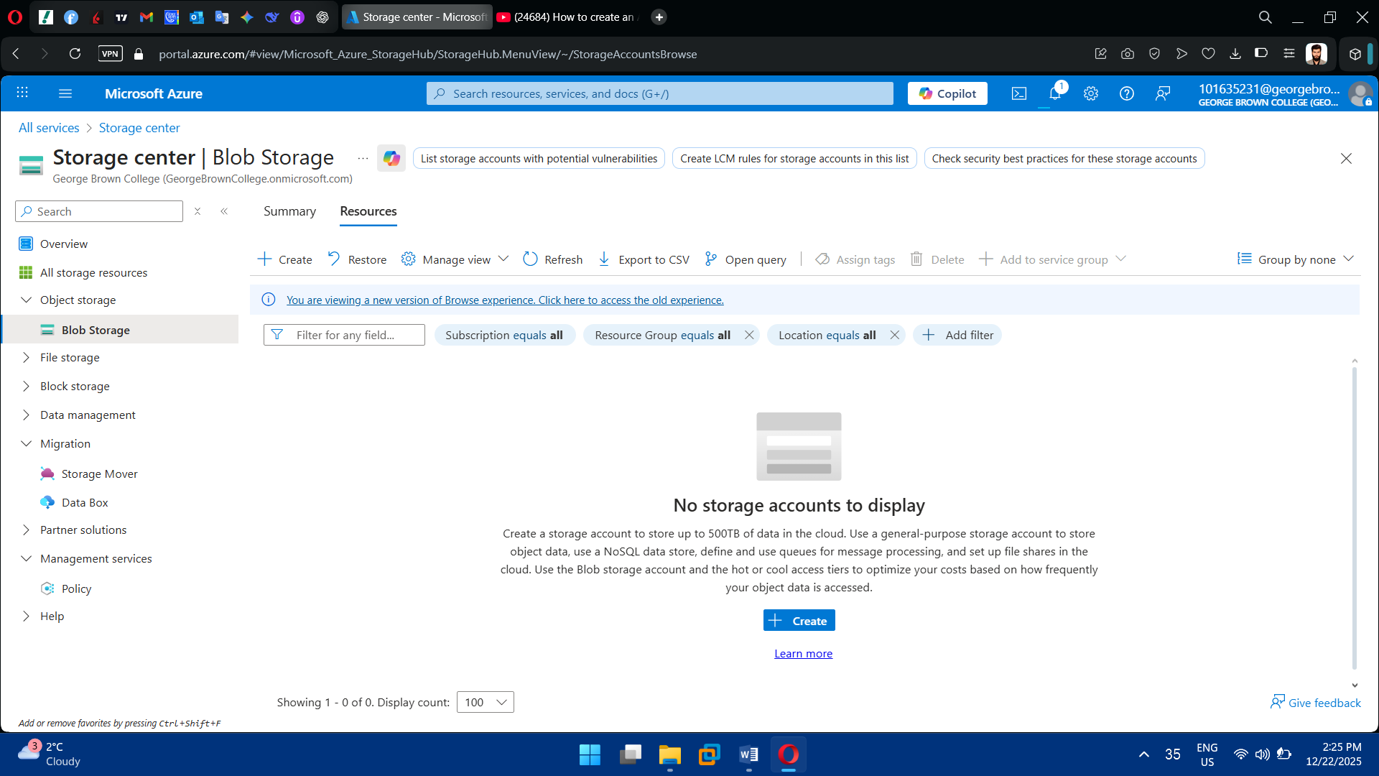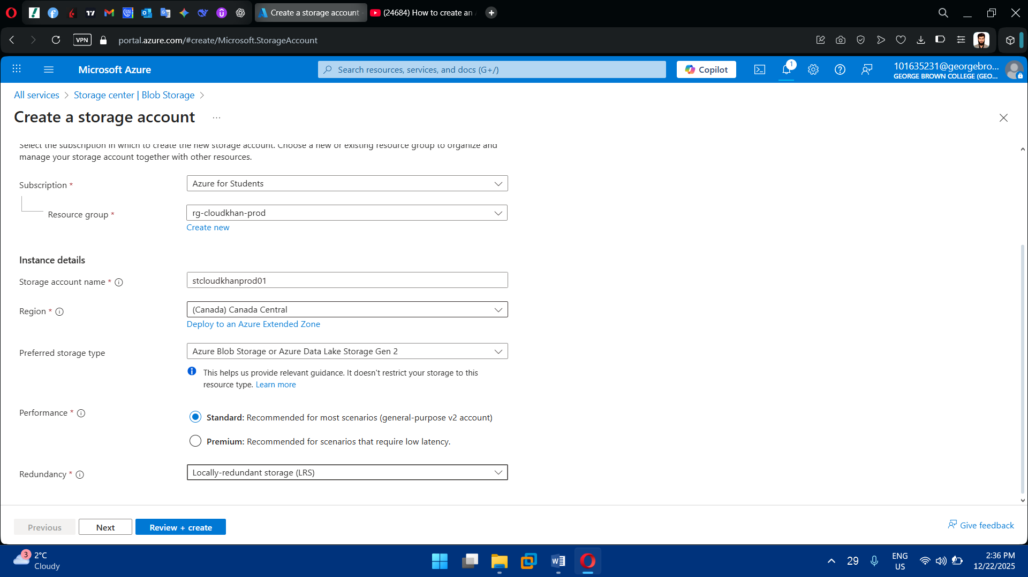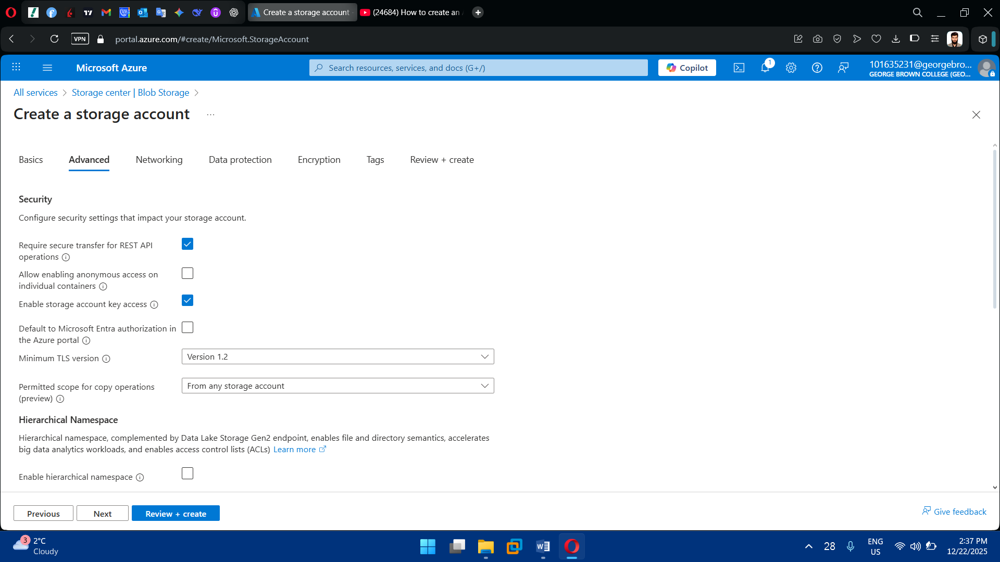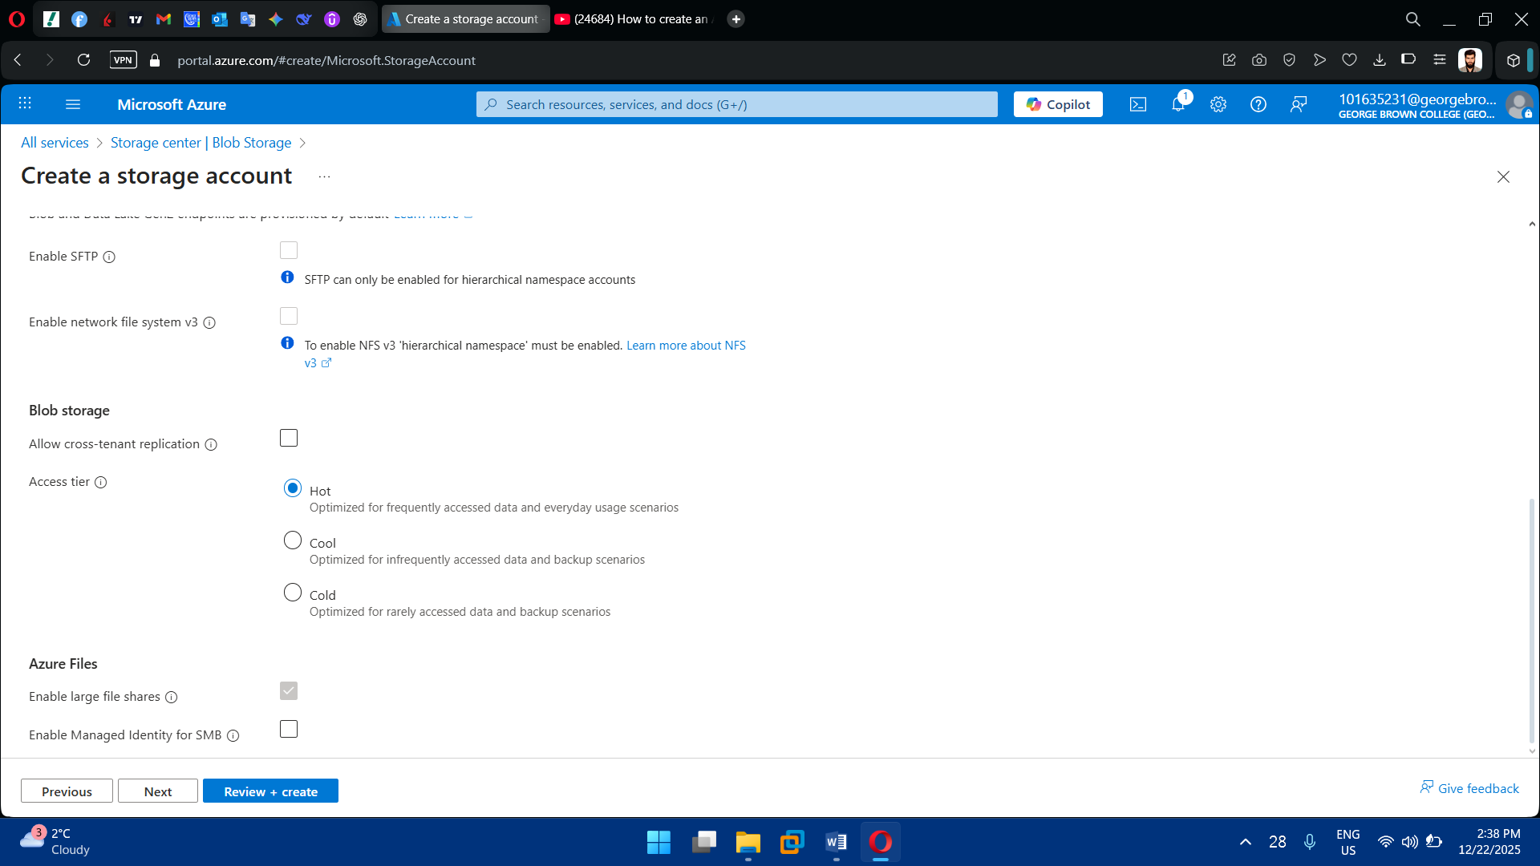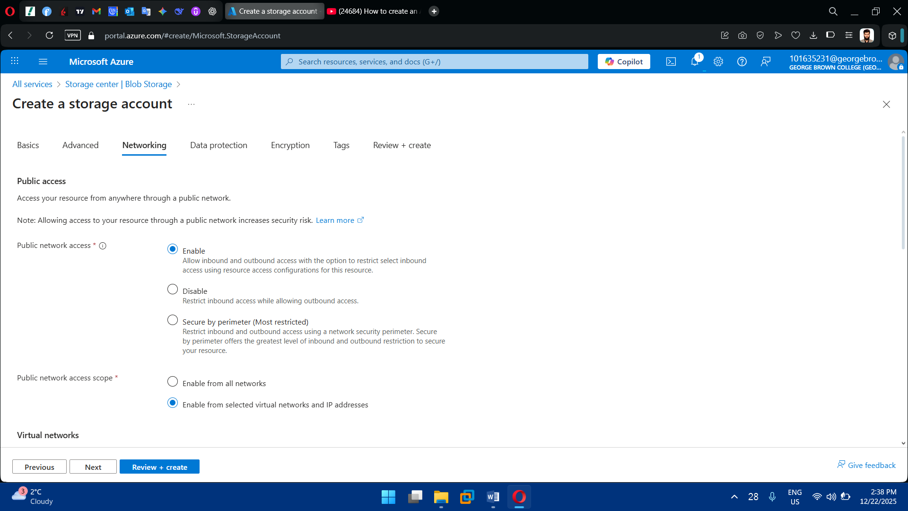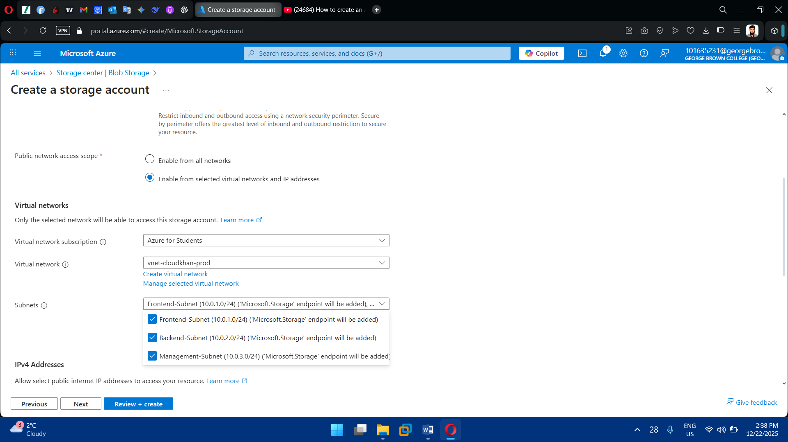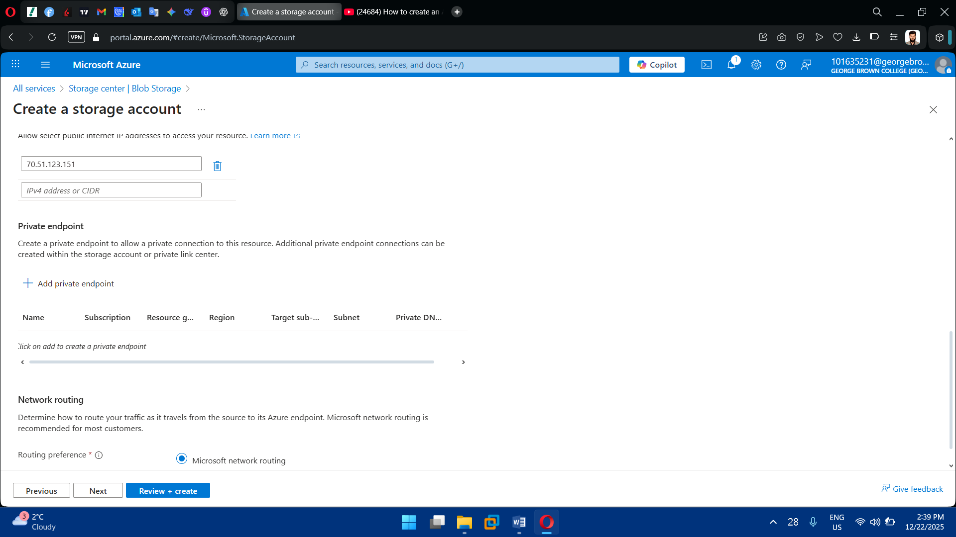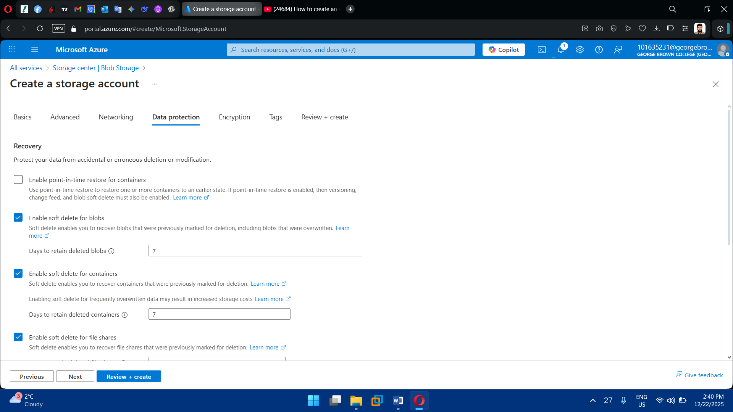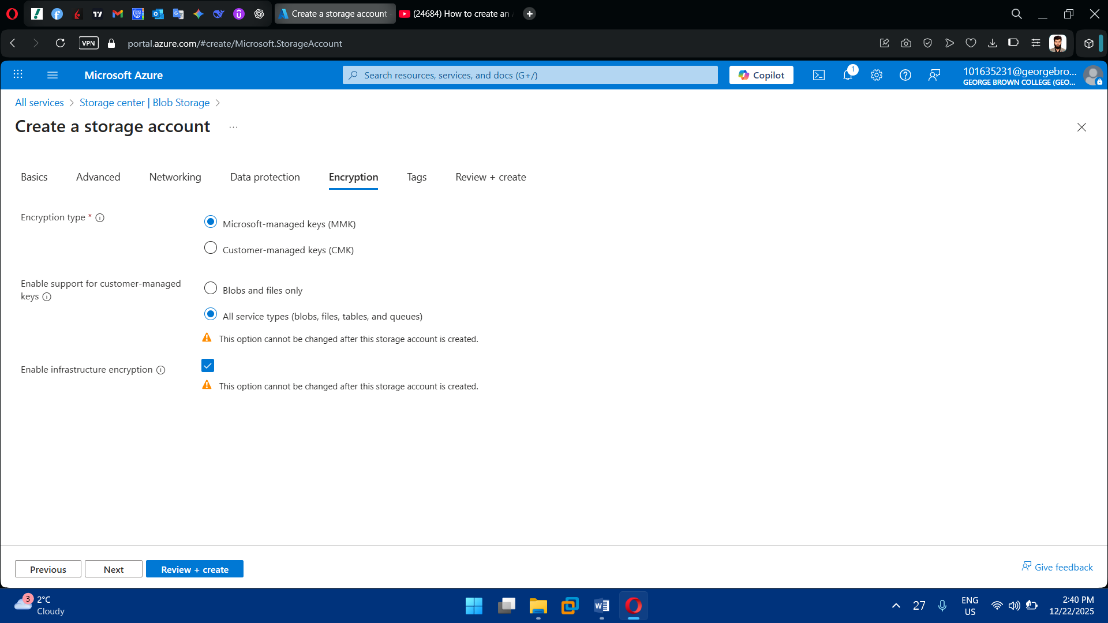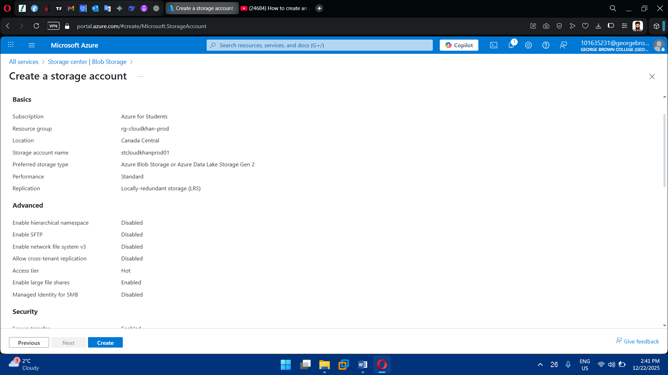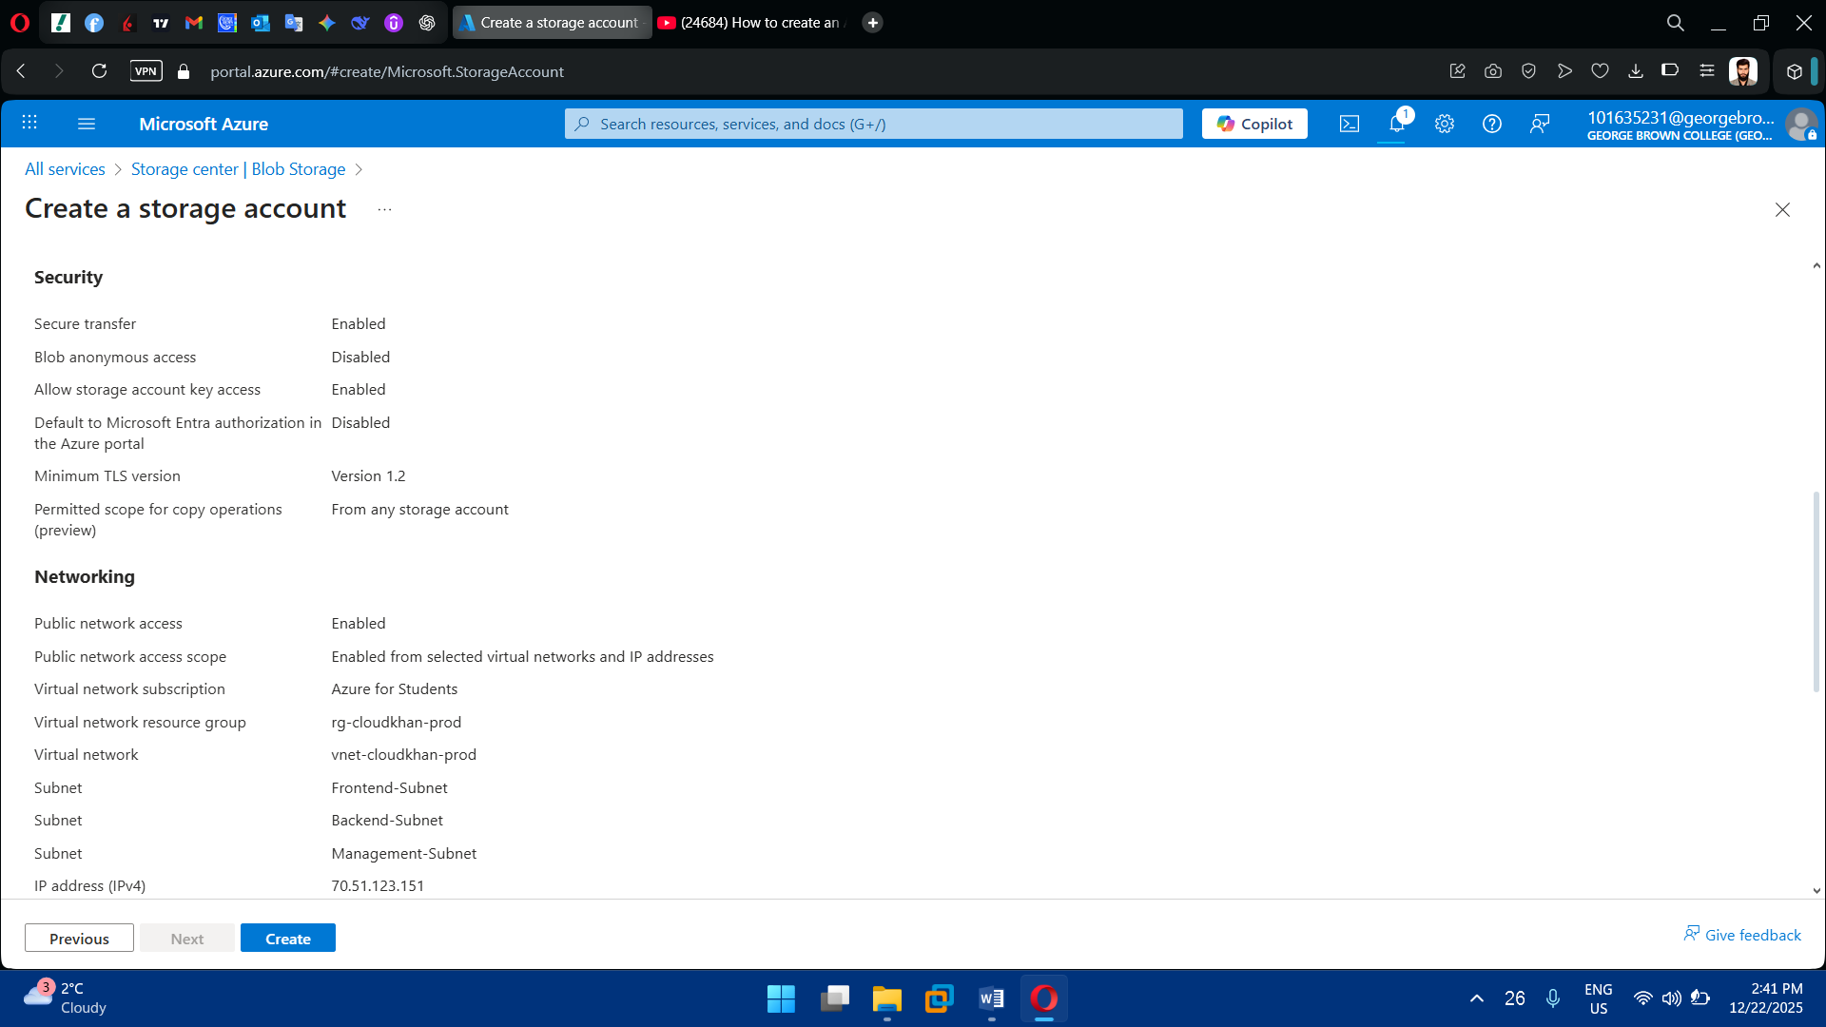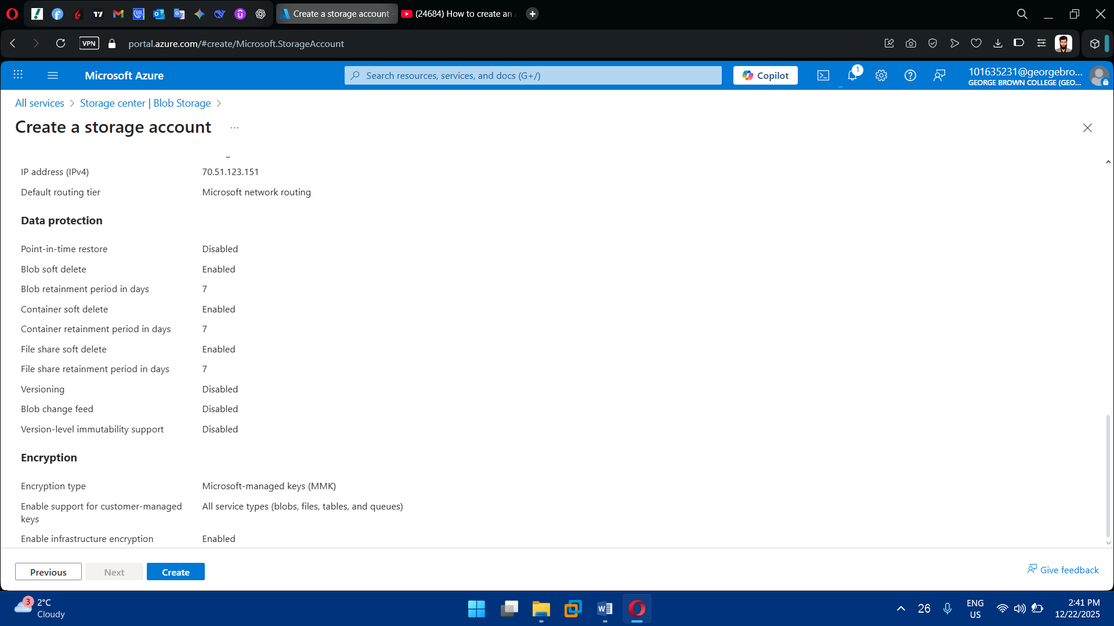

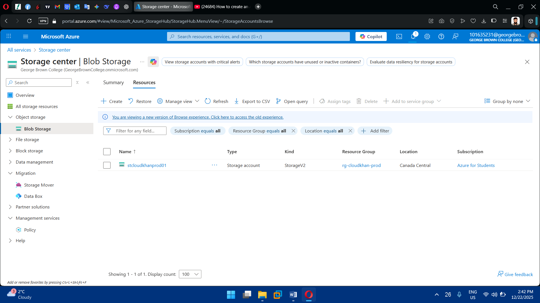

2. Configure Storage Features

* Blob containers
* Access tiers (Hot / Cool)
* RBAC-based access

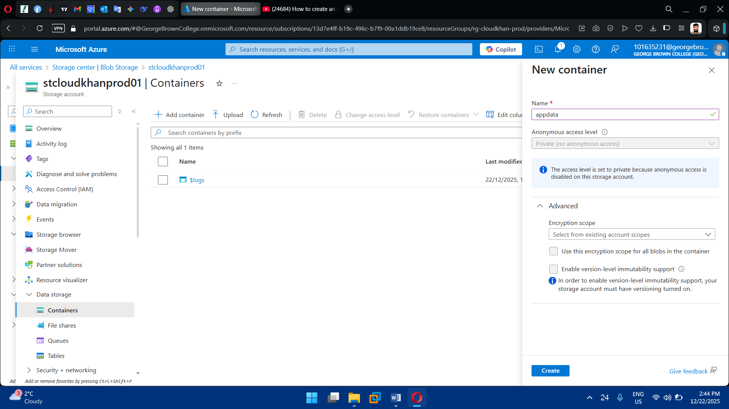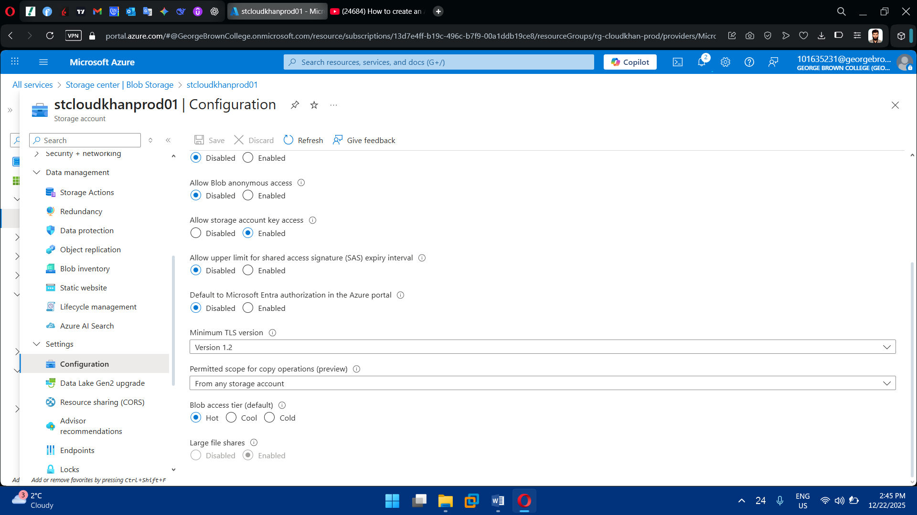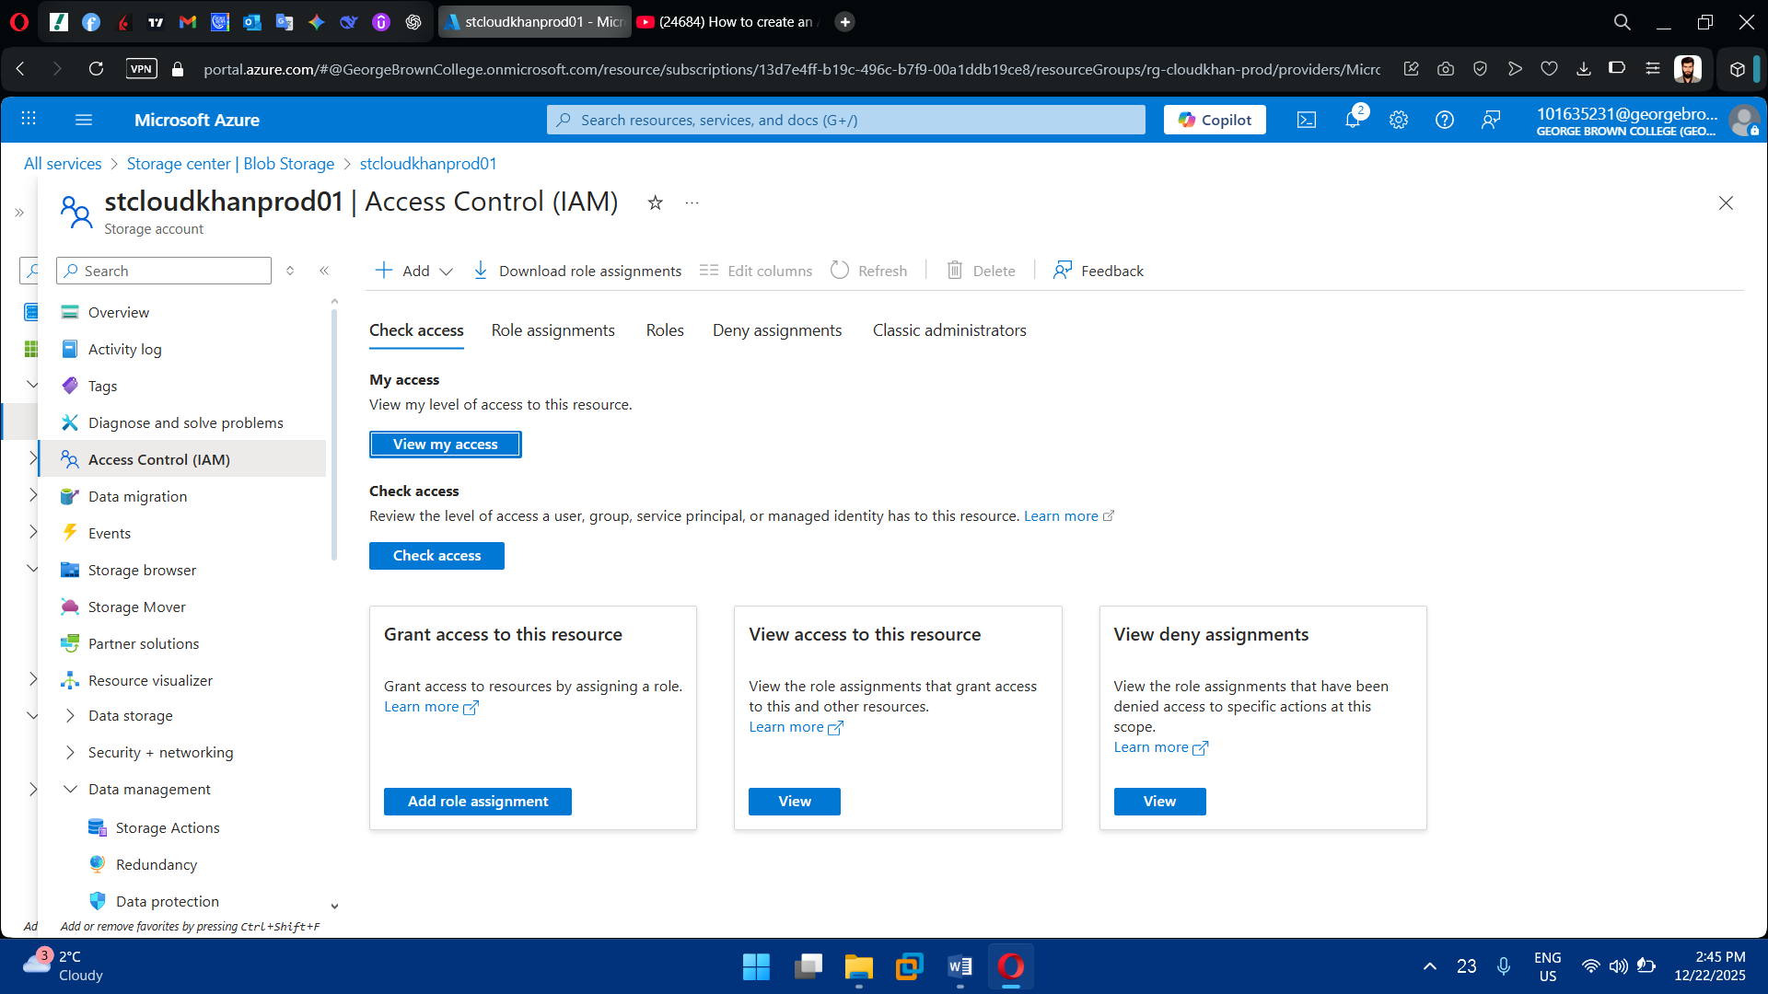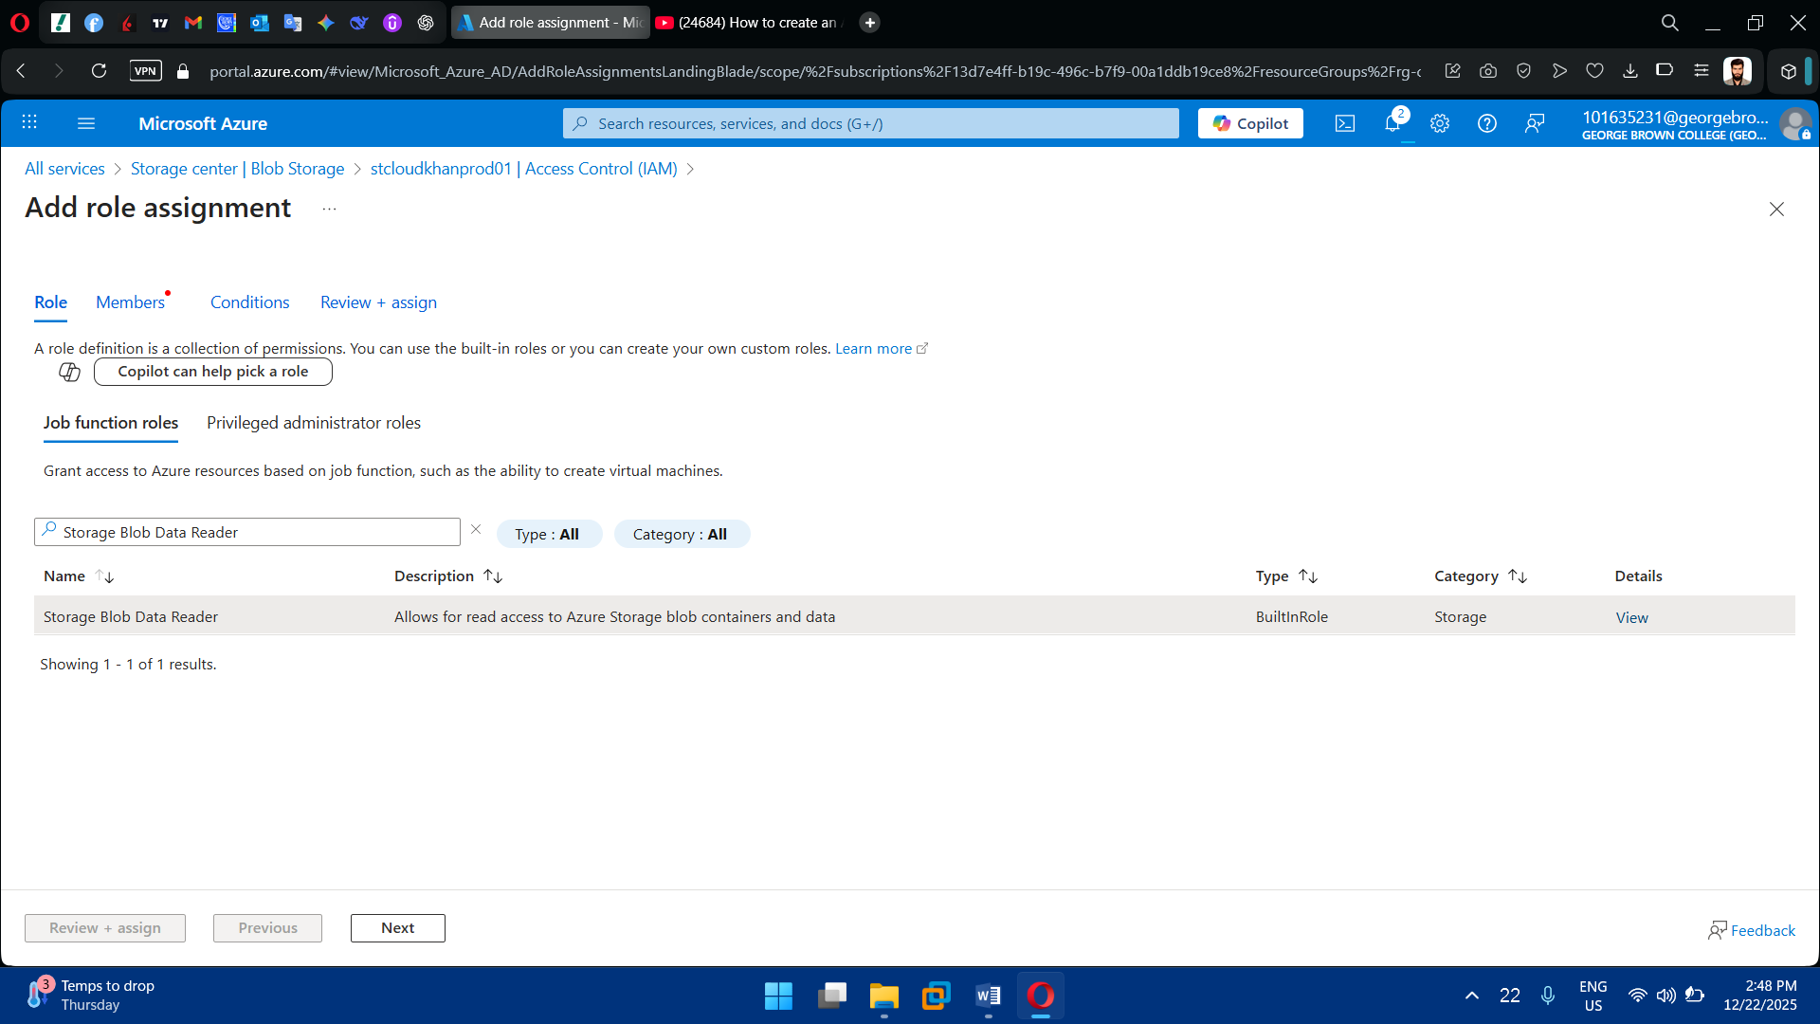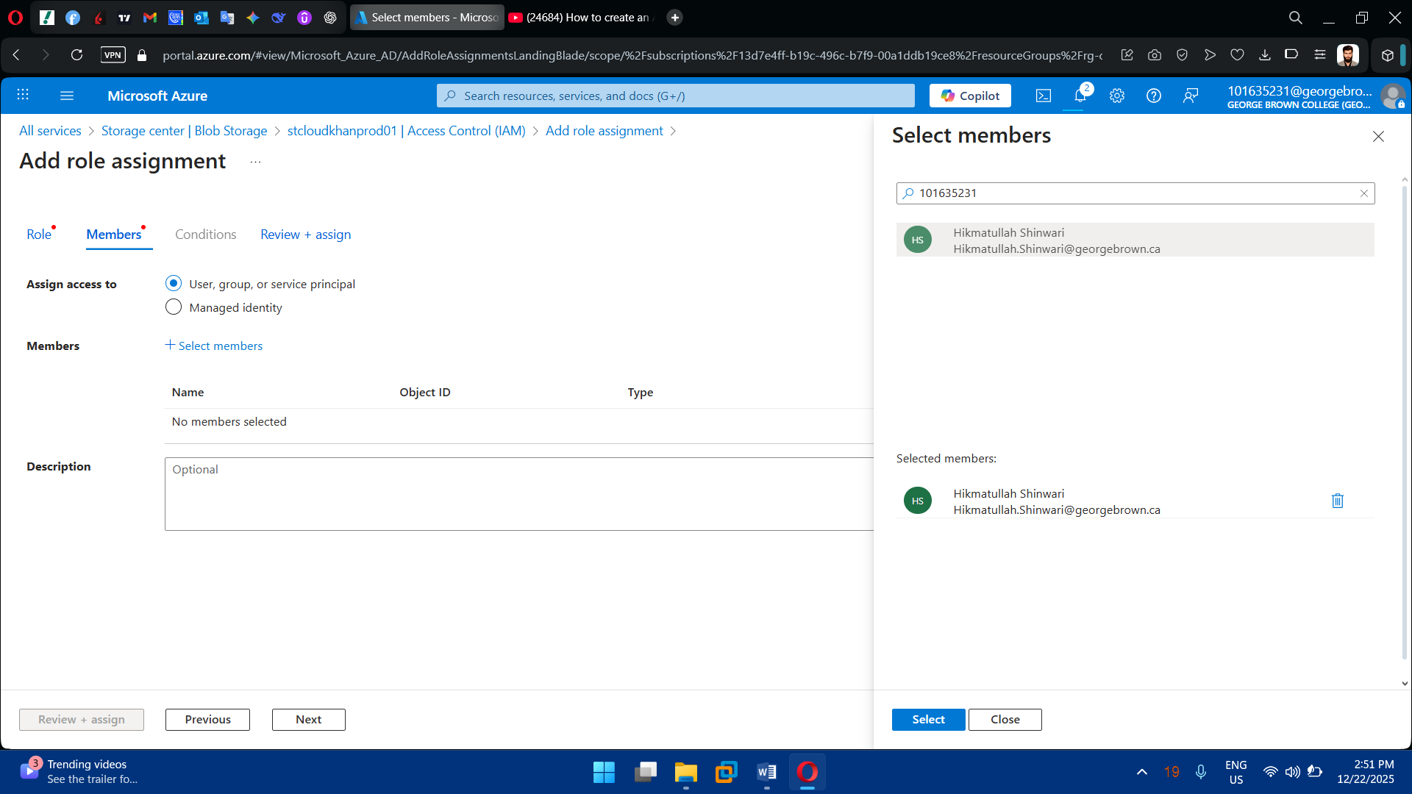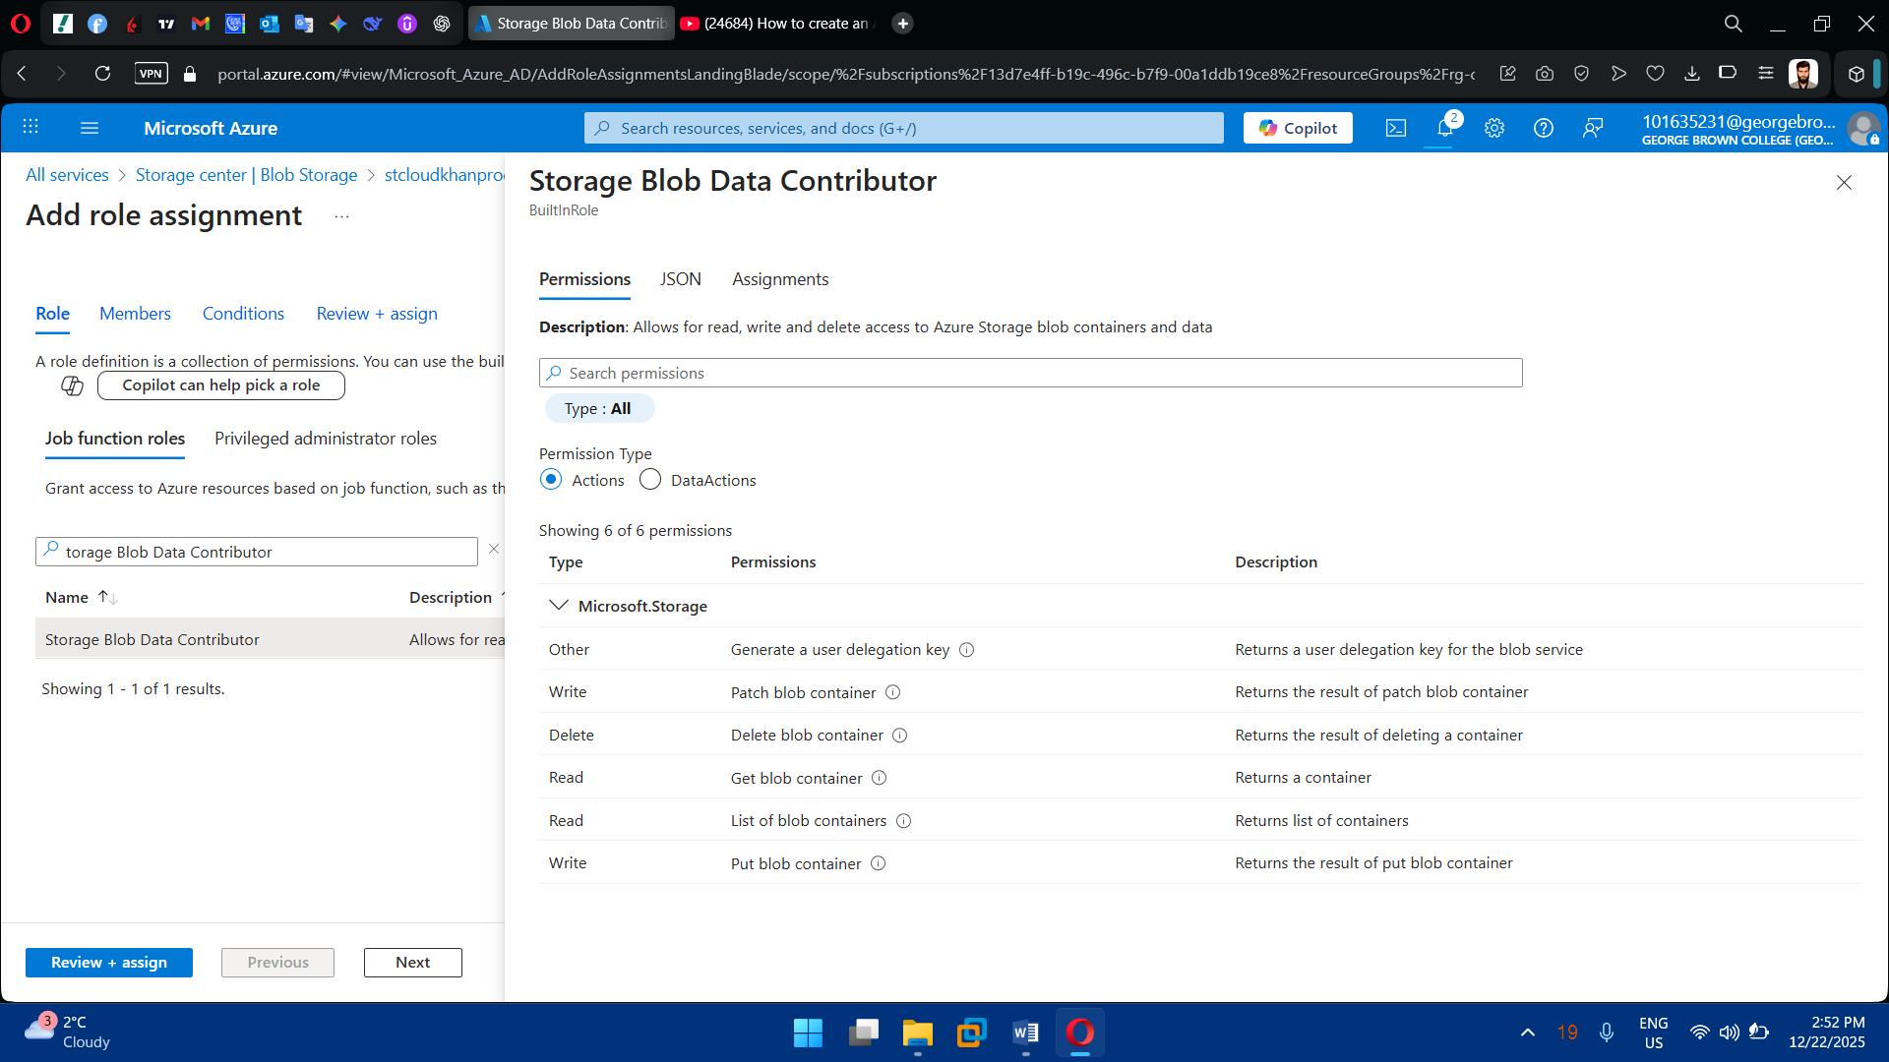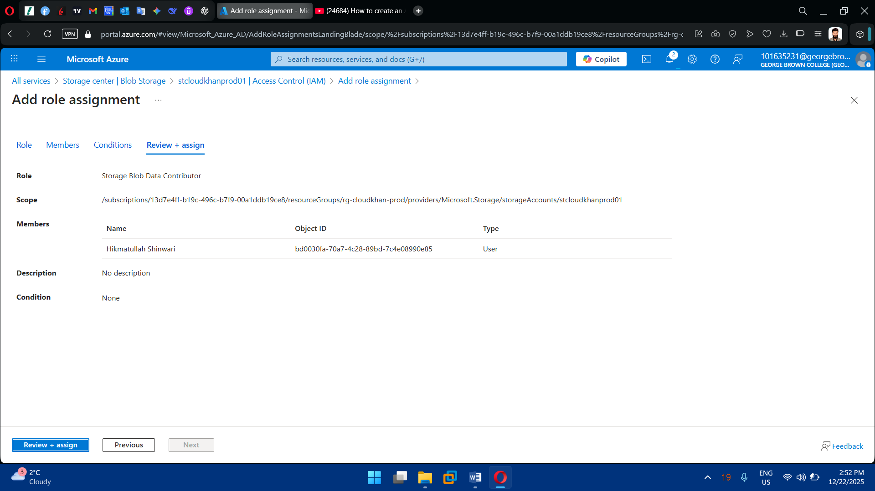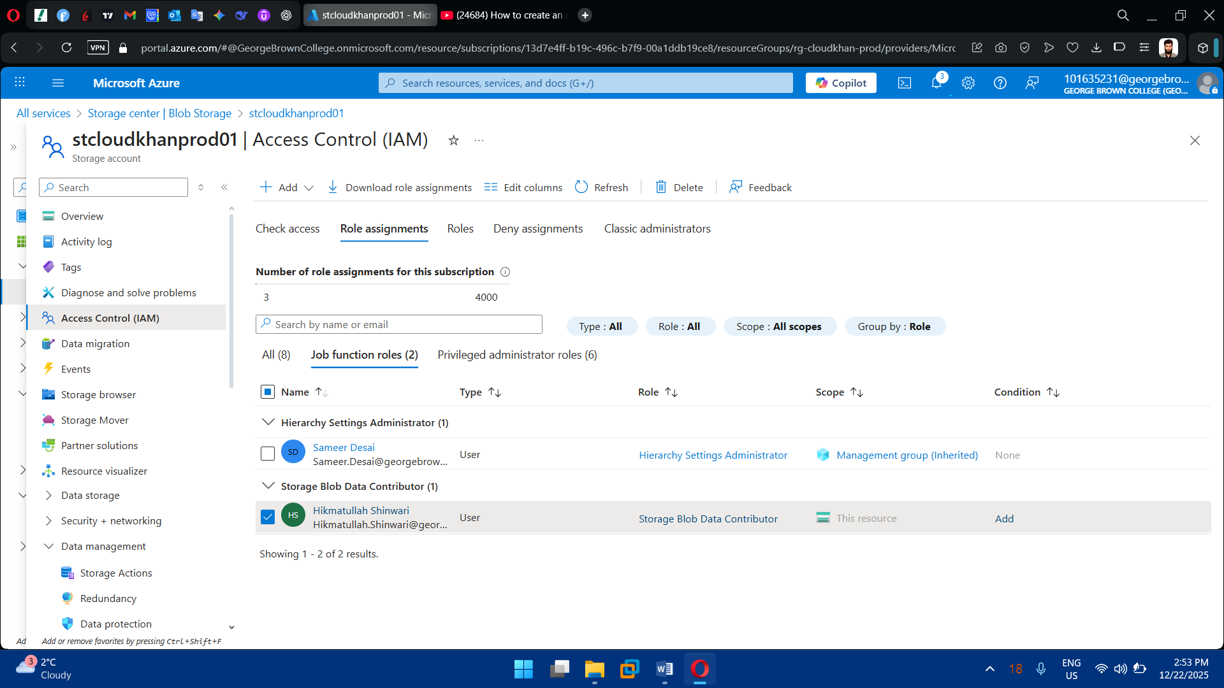

**Task 6: Secrets & Key Management**

1. Deploy Azure Key Vault

* Create Key Vault in same region
* Enable:
  + Soft delete
  + Purge protection

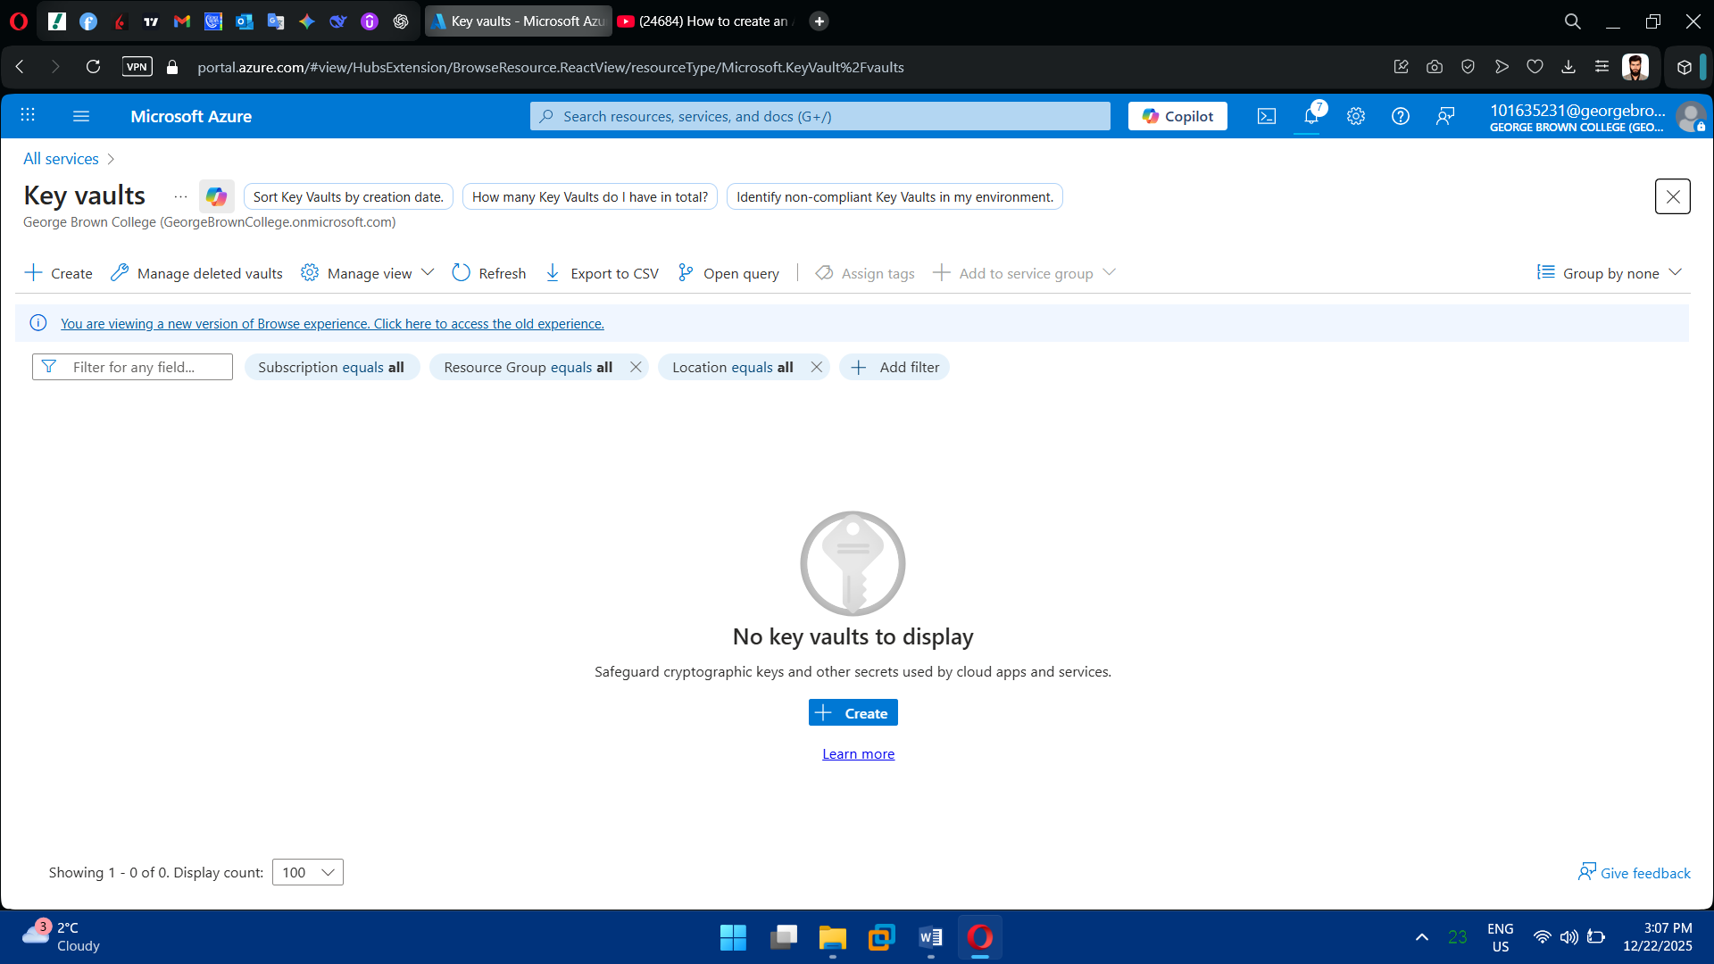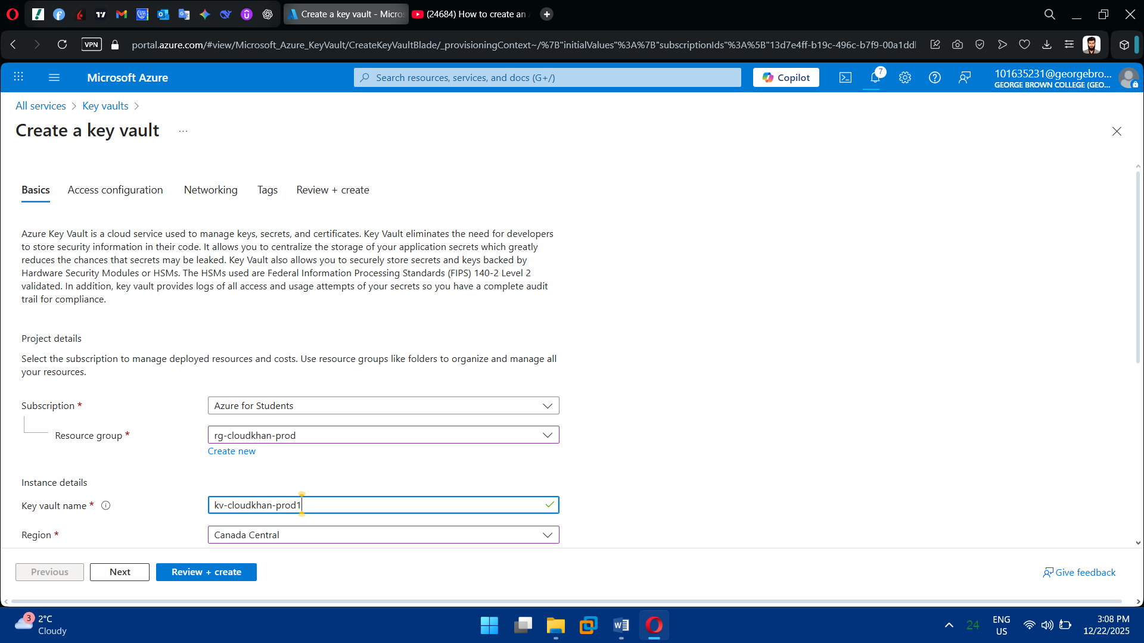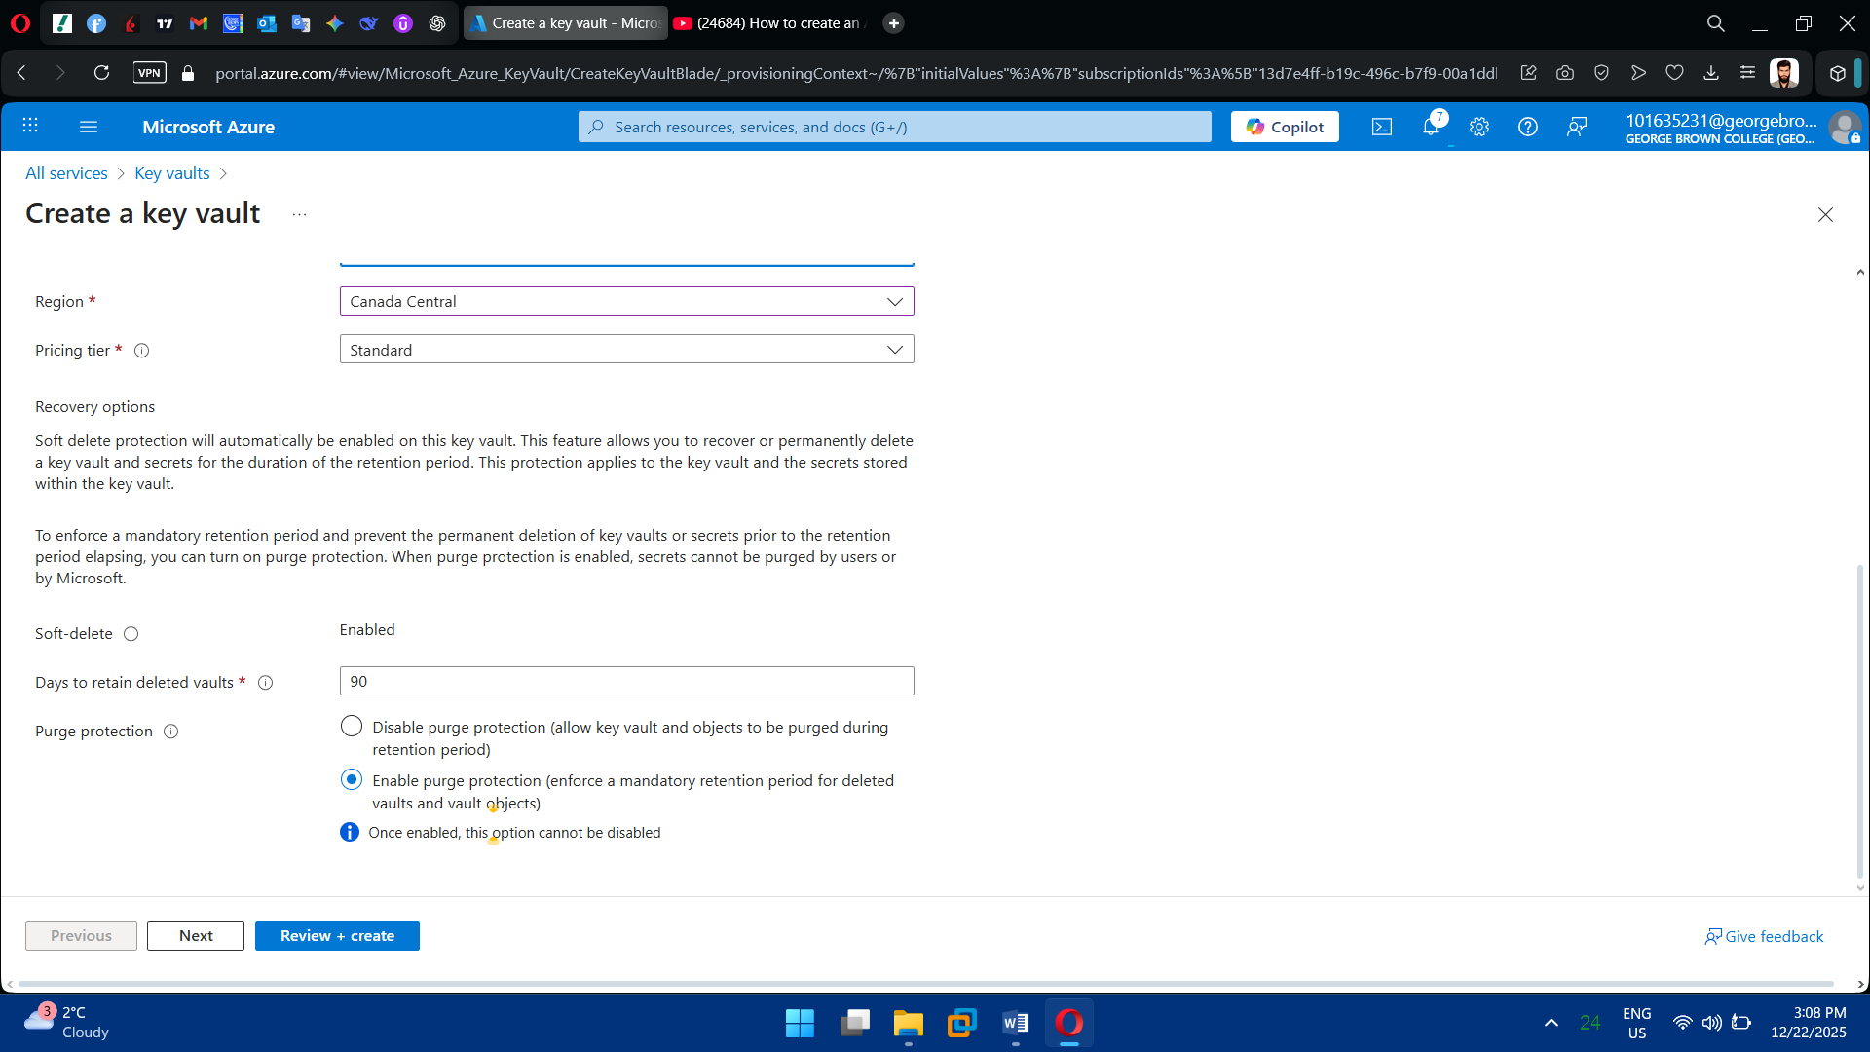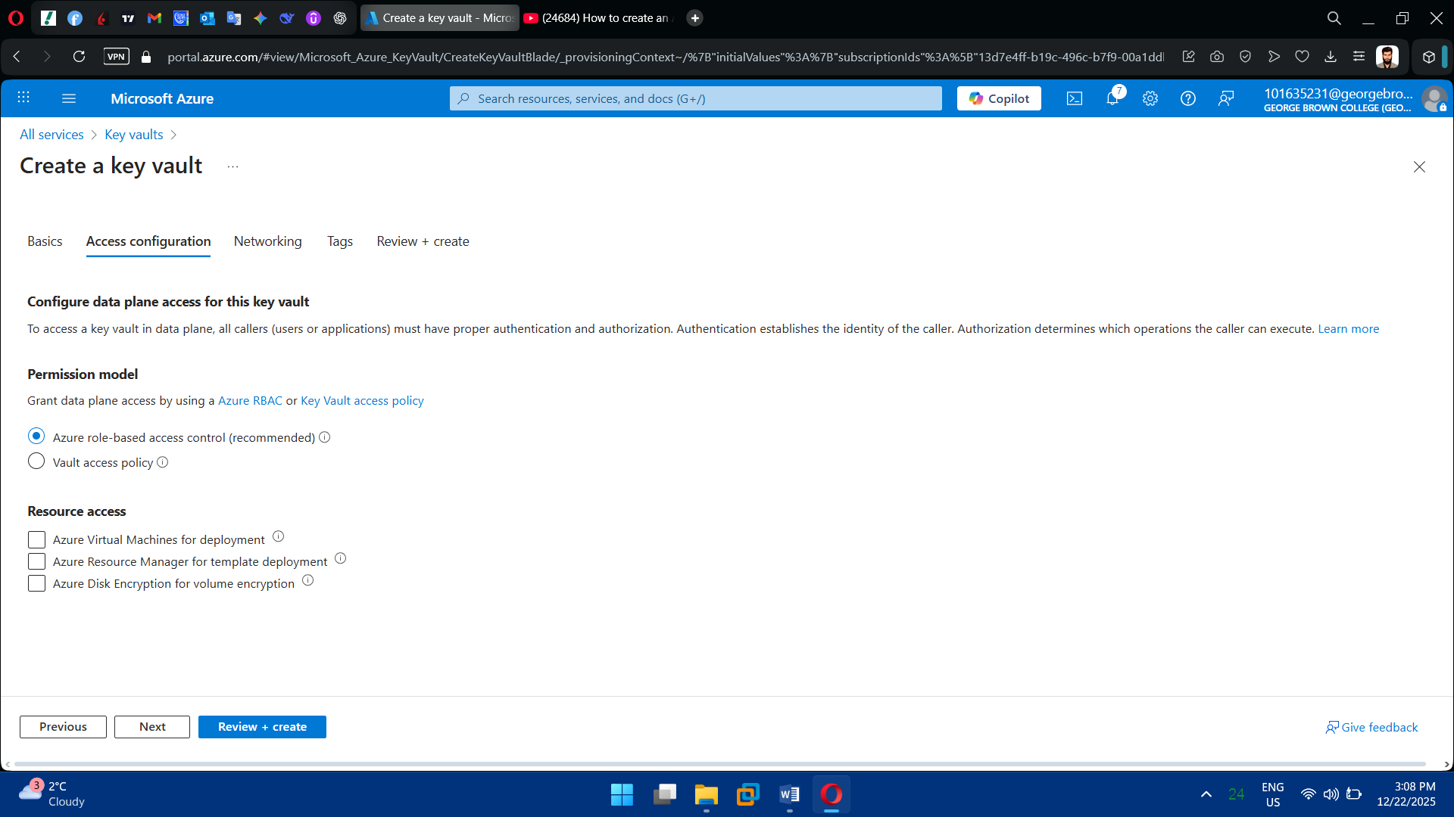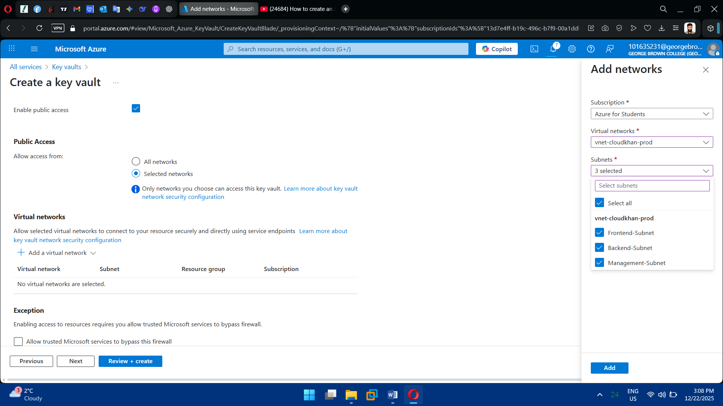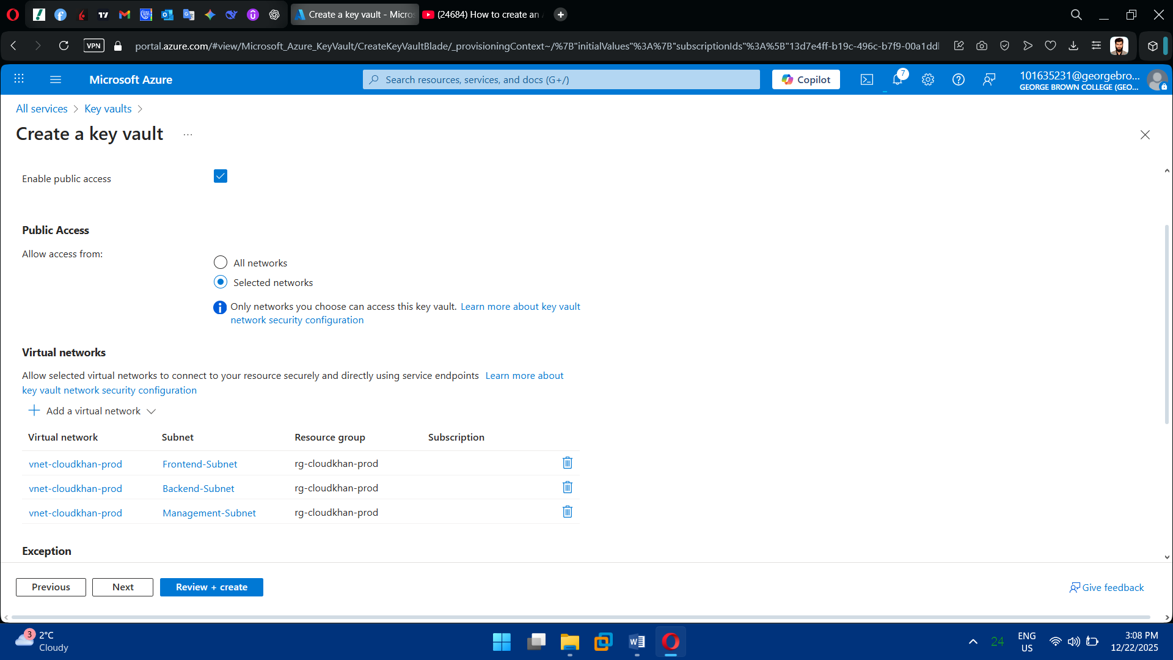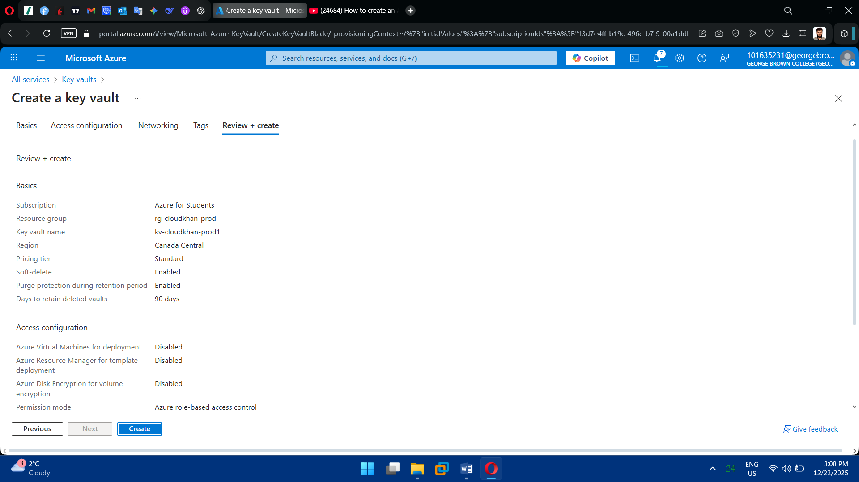

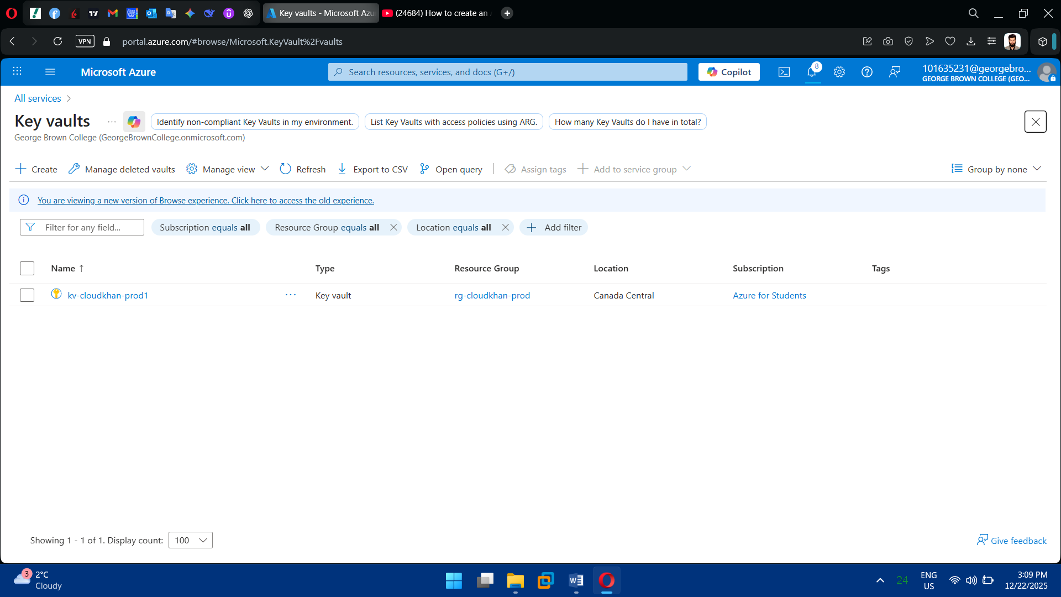

2. Store Secrets

* VM admin passwords
* Storage account keys
* SSH private keys (optional)

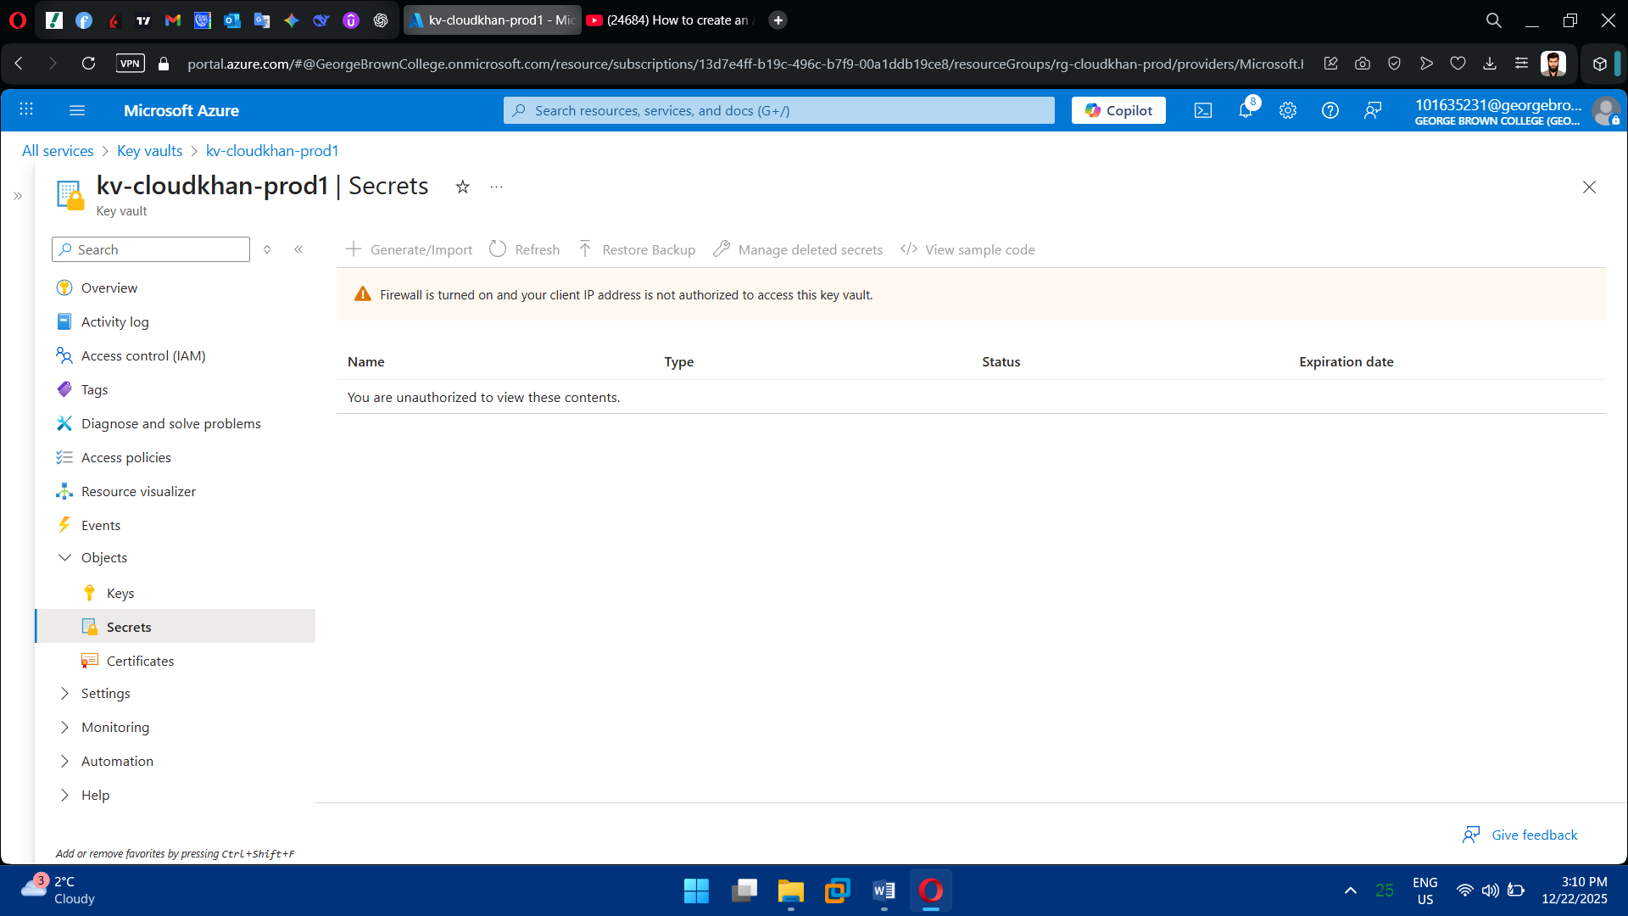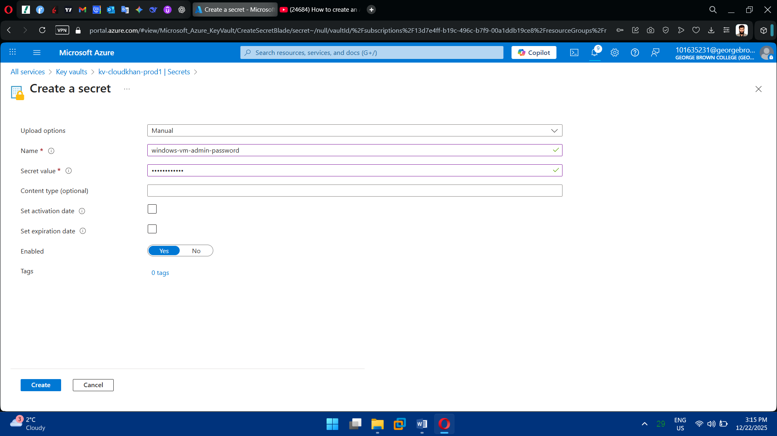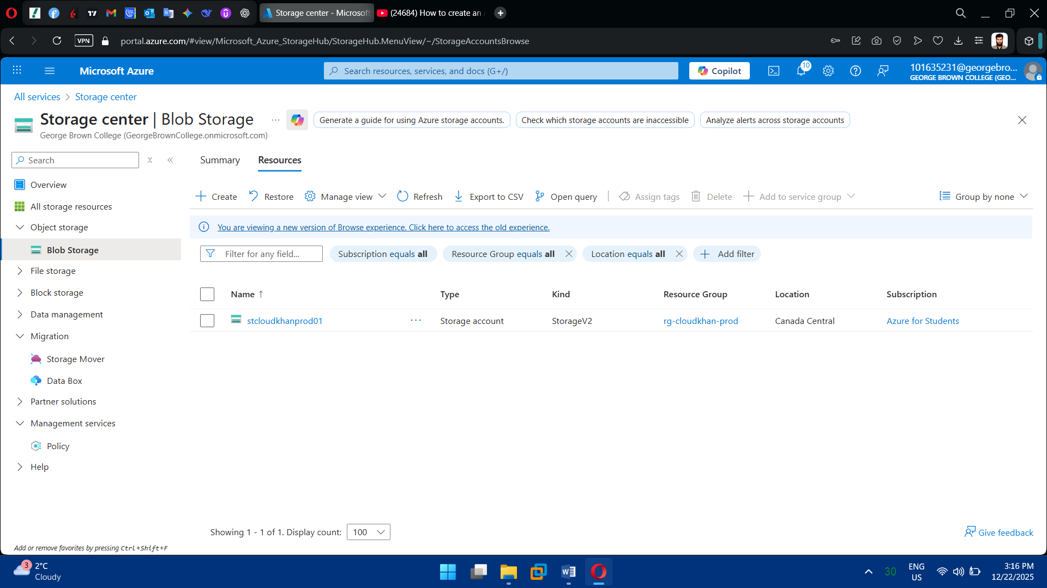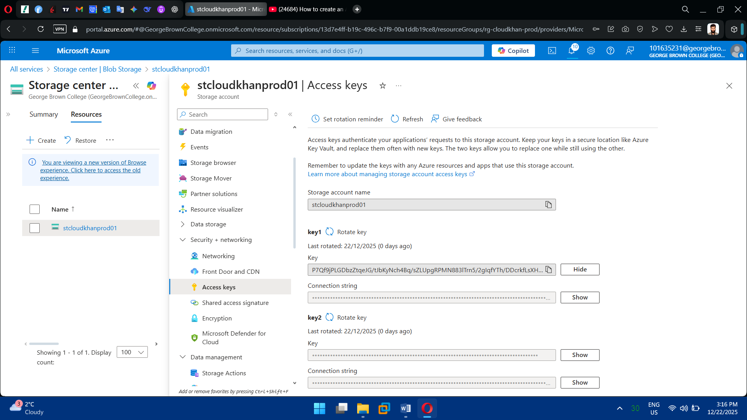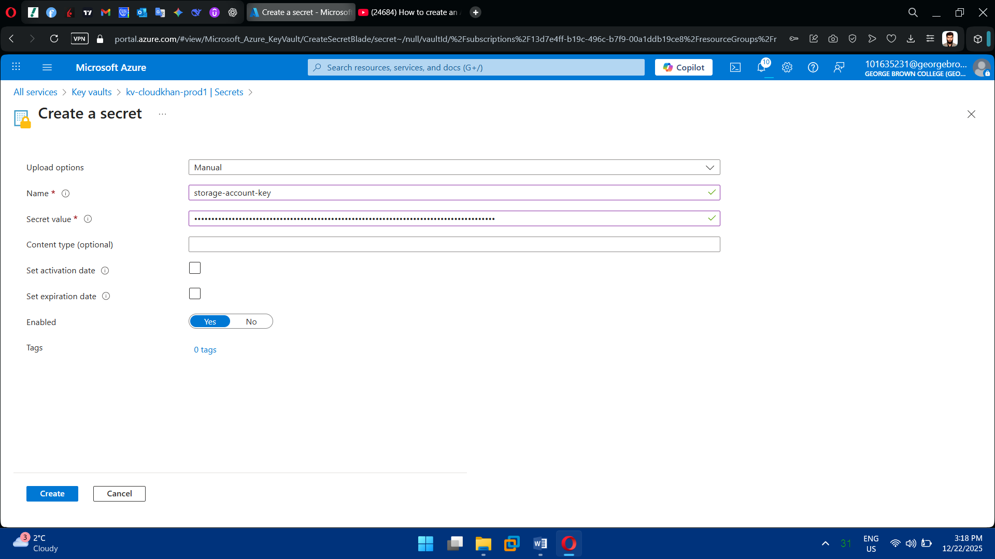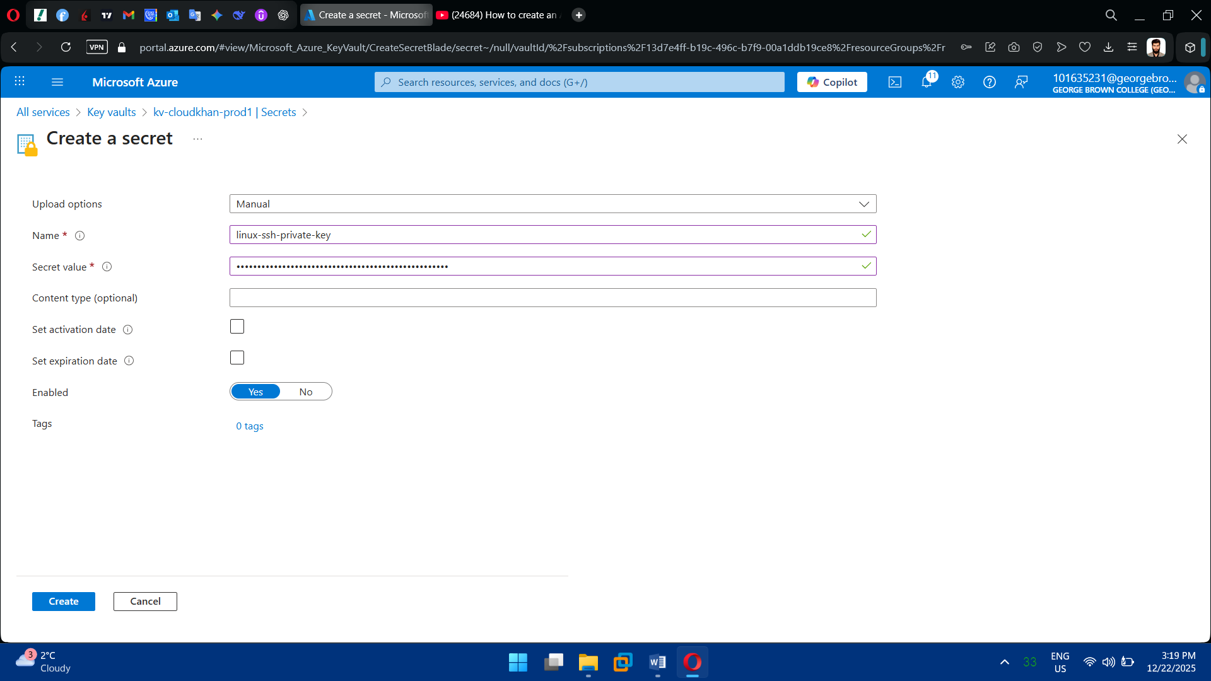

**3.** Configure Access Policies / RBAC

* Allow VM or admin access to secrets
* Follow least-privilege principle

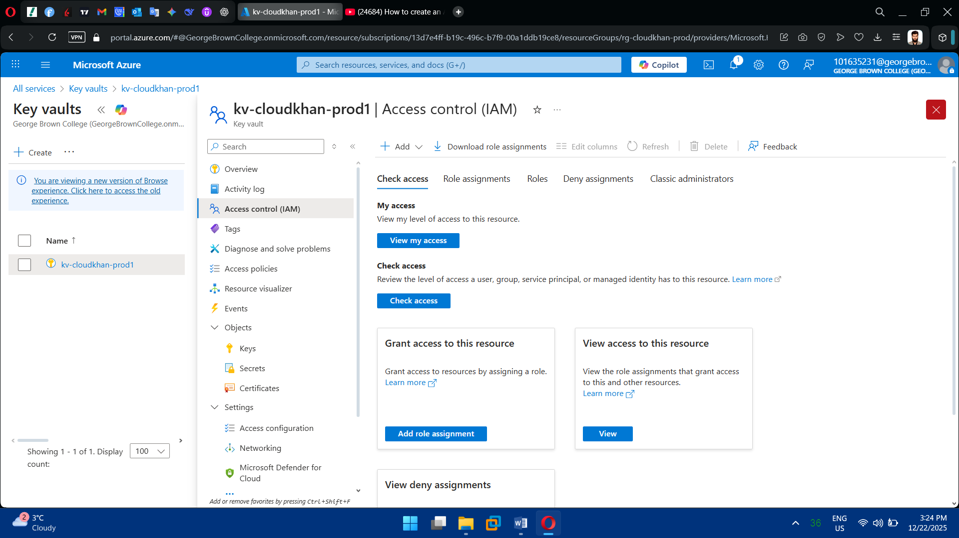

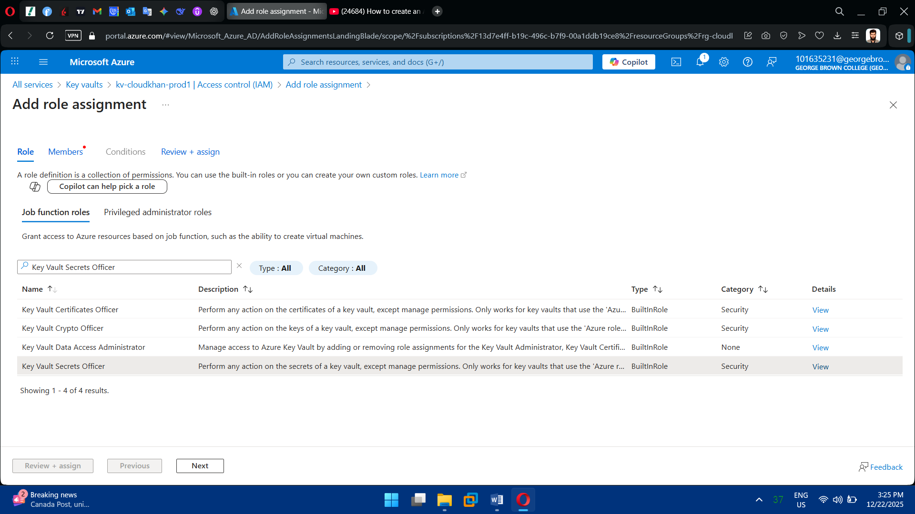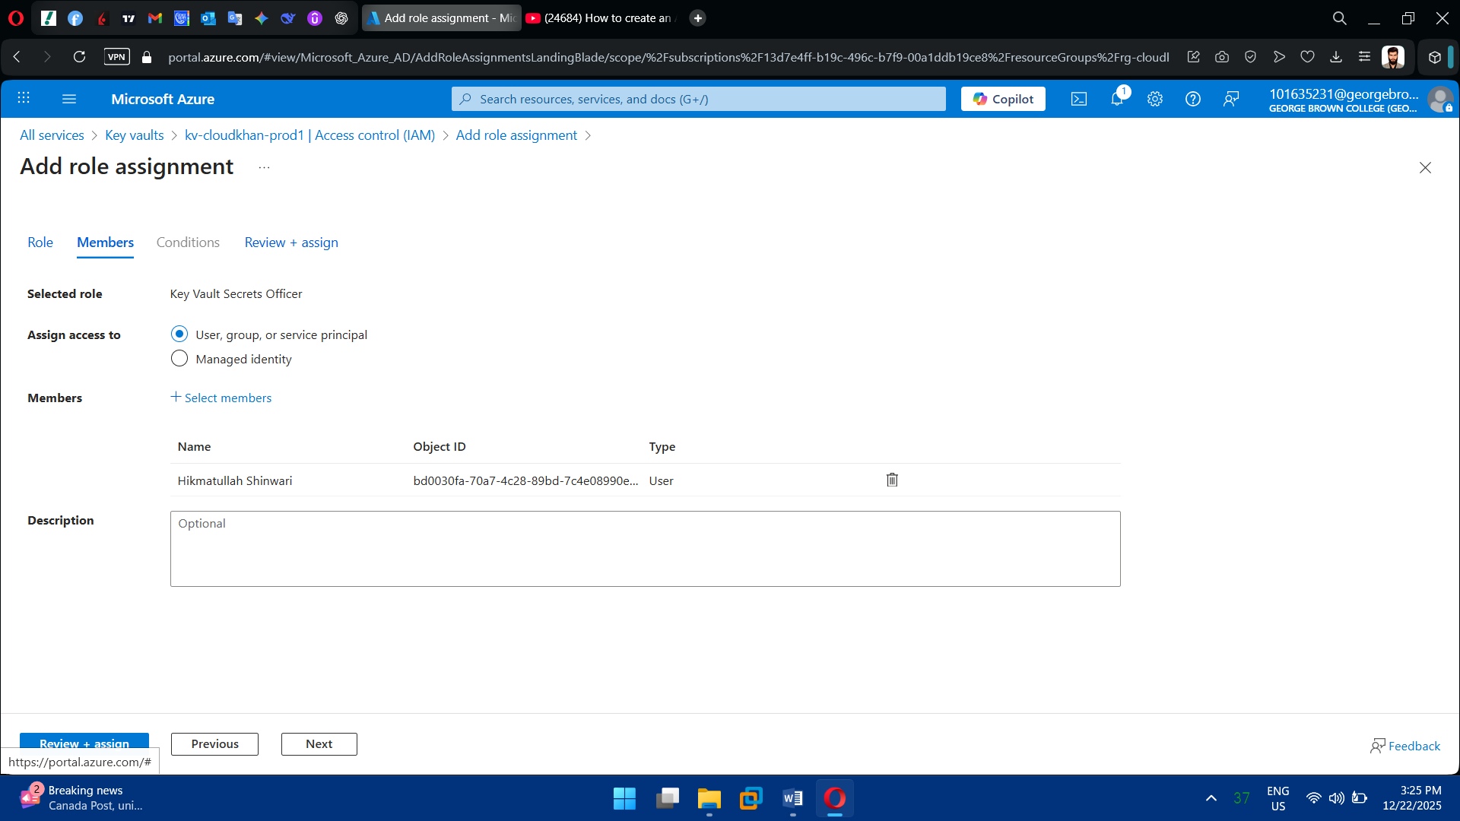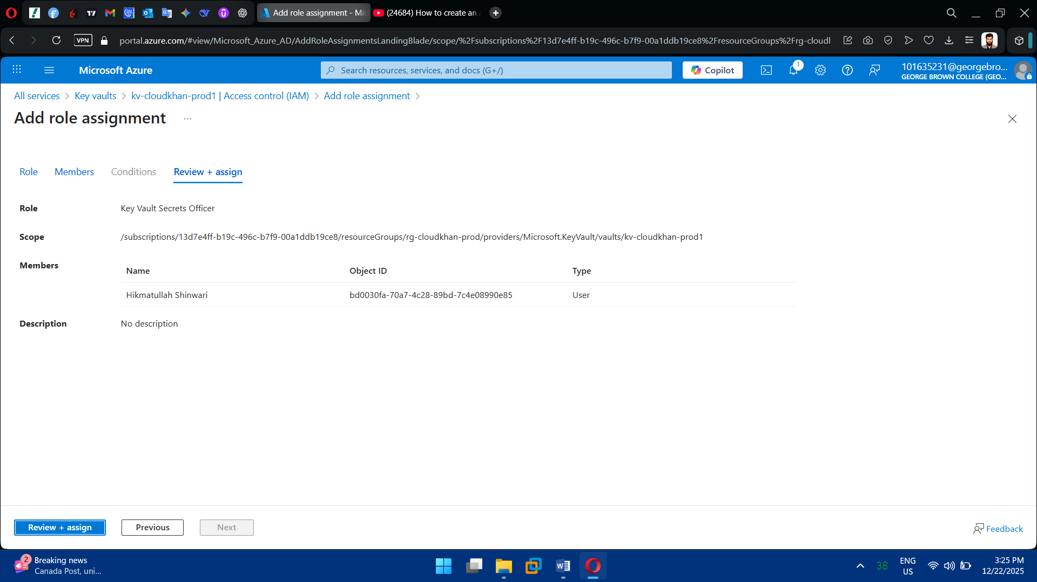

**Task 7: Backup & Recovery Implementation**

1. Create Recovery Services Vault

* Deploy Recovery Services Vault
* Configure storage redundancy

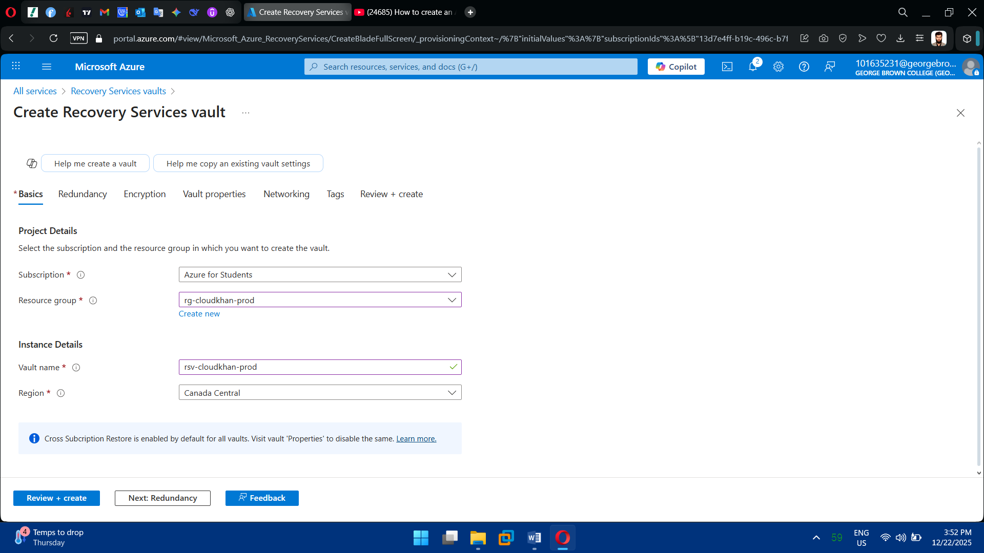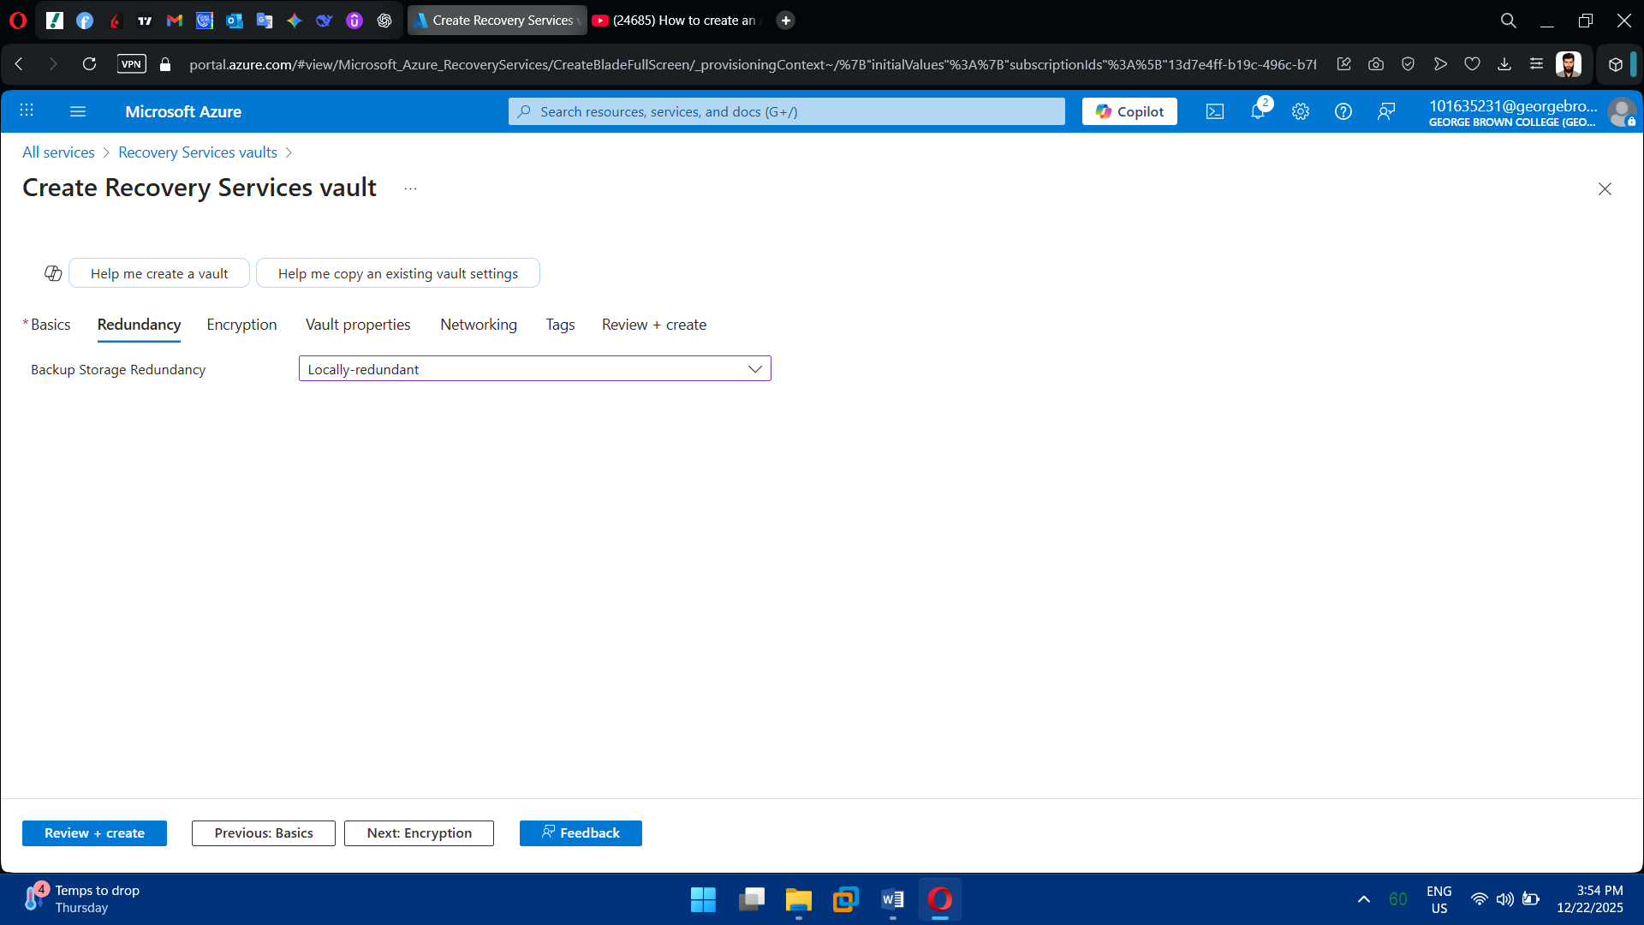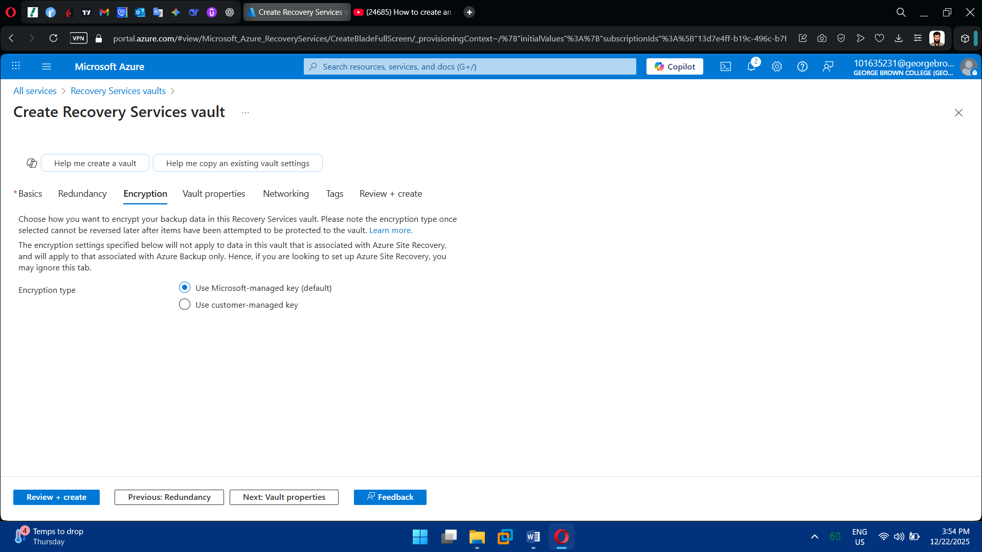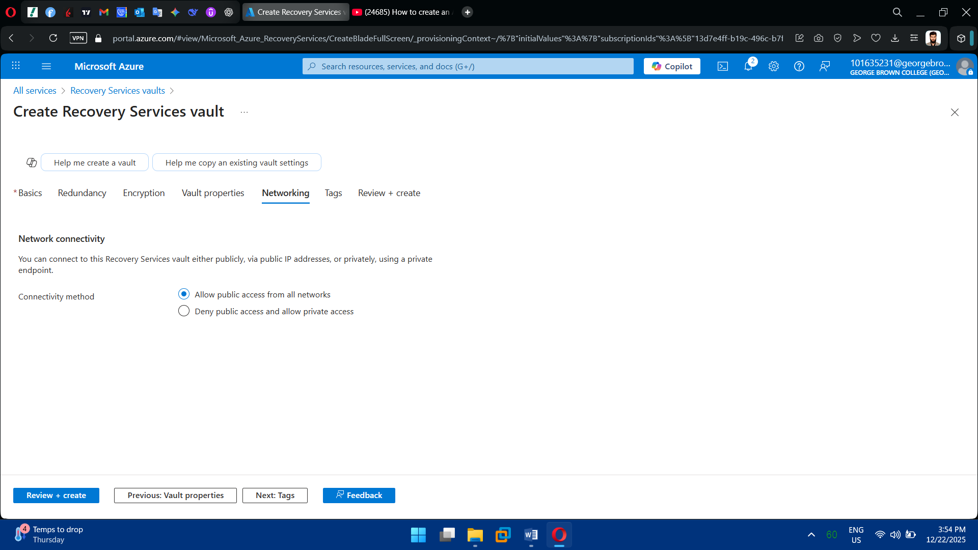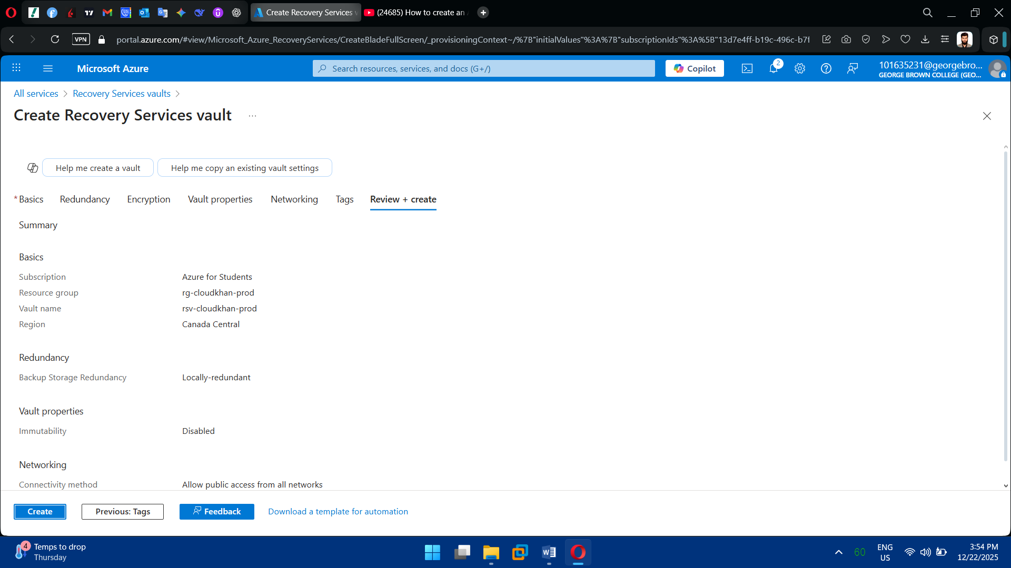

2. Enable Azure Backup for VMs

* Register both Windows & Linux VMs
* Apply backup policy:
  + Daily backup
  + Retention (30 days or more)

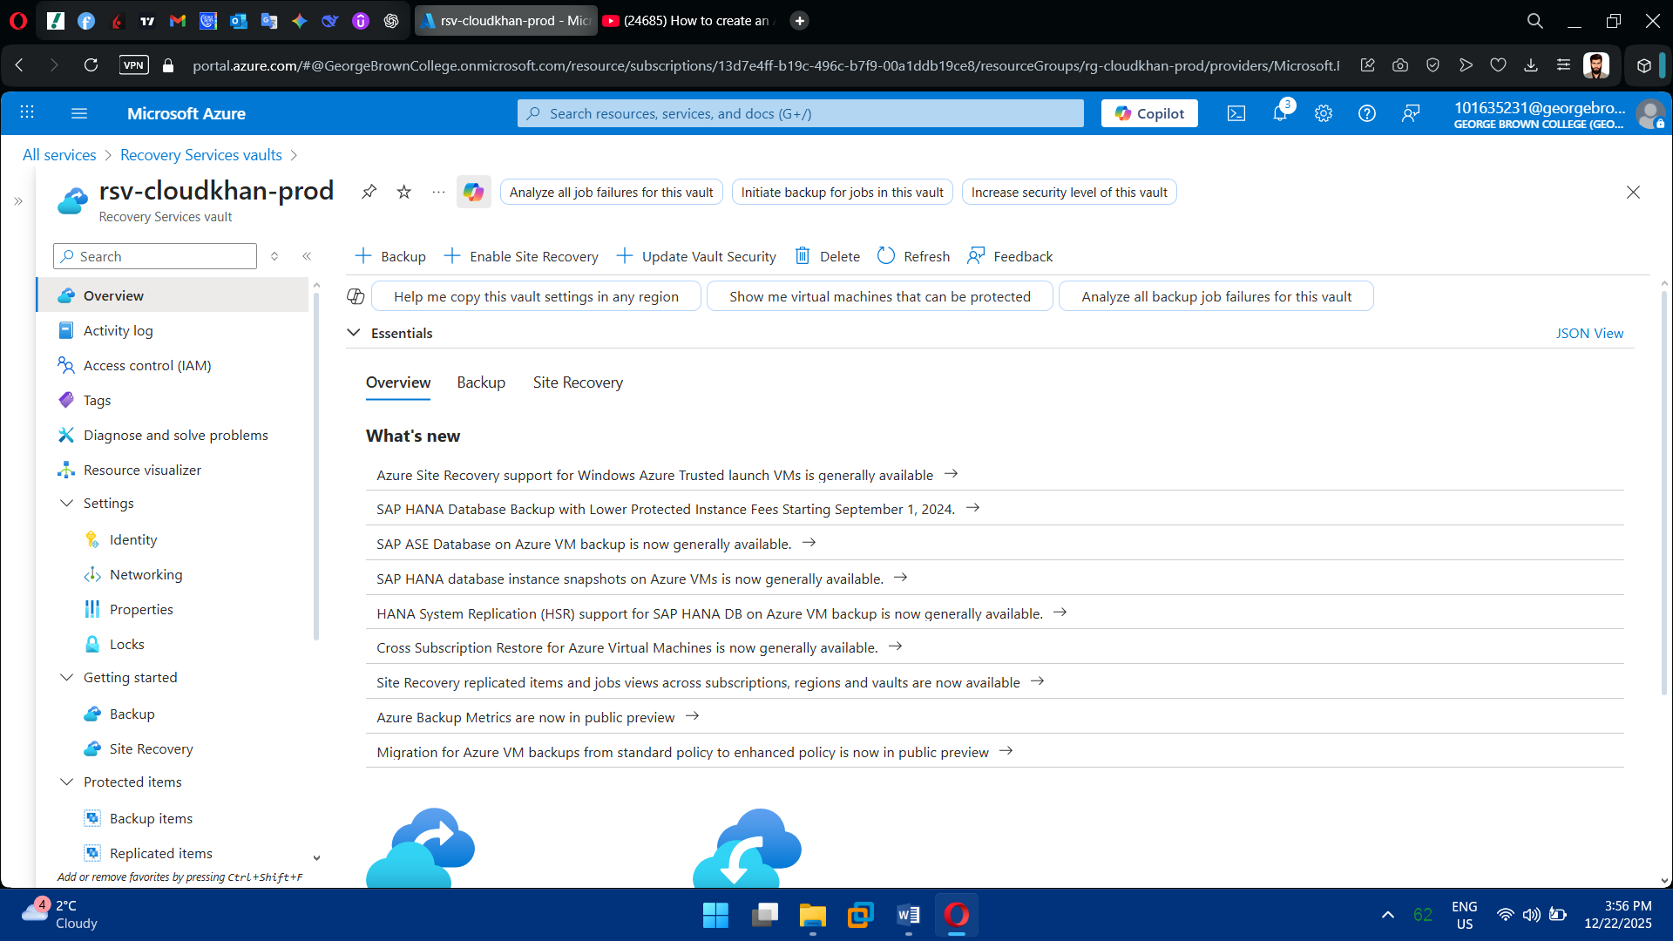

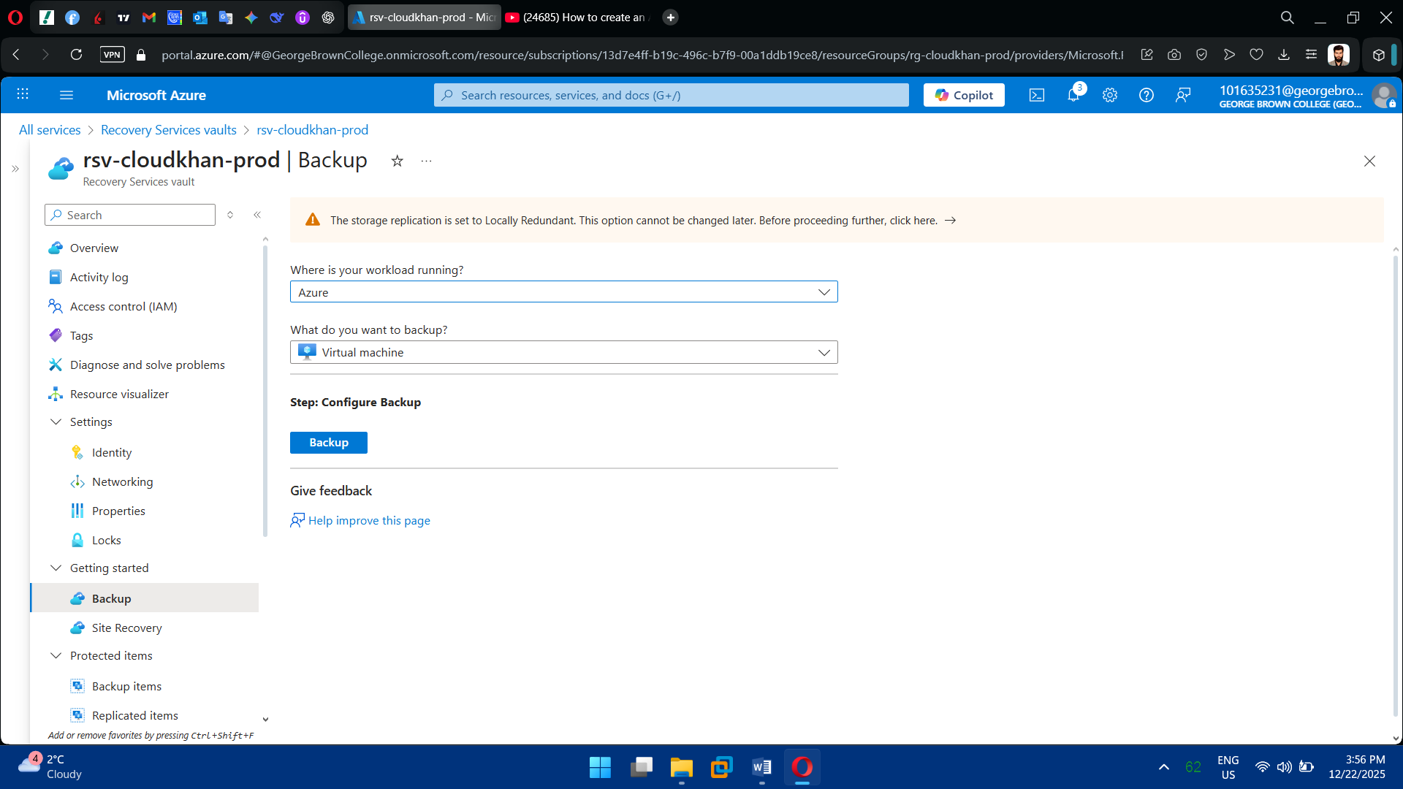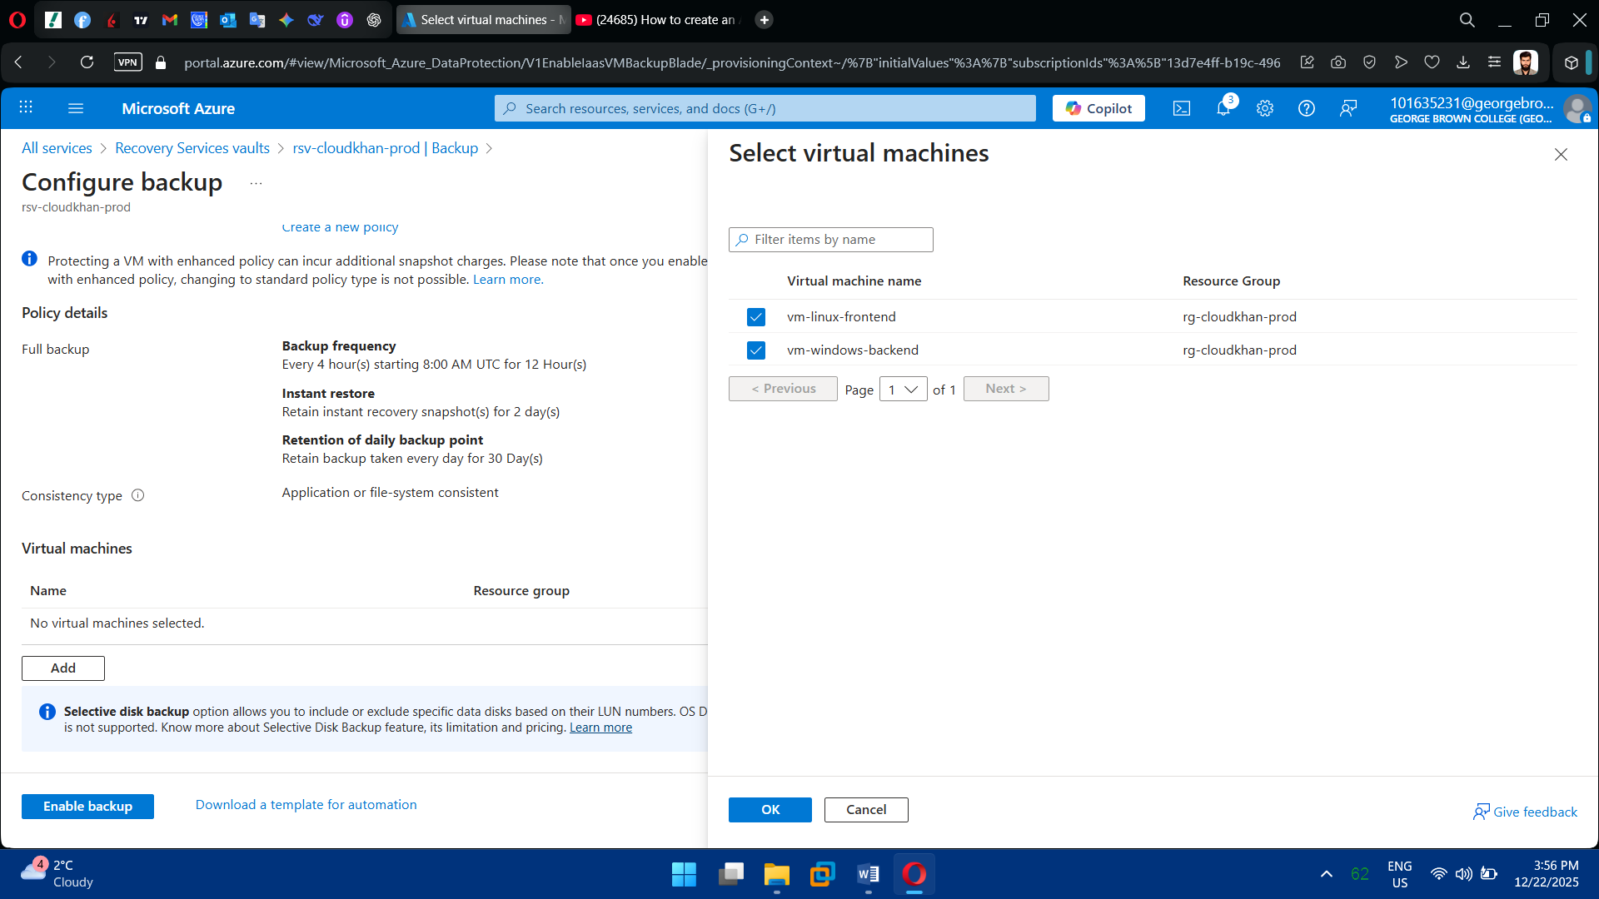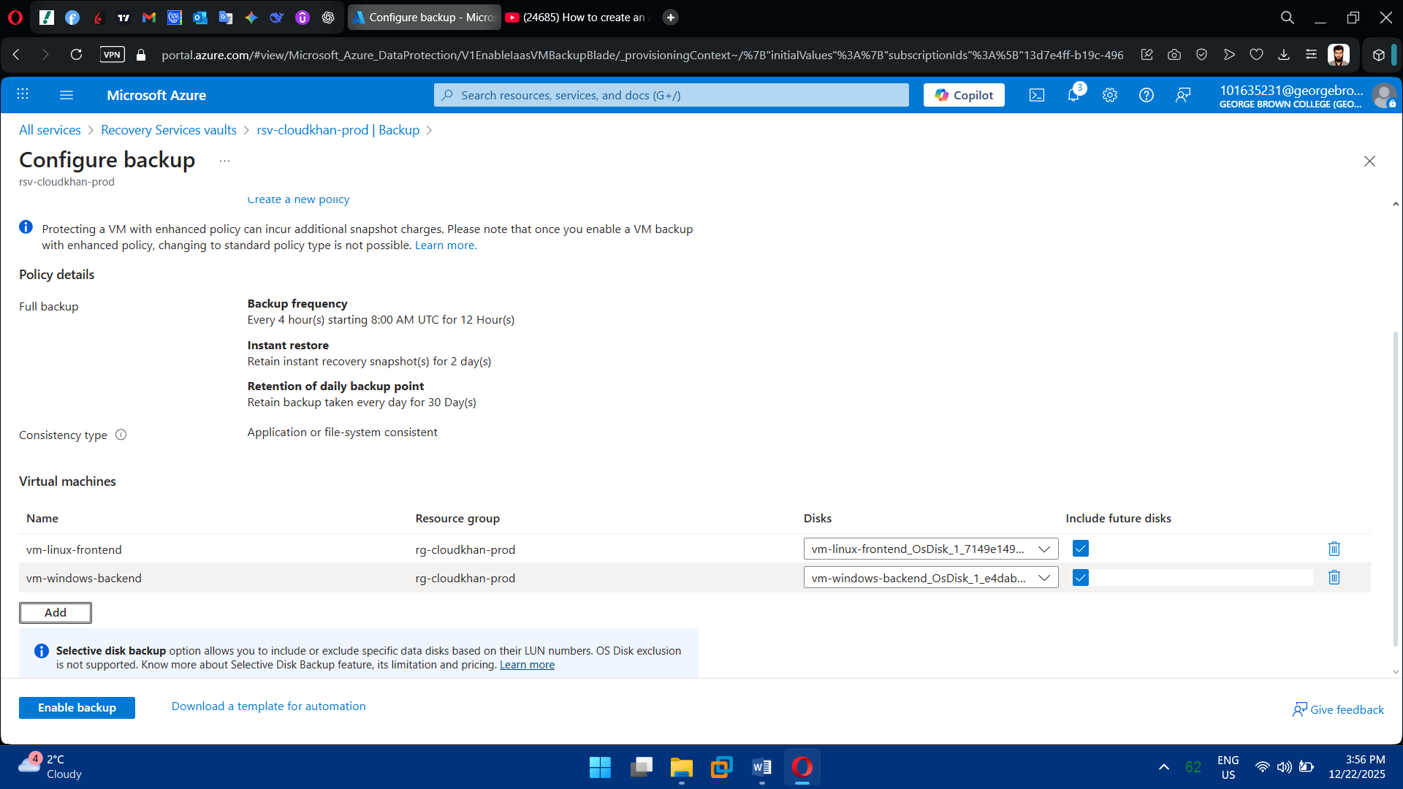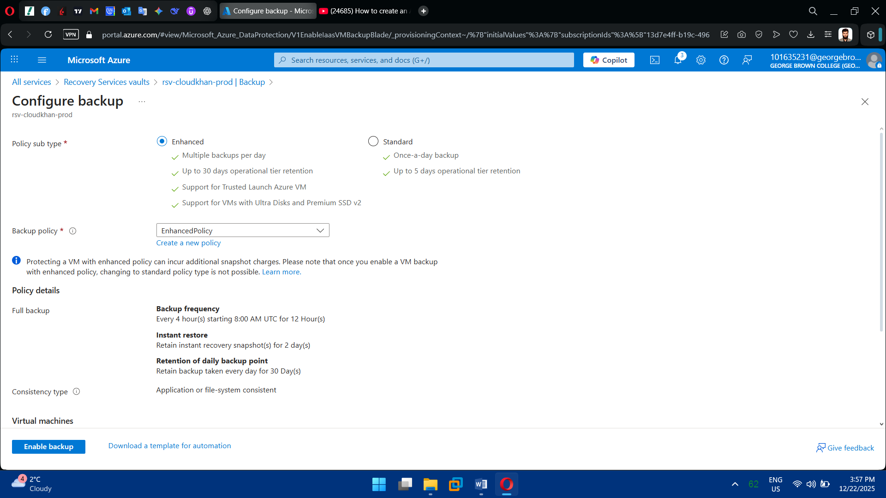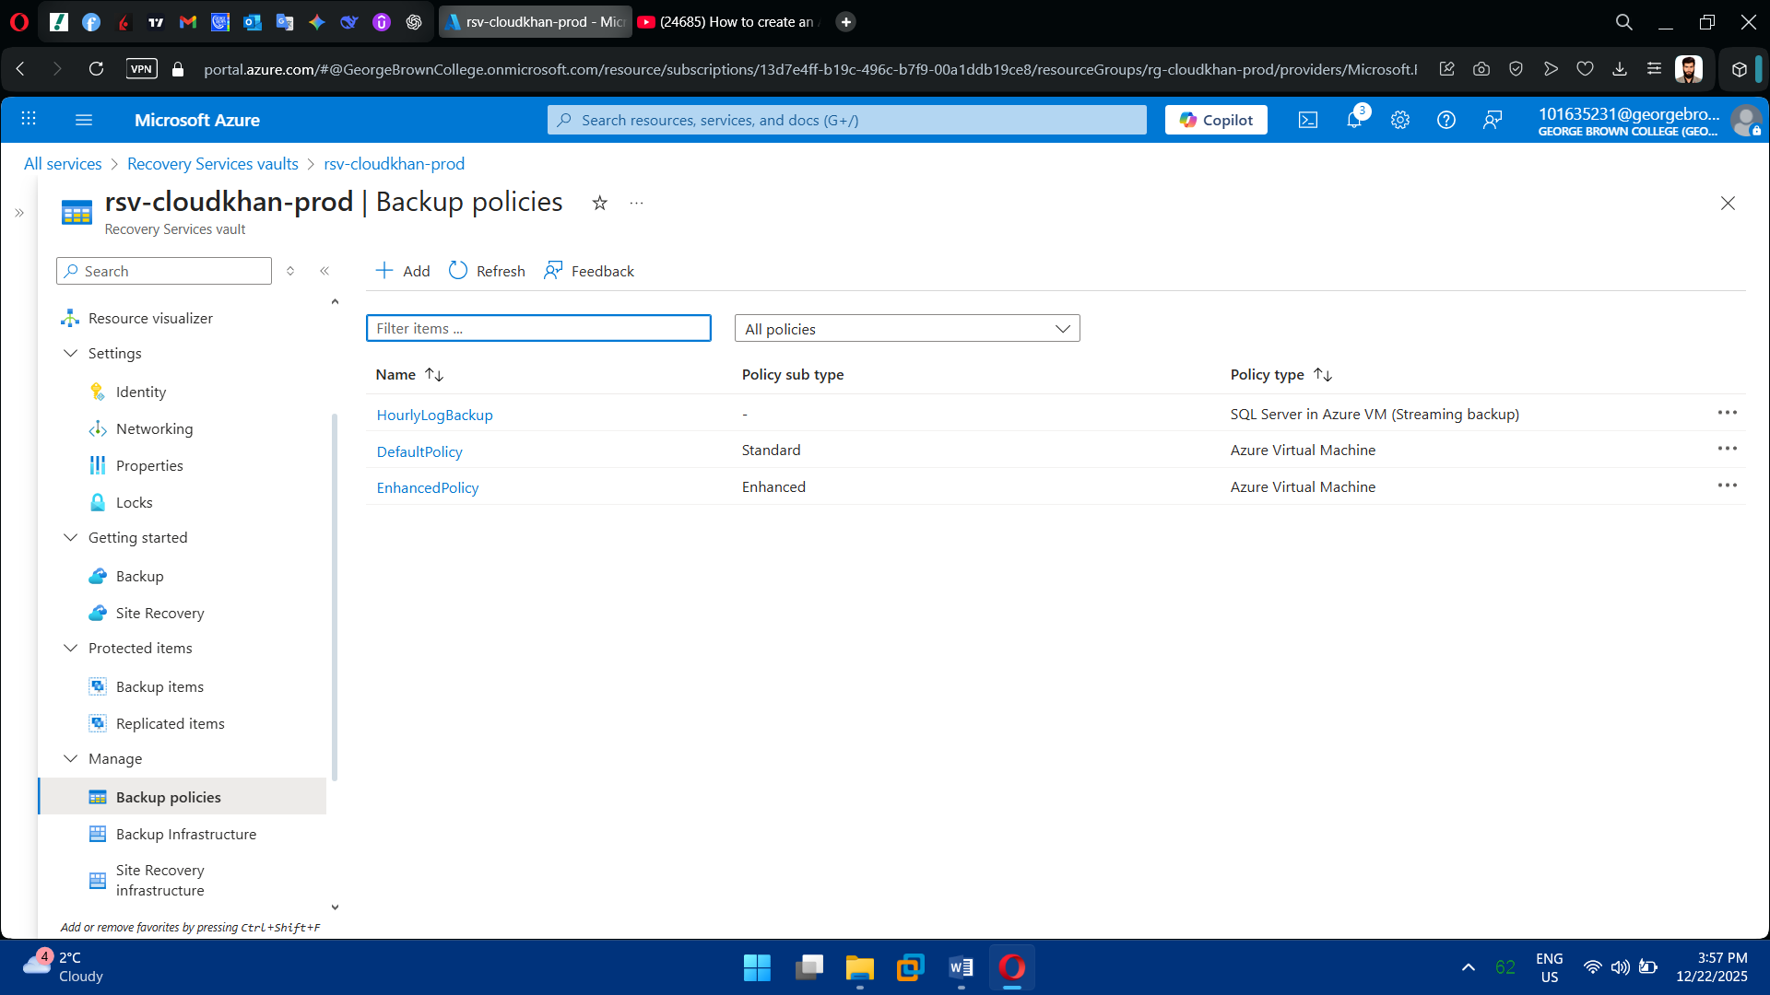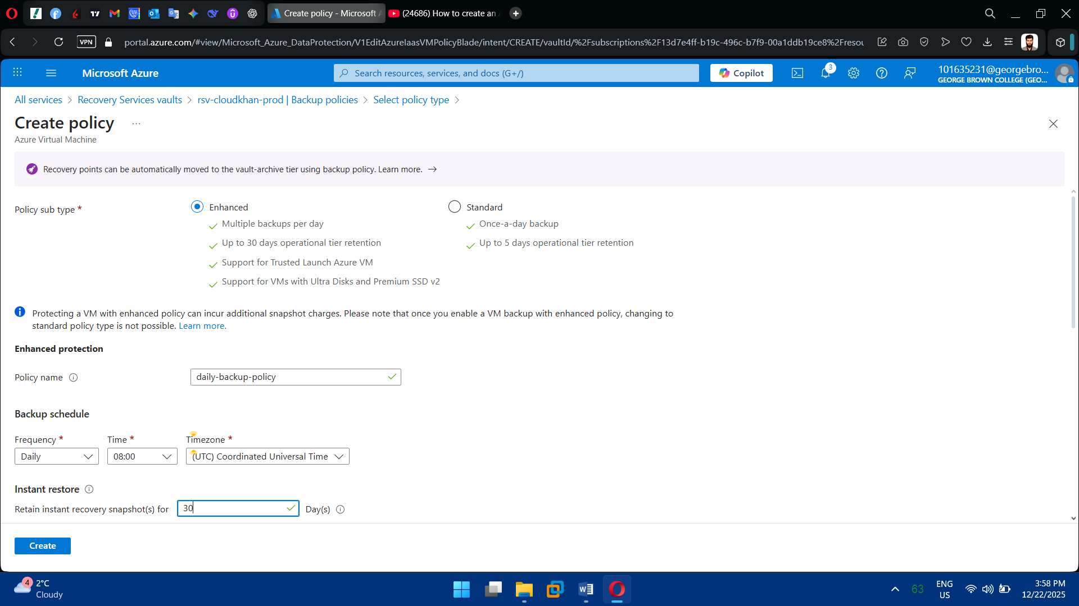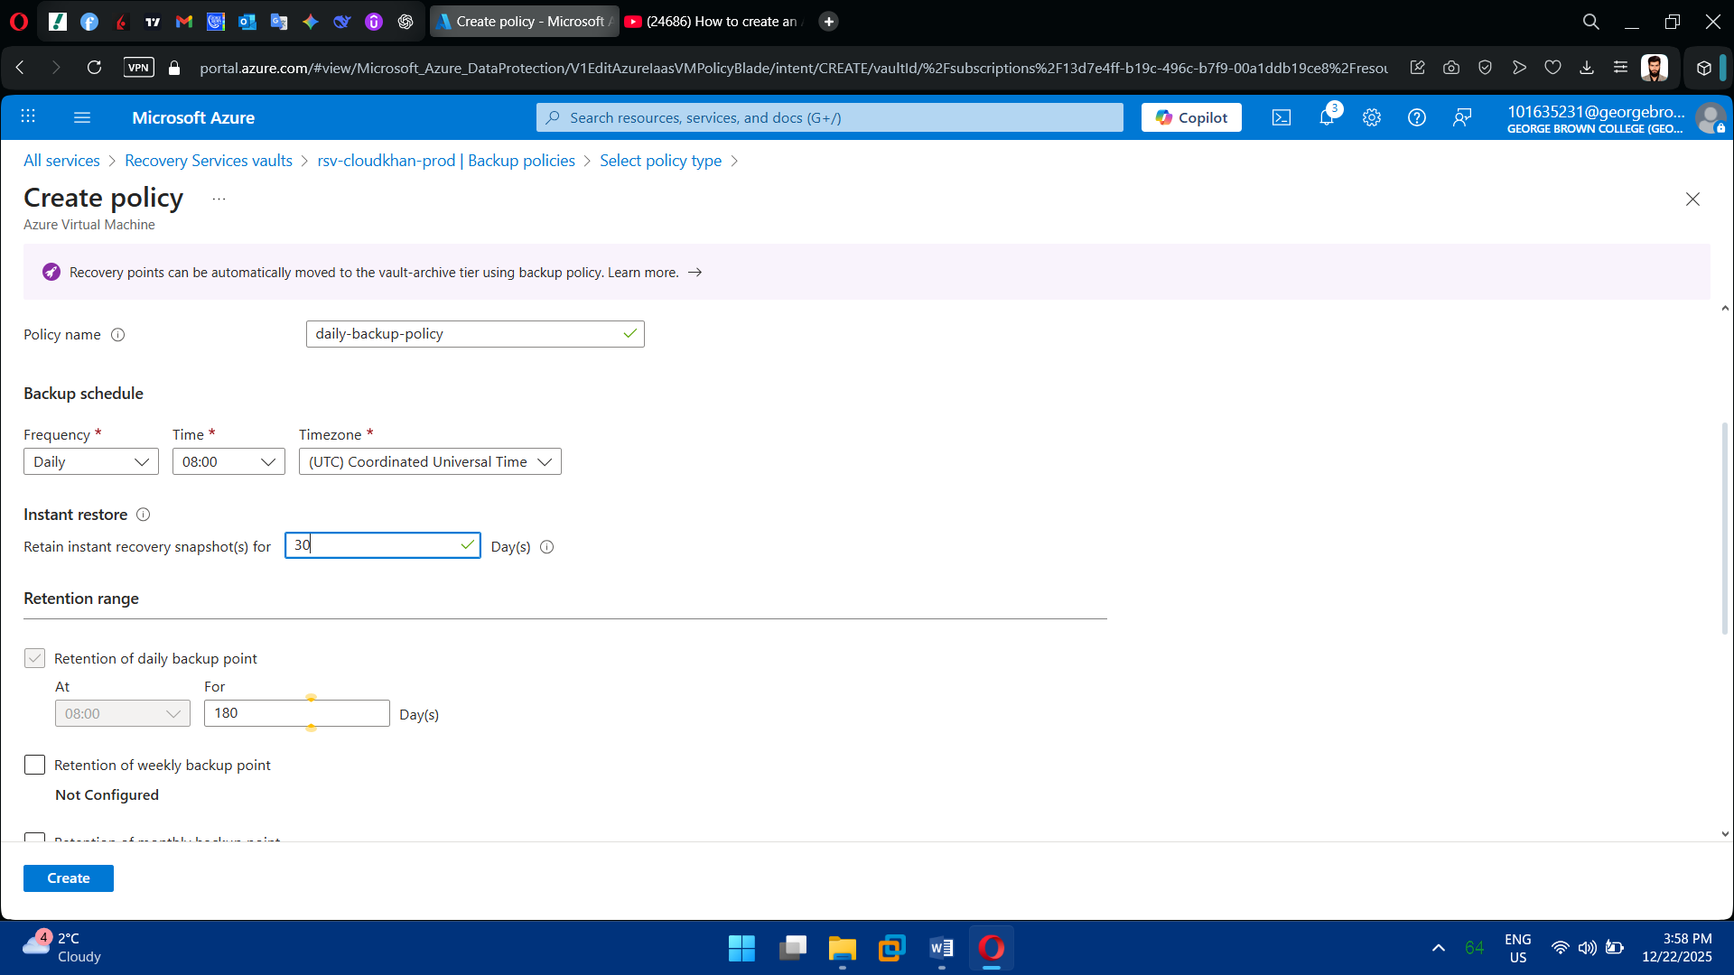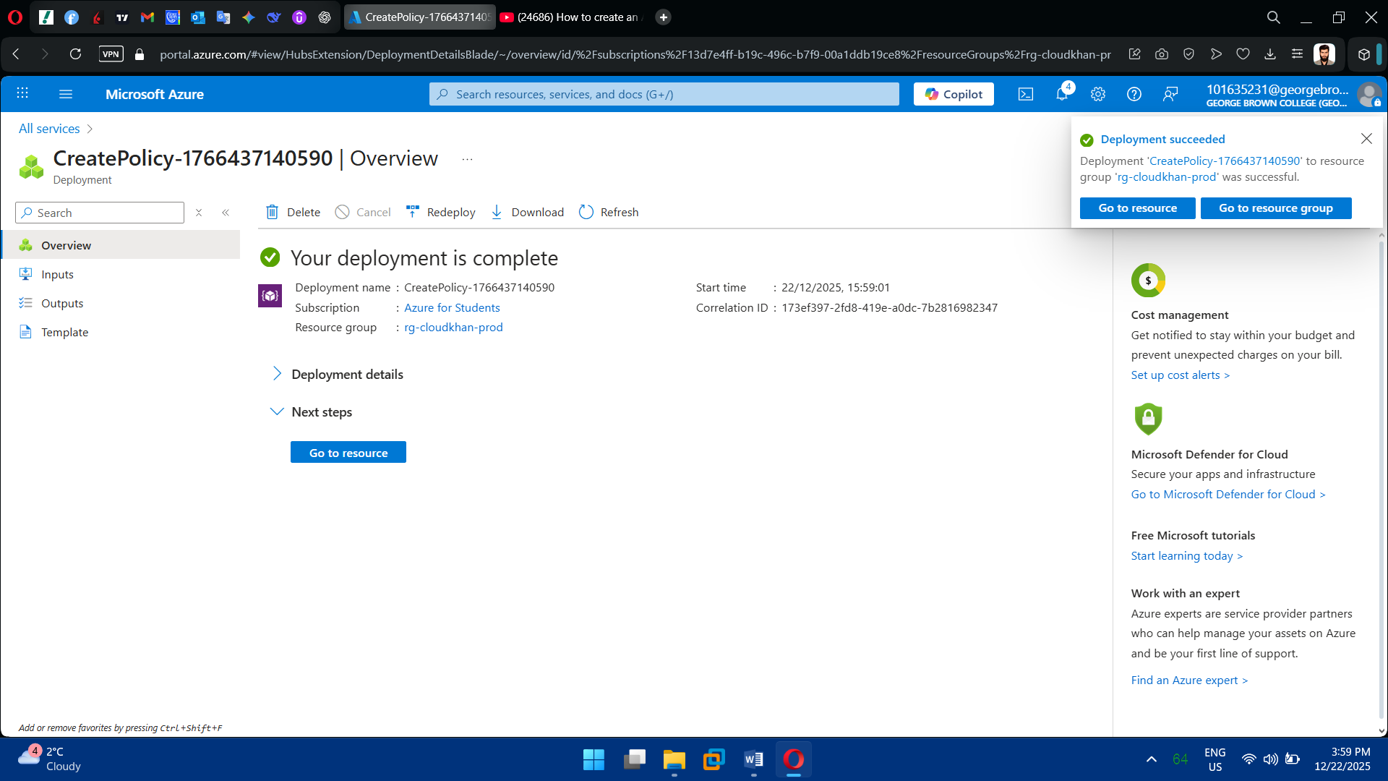

**Task 8: Infrastructure as Code (ARM/Bicep)**

1. Create Bicep Templates

* Main Bicep file (orchestrates deployment)
* Modular templates:
  + Network
  + Compute
  + Storage
  + Security
  + Backup

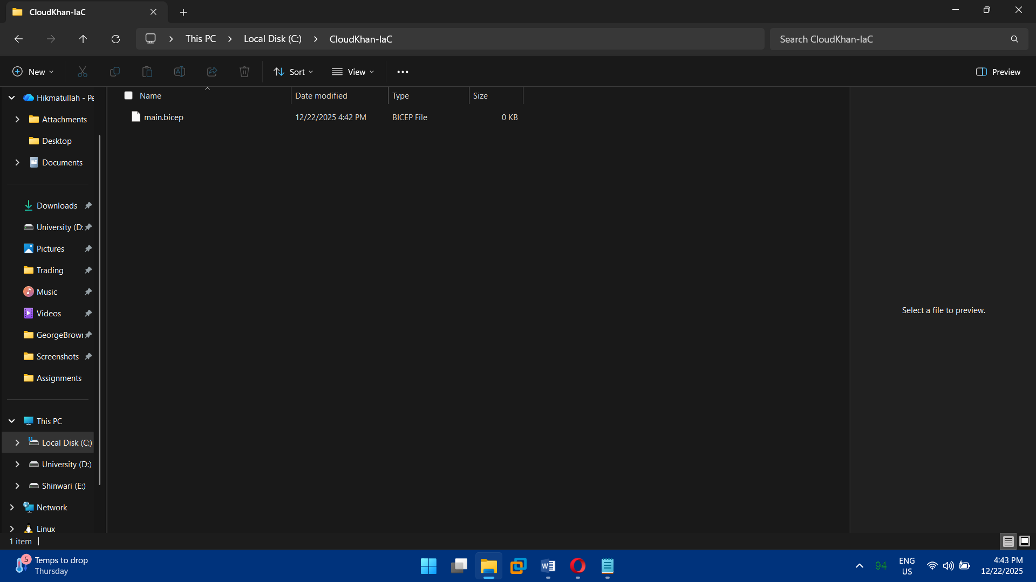

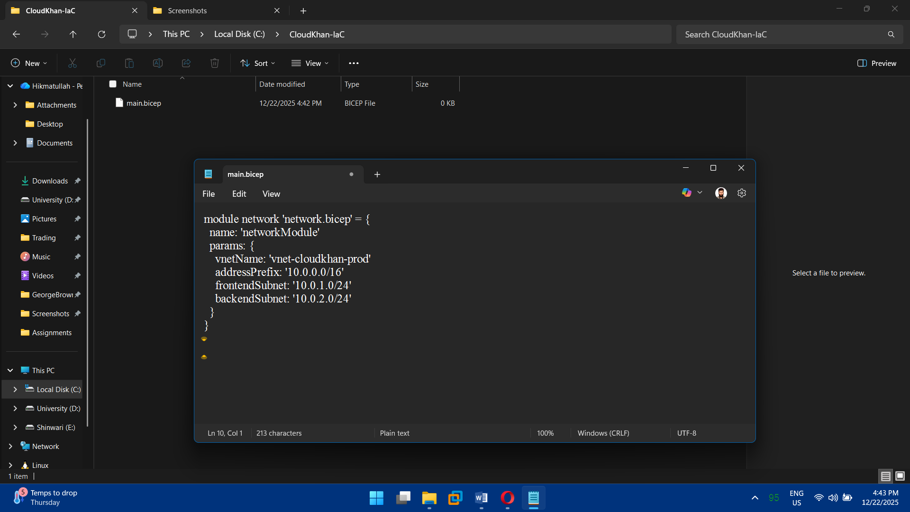

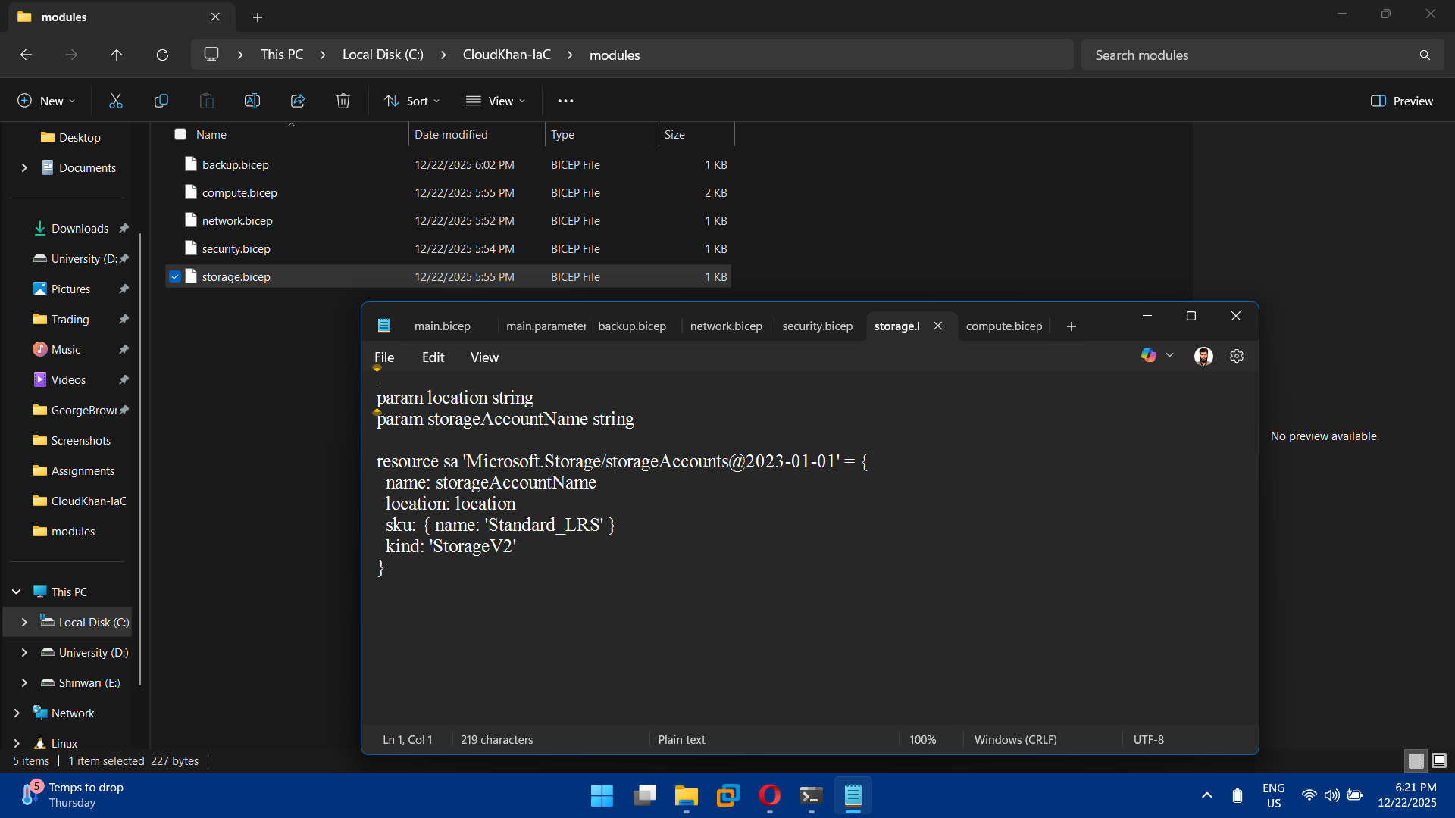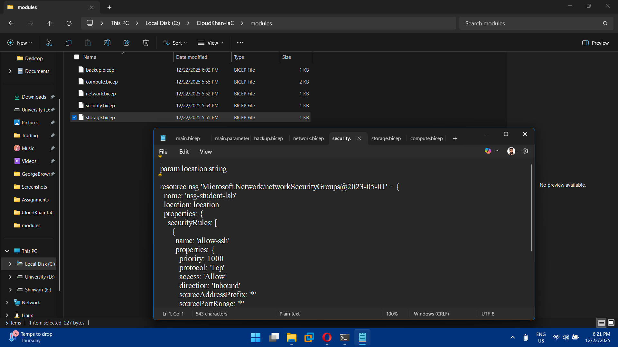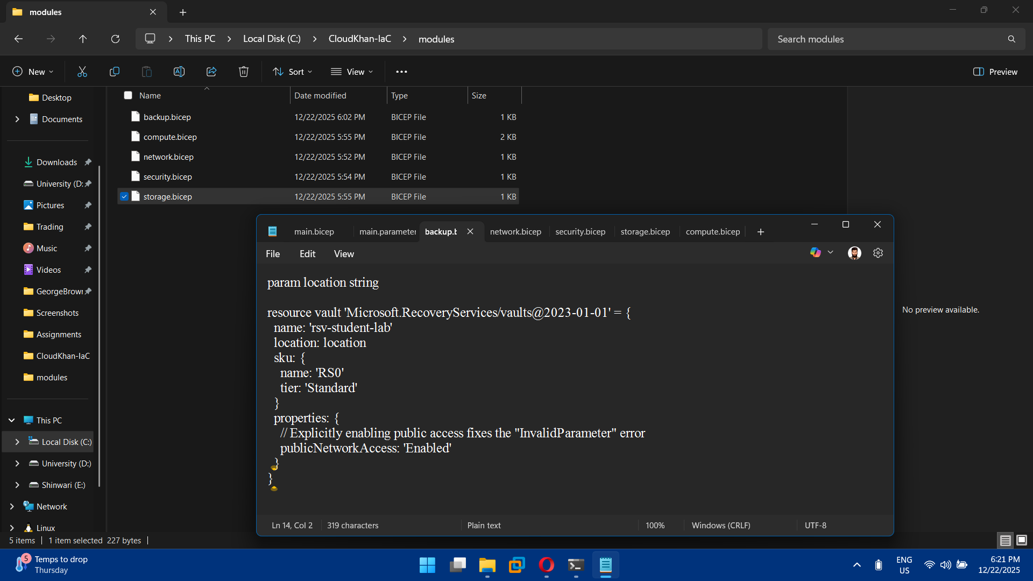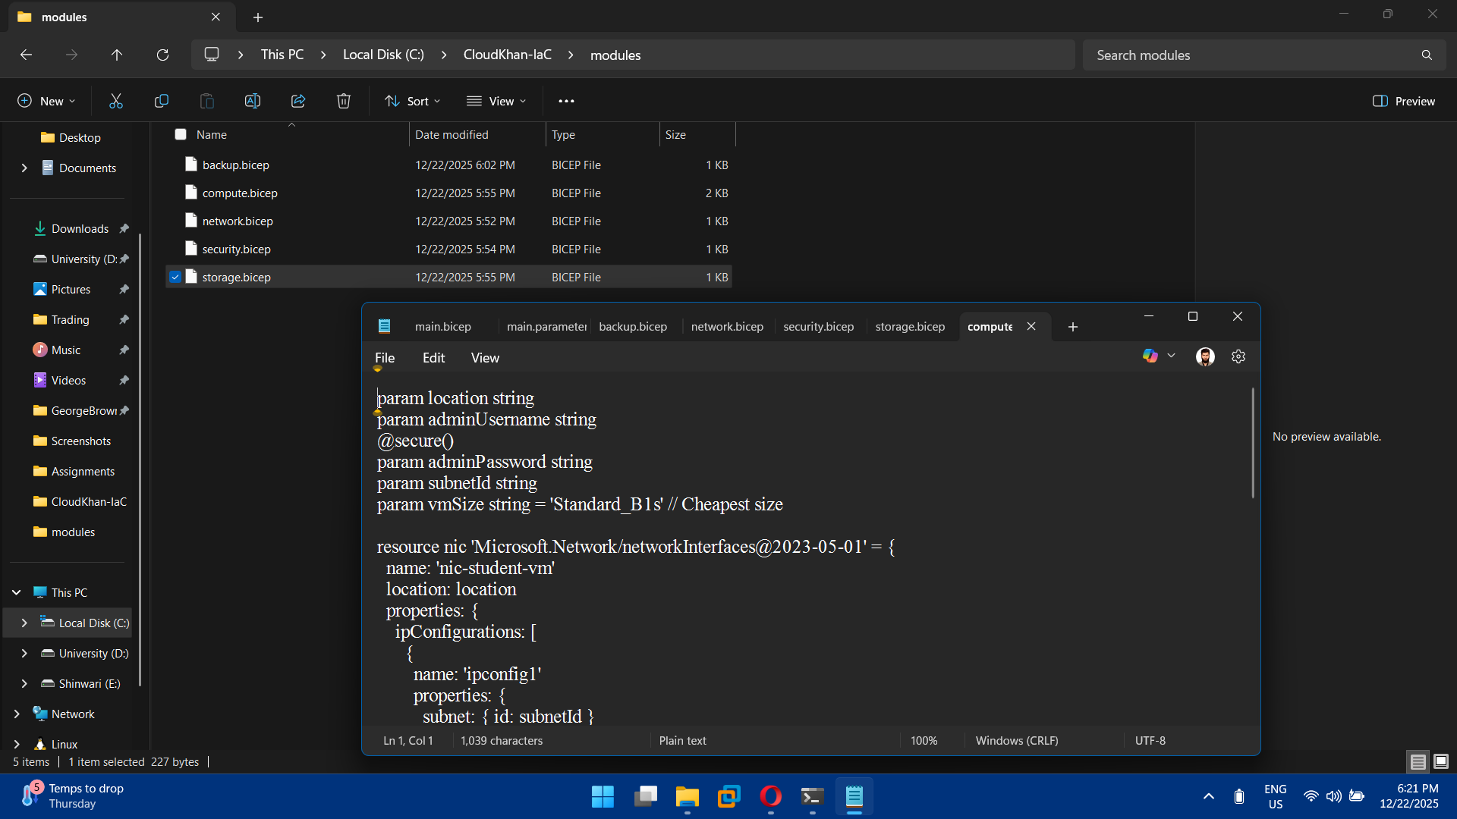

2. Use Parameters

* VM size
* Admin username
* Location
* Address spaces

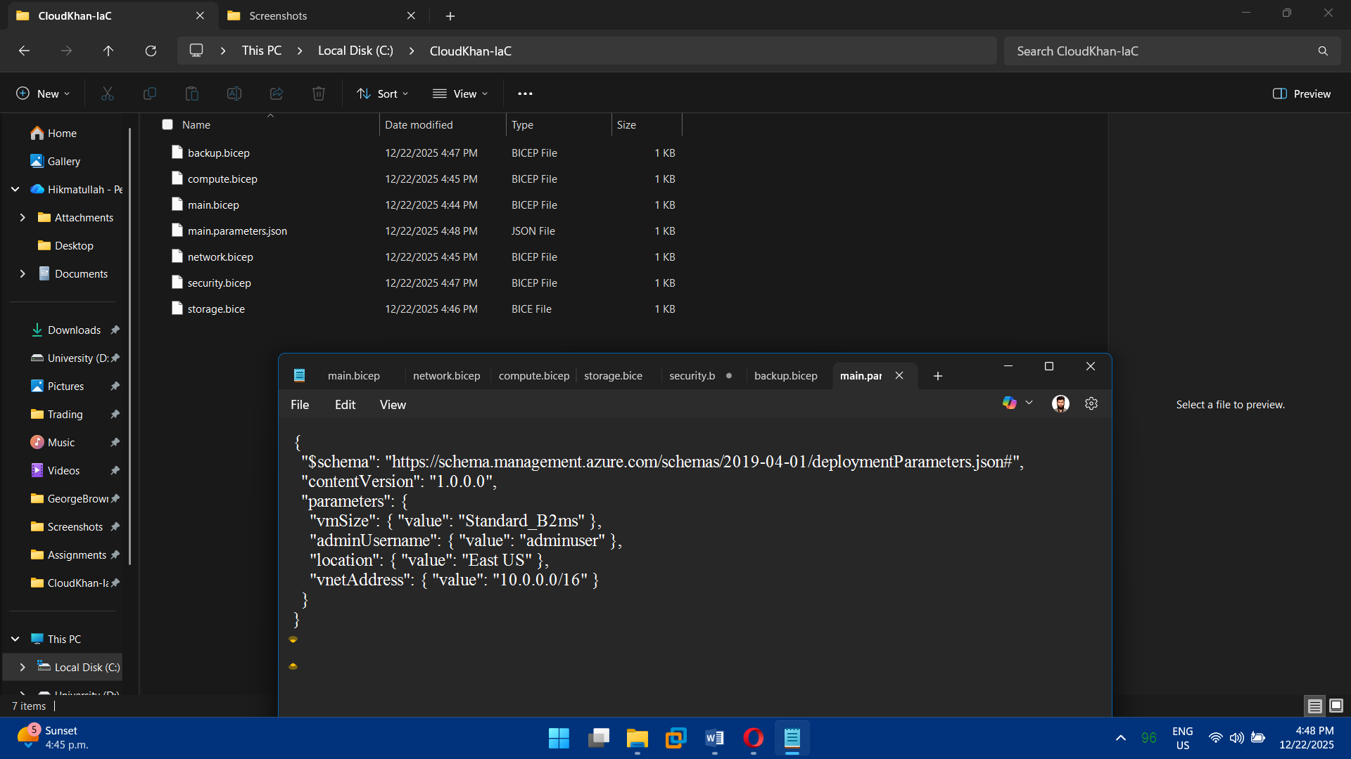

3. Deploy Using Automation

* Azure CLI
* PowerShell
* Repeatable, version-controlled deployments

